# ICECAPS Weekly Report

February 23 - March 1, 2015

Sam Dorsi

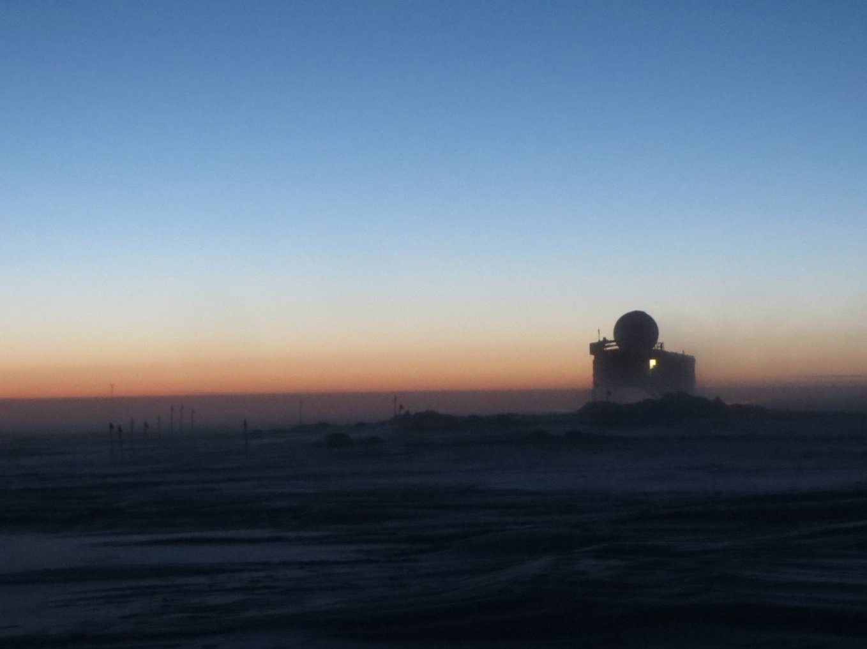

**The evening walk back from MSF. Guy is roasting chicken in the big house! --SWD**

**General:**

* 2/27: Daily checks delayed until afternoon due high winds and low visibility.
* 2/28: DOE is doing an inventory check, and we can’t locate their stickered computers. There should be 2 here.

**Significant Weather Observations:**

* 2/23: Few low stratus, estimated 3 kts (all anemometers rimed), -57C
* 2/24: Scattered altostratus and blowing snow, 10 kts, -49C
* 2/25: Blowing snow, 15 kts, -37C.
* 2/26: Overcast stratus and blowing snow, 16 kts, -38C.
* 2/27: Blowing snow, 29 kts, -33C.
* 2/28: Scattered thin cirrostratus, 9 kts, -44C.
* 3/1: Scattered thin cirrostratus, estimated 5 kts (all anemometers rimed), -47C.

**Dataman Account:**

* Operating normally.
* 2/23: The queued IceCam JPGs and Sodar netCDF files were moved out of the ToBoulder folder overnight, though their transfer doesn’t show up in the Dataman spot_check_archive.sh script output. Radiosonde mount was down overnight, and these data were not uploaded. This was attributed to an operator leaving the radiosonde computer in sleep mode.
* 2/24: Radiosonde data from previous day uploaded automatically.

**MWR:**

* HATPRO: operating normally.
* 150-90: operating normally.

**SODAR:**

* Operating normally.

**POSS:**

* Operating normally.

**MMCR:**

* Operating normally.
* Instrument has reached 0.2-degree off-zenith pointing limit.

**CAPABL:**

* Offsite as of 8/19.
* Continuing to monitor water storage system during winter.

**MPL:**

* Operating normally.
* 2/27: After period of high winds, MPL registered a “Can’t open AMCS card” error. Rebooted MPL, and reinitiated data collection without issue. No data were collected 04:26-17:15z.

**VCEIL:**

* Operating normally.

**Hotplate:**

* Offline due to technical issues.
* 2/23: With the instrument down on the lab bench, opened case and checked resistances of bottom heater plate circuit, following instructions from the manufacturer.
* 2/26: Powered up instrument inside and found no faults.
* 2/27: Tested response of hotplate to wind and simulated precipitation; reassembled and sealed case; will reinstall on stand and test in cold conditions.

**IceCAM:**

* Operating normally.

**PAERI:**

* Operating normally.
* 2/23: Due to unusual spectra, PAERI was taken offline by Von from 0400z to 0730z.
* 2/24: Cold temperatures are affecting PAERI scene mirror. Taken offline by Von; external fan removed at 1222z and instrument rebooted at 1322z by Sam.
* 2/25 – 3/1: PAERI continues to operate with external fan removed.

**ASIA-A:**

* Offline until summer due to broken radio component.

**TSI:**

* Offline and stored in MSF for winter.

**IcePIC:**

* No pictures taken.

**Radiosonde:**

* Twice daily sondes.
* 2/23: Sounding at 00z was not integrated into Met Office system, due to radiosonde mount being down overnight.