# ICECAPS Weekly Report

Feb 9-15, 2014

Jennie Mowatt and Sam Dorsi

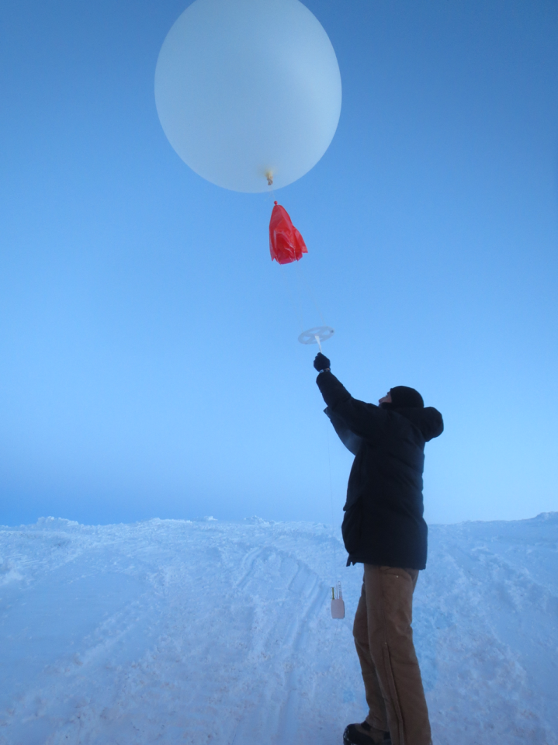

**Sam launches his first balloon… success.**

**General:**

* Turnover finally started on 2/11.

**Significant Weather Observations:**

* 2/9: Few clouds, 4 kts, -55C
* 2/10: Few clouds, 12 kts, -56C
* 2/11: Few clouds, 6 kts. -56C
* 2/12: Few clouds, 7 kts, -61C
* 2/13: Few clouds, 12 kts, -60C
* 2/14: Few clouds, 12 kts, -53C
* 2/15: Few clouds, 14 kts, -49C

**Dataman Account:**

* Operating normally.
* 2/13: Master HD # 3 swapped out with #1. #3 will be sent back to Boulder with Matt O. #4 remains in house as spare.

**MWR:**

* HATPRO: operating normally.
* 150-90: operating normally.
* 2/14: 1448Z rebooted MWRs for turnover training. Data collection resumed at 1451Z.

**SODAR:**

* Operating normally.
* 2/12: 1705-1717Z at SODAR for turnover training

**POSS:**

* Operating normally.
* 2/14: 1442Z rebooted POSS for turnover training. Data collection resumed at 1444Z.

**MMCR:**

* Operating normally.

**CAPABL:**

* Offsite as of 8/19.
* Continuing to monitor water storage system during winter.

**MPL:**

* Operating normally.
* 2/15: Afterpulse calibration performed starting at 1413Z. Data collection resumed at 1432Z.

**VCEIL:**

* Operating normally.
* 2/14: Ceilometer mount down overnight; data did not transfer.
* 2/15: Ceilometer mount back online. All remaining data transferred successfully.

**Hotplate:**

* Offline due to technical issues.
* 2/15: Confirmed data is being taken through TeraTerm. Troubleshooting ongoing.

**IceCAM:**

* Operating normally.

**PAERI:**

* Operating normally.
* 2/13: Rebooted at 13:39z. Data collection resumed 13:48z.
* 2/12-13: Red flags occurred at various times and the fan was removed and replaced multiple times due to extremely low outside temperatures.

**ASIA-A:**

* Operating normally.
* 2/7: Data looking odd, Pierre confirmed voltages are off. Troubleshooting will be left to warmer temperatures. Instrument currently in standby mode.

**TSI:**

* Offline and stored in MSF for winter.

**IcePIC:**

* No pictures taken.

**Radiosonde:**

* Twice daily sondes.