# ICECAPS Weekly Report

Jan 12-18, 2014

Jennie Mowatt

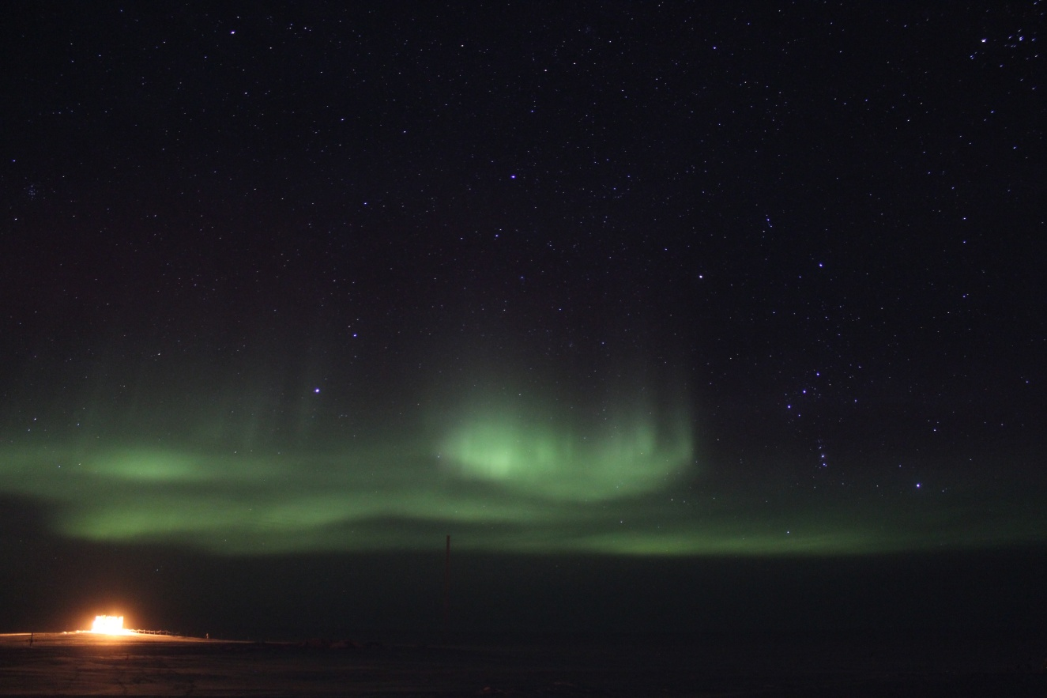

*Auroras over MSF before a storm hits. JM*

**General:**

* 1/15: There was an E-Gen swap test performed. Power was briefly out between the times of 1314-1315Z and 1321-1322Z.
* 1/17: Main MSF power cables were raised due to extensive drifting. SODAR, POSS and Hotplate cables were also raised.

**Significant Weather Observations:**

* 1/12: Drifting snow, 17 kts, -35C
* 1/13: Broken clouds, 14 kts, -44C
* 1/14: Broken clouds, 16 kts, -40C
* 1/15: Broken clouds, 7 kts, -48C
* 1/16: Broken clouds, 12 kts, -33C
* 1/17: Broken clouds, 8 kts, -45C
* 1/18: Blowing snow, 20 kts, -29C

**Dataman Account:**

* Operating normally.

**MWR:**

* HATPRO: operating normally.
* 150-90: operating normally.
* 1/17: The plastic outer cover on the insulation blanket on 150-90 has ripped. Weather pending an additional plastic cover will be patched on as supplies for a new blanket are limited. PI is aware of the issue and will send more supplies for a new blanket in spring.

**SODAR:**

* Operating normally.

**POSS:**

* Operating normally.

**MMCR:**

* Operating normally.

**CAPABL:**

* Offsite as of 8/19.
* Continuing to monitor water storage system during winter.

**MPL:**

* Operating normally.
* 1/18: AMCS card timeout due to high winds starting at 2200Z on 1/17. Restarted computer and program, data collection resumed at 1248Z.

**VCEIL:**

* Operating normally.

**Hotplate:**

* Offline due to technical issues.

**IceCAM:**

* Operating normally.

**PAERI:**

* Operating normally.
* 1/14: Partial blue flags during rounds.

**ASIA-A:**

* Operating normally.
* 1/18: Comm error and frozen time due to high winds. Restarted computer and radiometer. Data collection resumed at 1251Z.

**TSI:**

* Offline and stored in MSF for winter.

**IcePIC:**

* No pictures taken.

**Radiosonde:**

* Twice daily sondes.