# ICECAPS Weekly Report

Jan 19-25, 2014

Jennie Mowatt

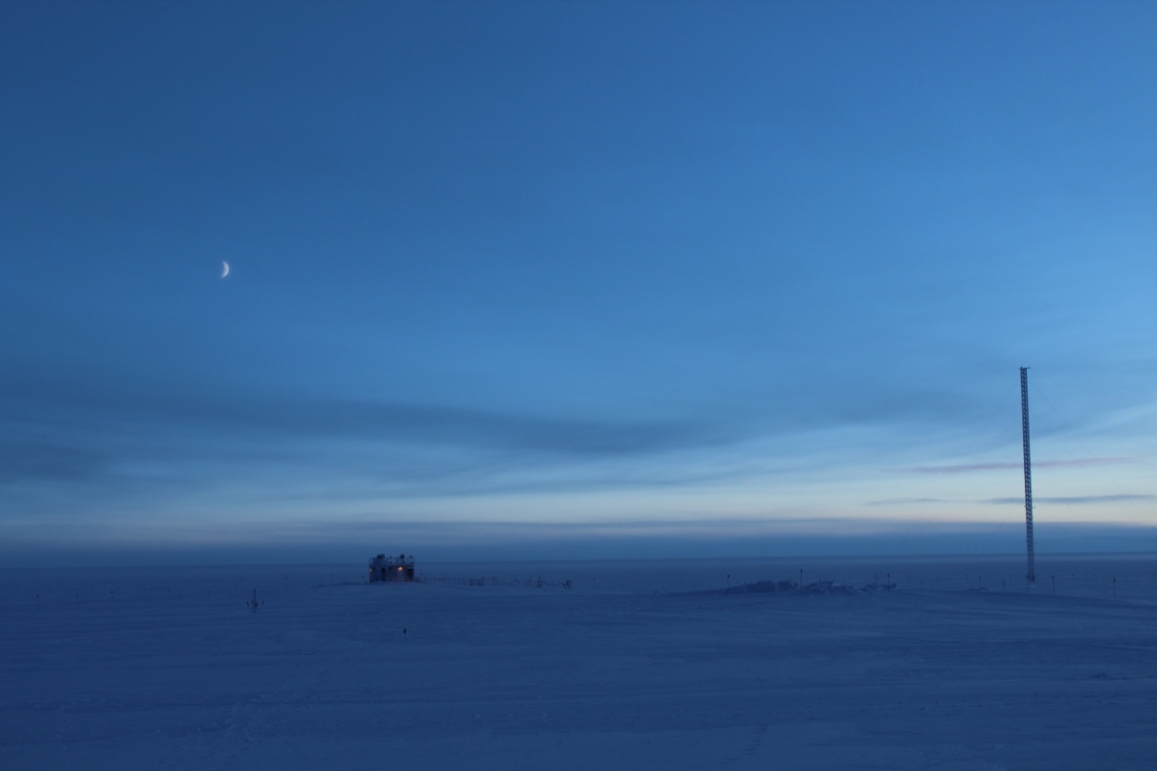

*Moon over MSF. JM*

**Significant Weather Observations:**

* 1/19: Blowing snow, 24 kts, -24C
* 1/20: Broken clouds, 8 kts, -30C
* 1/21: Blowing snow, 28 kts, -28C
* 1/22: Broken clouds, 12 kts, -36C
* 1/23: Drifting snow, 16 kts, -33C
* 1/24: Broken clouds, 14 kts, -40C
* 1/25: Scattered clouds, 13 kts, -44C

**Dataman Account:**

* Operating normally.

**MWR:**

* HATPRO: operating normally.
* 150-90: operating normally.
* 1/22: Comm error reported at 1310Z. Rebooted radiometers and program. Data collection resumed at 1313Z.
* 1/23: Re-leveled both MWRs in the North-South (short) axis.

**SODAR:**

* Operating normally.
* 1/22: Dishes cleaned from 1333-1420Z.

**POSS:**

* Operating normally.
* 1/22: POSS instrument stand raised due to drifting. Instrument offline from 1501-1604Z.

**MMCR:**

* Operating normally.

**CAPABL:**

* Offsite as of 8/19.
* Continuing to monitor water storage system during winter.

**MPL:**

* Operating normally.
* 1/19: AMCS card timeout starting on 1/18 at 1412Z. Afterpulse calibration performed starting at 1301Z. Data collection resumed at 1319Z.
* 1/21: AMCS card timeout error due to high winds. Data collection resumed at 1310Z.
* 1/22: AMCS card timeout error due to high winds starting at 0031Z on 1/22. Data collection resumed at 1319Z.
* 1/25: AMCS card timeout error due to high winds starting at 2102Z on 1/24. Data collection resumed at 1251Z.

**VCEIL:**

* Operating normally.

**Hotplate:**

* Offline due to technical issues.

**IceCAM:**

* Operating normally.

**PAERI:**

* Operating normally.
* 1/24: Partial blue flags during rounds.

**ASIA-A:**

* Operating normally.

**TSI:**

* Offline and stored in MSF for winter.

**IcePIC:**

* No pictures taken.

**Radiosonde:**

* Twice daily sondes.