# ICECAPS Weekly Report

Jan 26- Feb 1, 2014

Jennie Mowatt

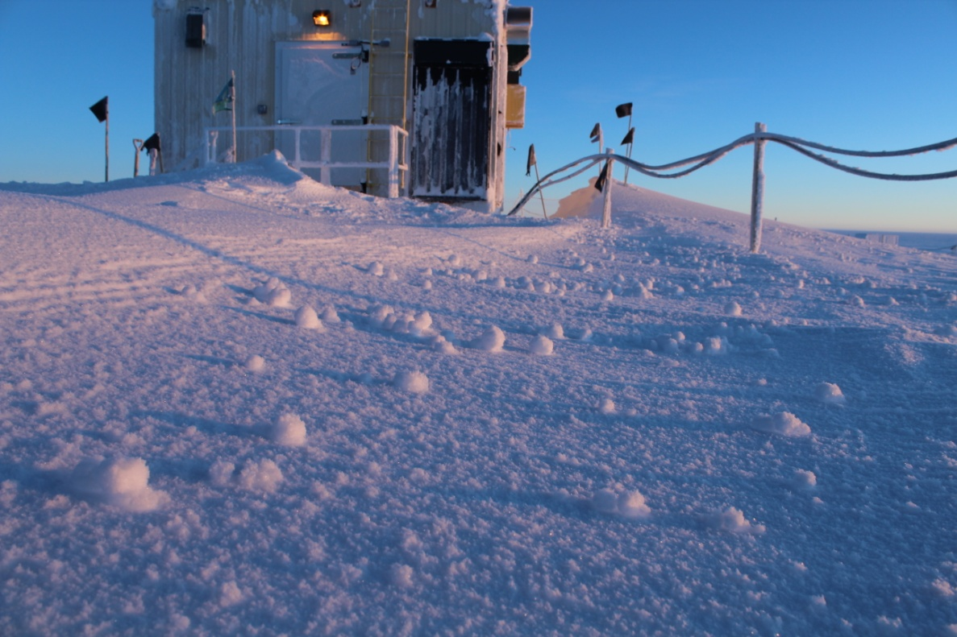

*Yukimarimo and the first real viewing of sun (2/1). JM*

**Significant Weather Observations:**

* 1/26: Few clouds, 14 kts, -48C
* 1/27: Blowing snow, 24 kts, -34C
* 1/28: Blowing snow, 20 kts, -33C
* 1/29: Scattered clouds, 13 kts, -39C
* 1/30: Scattered clouds, 12 kts, -44C
* 1/31: Scattered clouds and fog on the horizon, 10 kts, -50C
* 2/1: Few clouds, 7 kts, -53C

**Dataman Account:**

* Operating normally.

**MWR:**

* HATPRO: operating normally.
* 150-90: operating normally.

**SODAR:**

* Operating normally.

**POSS:**

* Operating normally.
* 1/30: Instrument offline due to hotplate raise (shared power source) 1638-1713Z.

**MMCR:**

* Operating normally.
* 1/28: Radar rebooted 4 times due to new error at 1305Z. PI was informed. Data collection resumed at 1410Z.

**CAPABL:**

* Offsite as of 8/19.
* Continuing to monitor water storage system during winter.

**MPL:**

* Operating normally.
* 1/27: AMCS card timeout starting at 011Z on 1/27 due to high winds. Computer rebooted. Data collection resumed at 1306Z.

**VCEIL:**

* Operating normally.
* 1/30: Rebooted computer at 1715Z. Data collection restarted at 1719Z.
* 1/31: Ceilometer data mount down overnight. Data did not transfer.
* 2/1: Remaining and new data transferred fine overnight.

**Hotplate:**

* Offline due to technical issues.
* 1/30: Raised ~1m due to extensive drifting.

**IceCAM:**

* Operating normally.

**PAERI:**

* Operating normally.
* 2/1: Fan in outside enclosure swapped out due to odd noises. Bearings will be replaced in the old fan.

**ASIA-A:**

* Operating normally.
* 1/27: Comm error due to high winds. Computer and radiometer rebooted. Data collection resumed at 1309Z.

**TSI:**

* Offline and stored in MSF for winter.

**IcePIC:**

* No pictures taken.

**Radiosonde:**

* Twice daily sondes.
* 1/31: Kestrel measurement discontinued indefinitely.