# ICECAPS Weekly Report

Jan 5-11, 2014

Jennie Mowatt

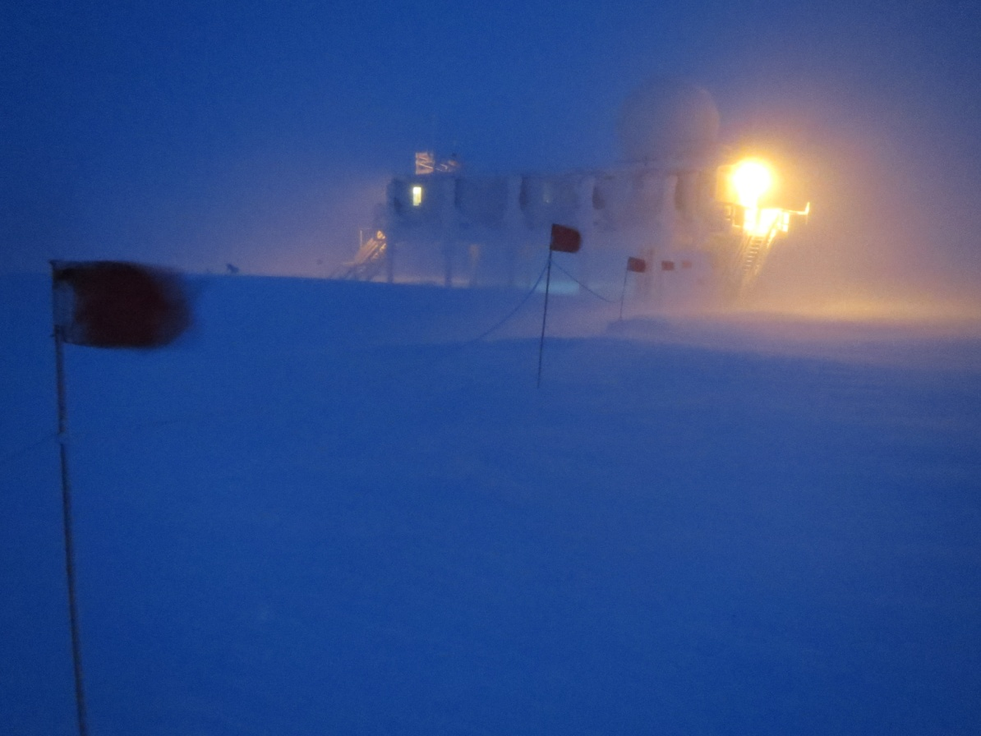

*High winds persist, this time from the east. JM*

**Significant Weather Observations:**

* 1/5: Blowing snow, 27 kts, -32C
* 1/6: Few clouds, 12 kts, -50C
* 1/7: Blowing snow, 16 kts, -37C
* 1/8: Blowing snow, 23 kts, -35C
* 1/9: Broken clouds, 15 kts, -35C
* 1/10: Drifting snow, 17 kts, -38C
* 1/11: Drifting snow, 17 kts, -37C

**Dataman Account:**

* Operating normally.

**MWR:**

* HATPRO: operating normally.
* 150-90: operating normally.

**SODAR:**

* Operating normally.
* Dishes cleaned twice this week. It was found that despite being fully seated, the connection to the sound module in the dish is slightly loose and when bumped, can impact data readout.

**POSS:**

* Operating normally.
* 1/5: Shut down POSS at 1939Z to reset hotplate. Data collection resumed at 1951Z.

**MMCR:**

* Operating normally.

**CAPABL:**

* Offsite as of 8/19.
* Continuing to monitor water storage system during winter.

**MPL:**

* Operating normally.
* 1/5: Afterpulse calibration performed. Data collection resumed at 1411Z.
* 1/8: AMCS card timeout error occurred on 1/7 at 1300Z. Restarted computer and program and 1245Z. Data collection resumed at 1249Z.
* 1/11: AMCS card timeout error occurred on 1/10 at 2035Z. Restarted computer and program. Data collection resumed at 1245Z.

**VCEIL:**

* Operating normally.
* 1/5: Computer rebooted at 1952Z to troubleshoot hotplate. Data collection resumed at 2000Z.
* 1/6: Ceilometer mount down overnight. Data did not transfer. Remounted drive manually.
* 1/7: All remaining data transferred overnight.

**Hotplate:**

* Operating normally.
* 1/5: Comms fault (likely due to high winds). Data collection is currently suspended due to troubleshooting.

**IceCAM:**

* Operating normally.

**PAERI:**

* Operating normally.
* 1/9: Partial blue flags during rounds.

**ASIA-A:**

* Operating normally.
* 1/8: Rebooted computer and radiometer at 1249Z due to comm error.

**TSI:**

* Offline and stored in MSF for winter.

**IcePIC:**

* No pictures taken.

**Radiosonde:**

* Twice daily sondes.