# ICECAPS Weekly Report

July 13 – July 19, 2015

Clair Von Handorf

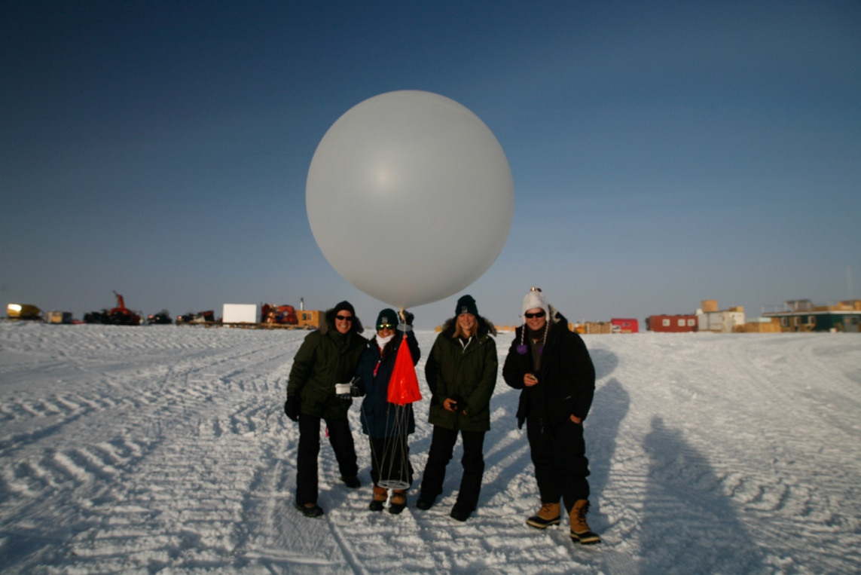

JSEP Group helps with balloon launch on 7/19--CVH

**General:**

* Flight Plan 5 began on 7/15, beginning with a group of distinguished visitors, including the U.S. Ambassador to Denmark, a reporter from the New York Times, and their camera crews. The JSEP Group (Joint Science Education Project) was at Summit from 715-7/18.

**Significant Weather Observations:**

* 7/13: broken stratocumulus, 15kts, -7.8C
* 7/14: few altostratus, 10kts, -11.4C
* 7/15: few altostratus, 5kts, -12.5C
* 7/16: few altostratus, 7kts, -13.3C
* 7/17: few altostratus, 10kts, -11.1C
* 7/18: few cirrus, 4kts, -10.8C
* 7/19: broken stratus, 8kts, -6.6C

**Dataman Account:**

* Operating normally.

**MWR:**

* HATPRO: operating normally.
* 150-90: operating normally.

**SODAR:**

* Operating normally.

**POSS:**

* Operating normally.

**MMCR:**

* Operating normally.
* 7/13-14: 12:35z during daily checks, the +5V #1 and #2 voltages were both reading at ~+4.05V. Duane Hazen and Matt Shupe were notified. The MMCR outdoor temperature is reading at +83*C.
* 7/14: 17:10z The back panel of the MMCR-Radar was removed and inspected. The wire installed on 7/1 was not solidly connected and after inspection the alarms mentioned above were resolved. Duane Hazen was notified and this will be monitored.
* 7/17-19: The Outdoor Temperature gauge is reading at 105C and the +5V low readings were present again. Duane Hazen and Matt Shupe were notified.

**CAPABL:**

* Operating normally.

**MPL:**

* Operating normally.
* 7/14: 12:17z-12:35z Monthly Afterpulse Calibration performed.

**VCEIL:**

* Operating normally.

**Hotplate:**

* Operating normally.

**IceCAM:**

* Operating normally.

**PAERI:**

* Operating normally.

**ASIA-A:**

* Offsite for repair since 4/30.

**TSI:**

* Operating normally.

**IcePIC:**

* 7/13: 13:34z Photos taken.

**Radiosonde:**

* Twice daily sondes.

**Doppler Wind Lidar:**

* Offsite on 6/29/15.

**MASC:**

* Operating normally.