# ICECAPS Weekly Report

July 27 – August 2, 2015

Clair Von Handorf

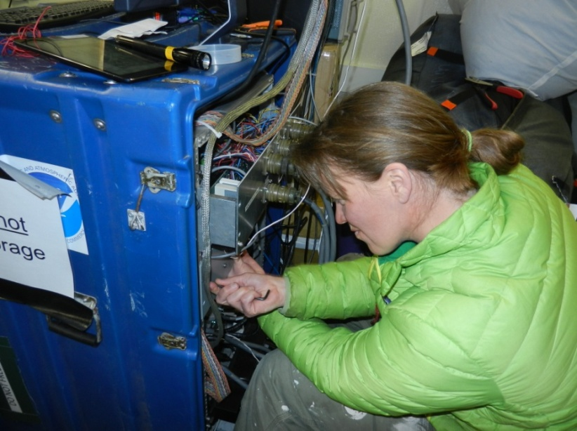

Trouble shooting on the MMCR –NS

**General:**

* None.

**Significant Weather Observations:**

* 7/27: broken stratus, 7kts, -13.7C
* 7/28: scattered altostratus, 6kts, -12.8C
* 7/29: broken altostratus, 12kts, -13.0C
* 7/30: broken altostratus, 16kts, -13.0C
* 7/31: broken stratus, drifting snow, 18kts, -10.0C
* 8/1: broken stratus, 12kts, -9.8C
* 8/2: broken stratus, 0kts, -10.0C

**Dataman Account:**

* Operating normally.

**MWR:**

* HATPRO: operating normally.
* 150-90: operating normally.

**SODAR:**

* Operating normally.

**POSS:**

* Operating normally.

**MMCR:**

* 7/28: 17:33z MMCR was shut down for troubleshooting. Monitor Patch Panel removed and grounding wires were traced. The requested information was reported back to Duane and Matt. MMCR was restarted at 18:30z: +5V #1 and #2 are at +5.0V, Outdoor Temperature gauge at -8C. Pitch at 0.15.
* 7/29: 14:54z MMCR was shut down for troubleshooting. Other wires were traced and the information was reported. MMCR was restarted at 16:53z: +5V #1 and #2 are at +5.0V, Outdoor Temperature gauge at +200C. Pitch at 0.15.
* 8/1: 1156z MMCR was shut down. A 56K ohm resistor was installed between J1-12 to J1-16. MMCR was restarted at 12:14z: +5V #1 at +0.03 to +2V. Outdoor temperature at 0.98C. MMCR was rebooted twice with similar results.

**CAPABL:**

* Operating normally.
* 7/30: Received new CAPABL Manual quick sheet for daily checks from Robert Stillwell.

**MPL:**

* Operating normally.

**VCEIL:**

* Operating normally.

**Hotplate:**

* Operating normally.

**IceCAM:**

* Operating normally.

**PAERI:**

* Operating normally.

**ASIA-A:**

* Offsite for repair since 4/30.

**TSI:**

* Operating normally.

**IcePIC:**

* Photos taken on 7/29.

**Radiosonde:**

* Twice daily sondes.

**Doppler Wind Lidar:**

* Offsite on 6/29/15.

**MASC:**

* Operating normally.