# ICECAPS Weekly Report

July 6 – July 12, 2015

Clair Von Handorf

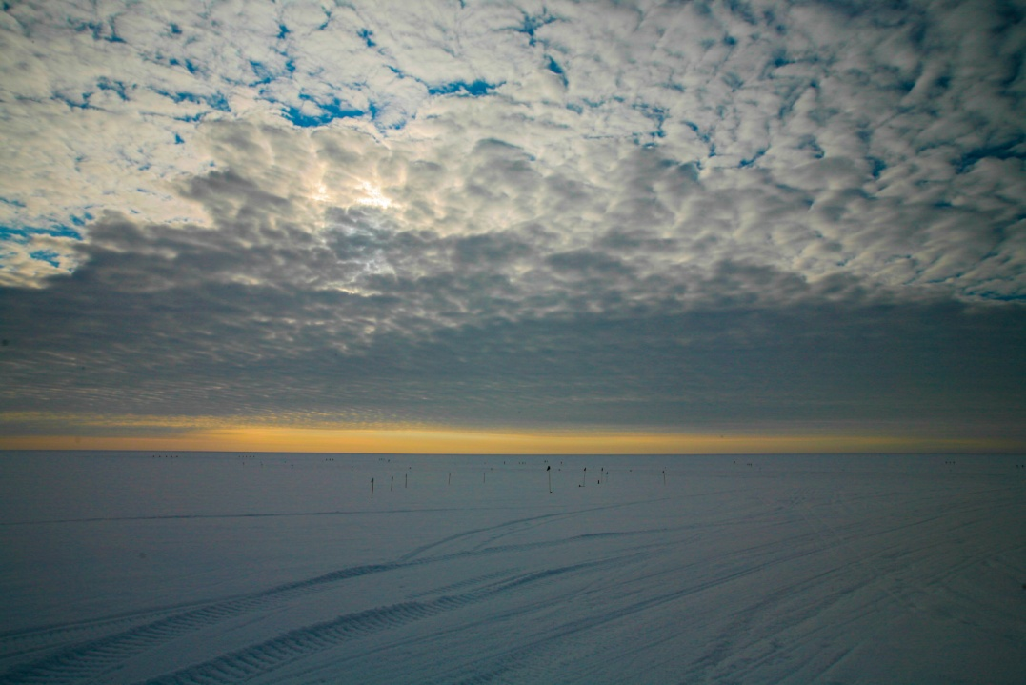

**7/8 Clouds return to Summit this week--CVH**

**General:**

* A planned power outage occurred on 7/12 at 16:00z. Instruments were on UPS power momentarily while the emergency generator was powered up. Power was switched back to the main generator at 16:18z.

**Significant Weather Observations:**

* 7/6: scattered cirrus, 4kts, -9.0C
* 7/7: few cirrostratus, 0kts, -10.0C
* 7/8: broken cirrocumulus, 8kts, -6.9C
* 7/9: scattered cirrocumulus, 11kts, -8.4C
* 7/10: broken altostratus, 14kts, -9.9C
* 7/11: broken altocumulus, 14kts, -9.9C
* 7/12: broken cirrostratus, 9kts, -8.1C

**Dataman Account:**

* Operating normally.

**MWR:**

* HATPRO: operating normally.
* 150-90: operating normally.

**SODAR:**

* Operating normally.
* 7/7: 16:18z In an attempt to eliminate PowerWare network error messages, the SODAR network connection was moved from port 13 to port 7. Error messages are still present.
* 7/9: 12:38-12:42z SODAR speaker and microphone mounting plate leveled.

**POSS:**

* Operating normally.

**MMCR:**

* Operating normally.
* 7/12: During and after planned power outage at 16:00z, all checks were made and MMCR appeared to be running normally. At 16:37z, however, the +5V #1 and #2 voltages were both reading at ~+4.05V. Duane Hazen and Matt Shupe were notified.

**CAPABL:**

* Operating normally.

**MPL:**

* Operating normally.

**VCEIL:**

* Operating normally.

**Hotplate:**

* Operating normally.

**IceCAM:**

* Operating normally.

**PAERI:**

* Operating normally.

**ASIA-A:**

* Offsite for repair since 4/30.

**TSI:**

* Operating normally.

**IcePIC:**

* An attempt to take pictures was made on 7/10 and 7/12, but strong winds and light snow prevented precipitation to accumulate on the slides. No photos taken.

**Radiosonde:**

* Twice daily sondes.
* 7/11: Morning sonde failed immediately after launch.

**Doppler Wind Lidar:**

* Offsite on 6/29/15.

**MASC:**

* Operating normally.