# ICECAPS Weekly Report

June 1 – 7, 2015

Sam Dorsi

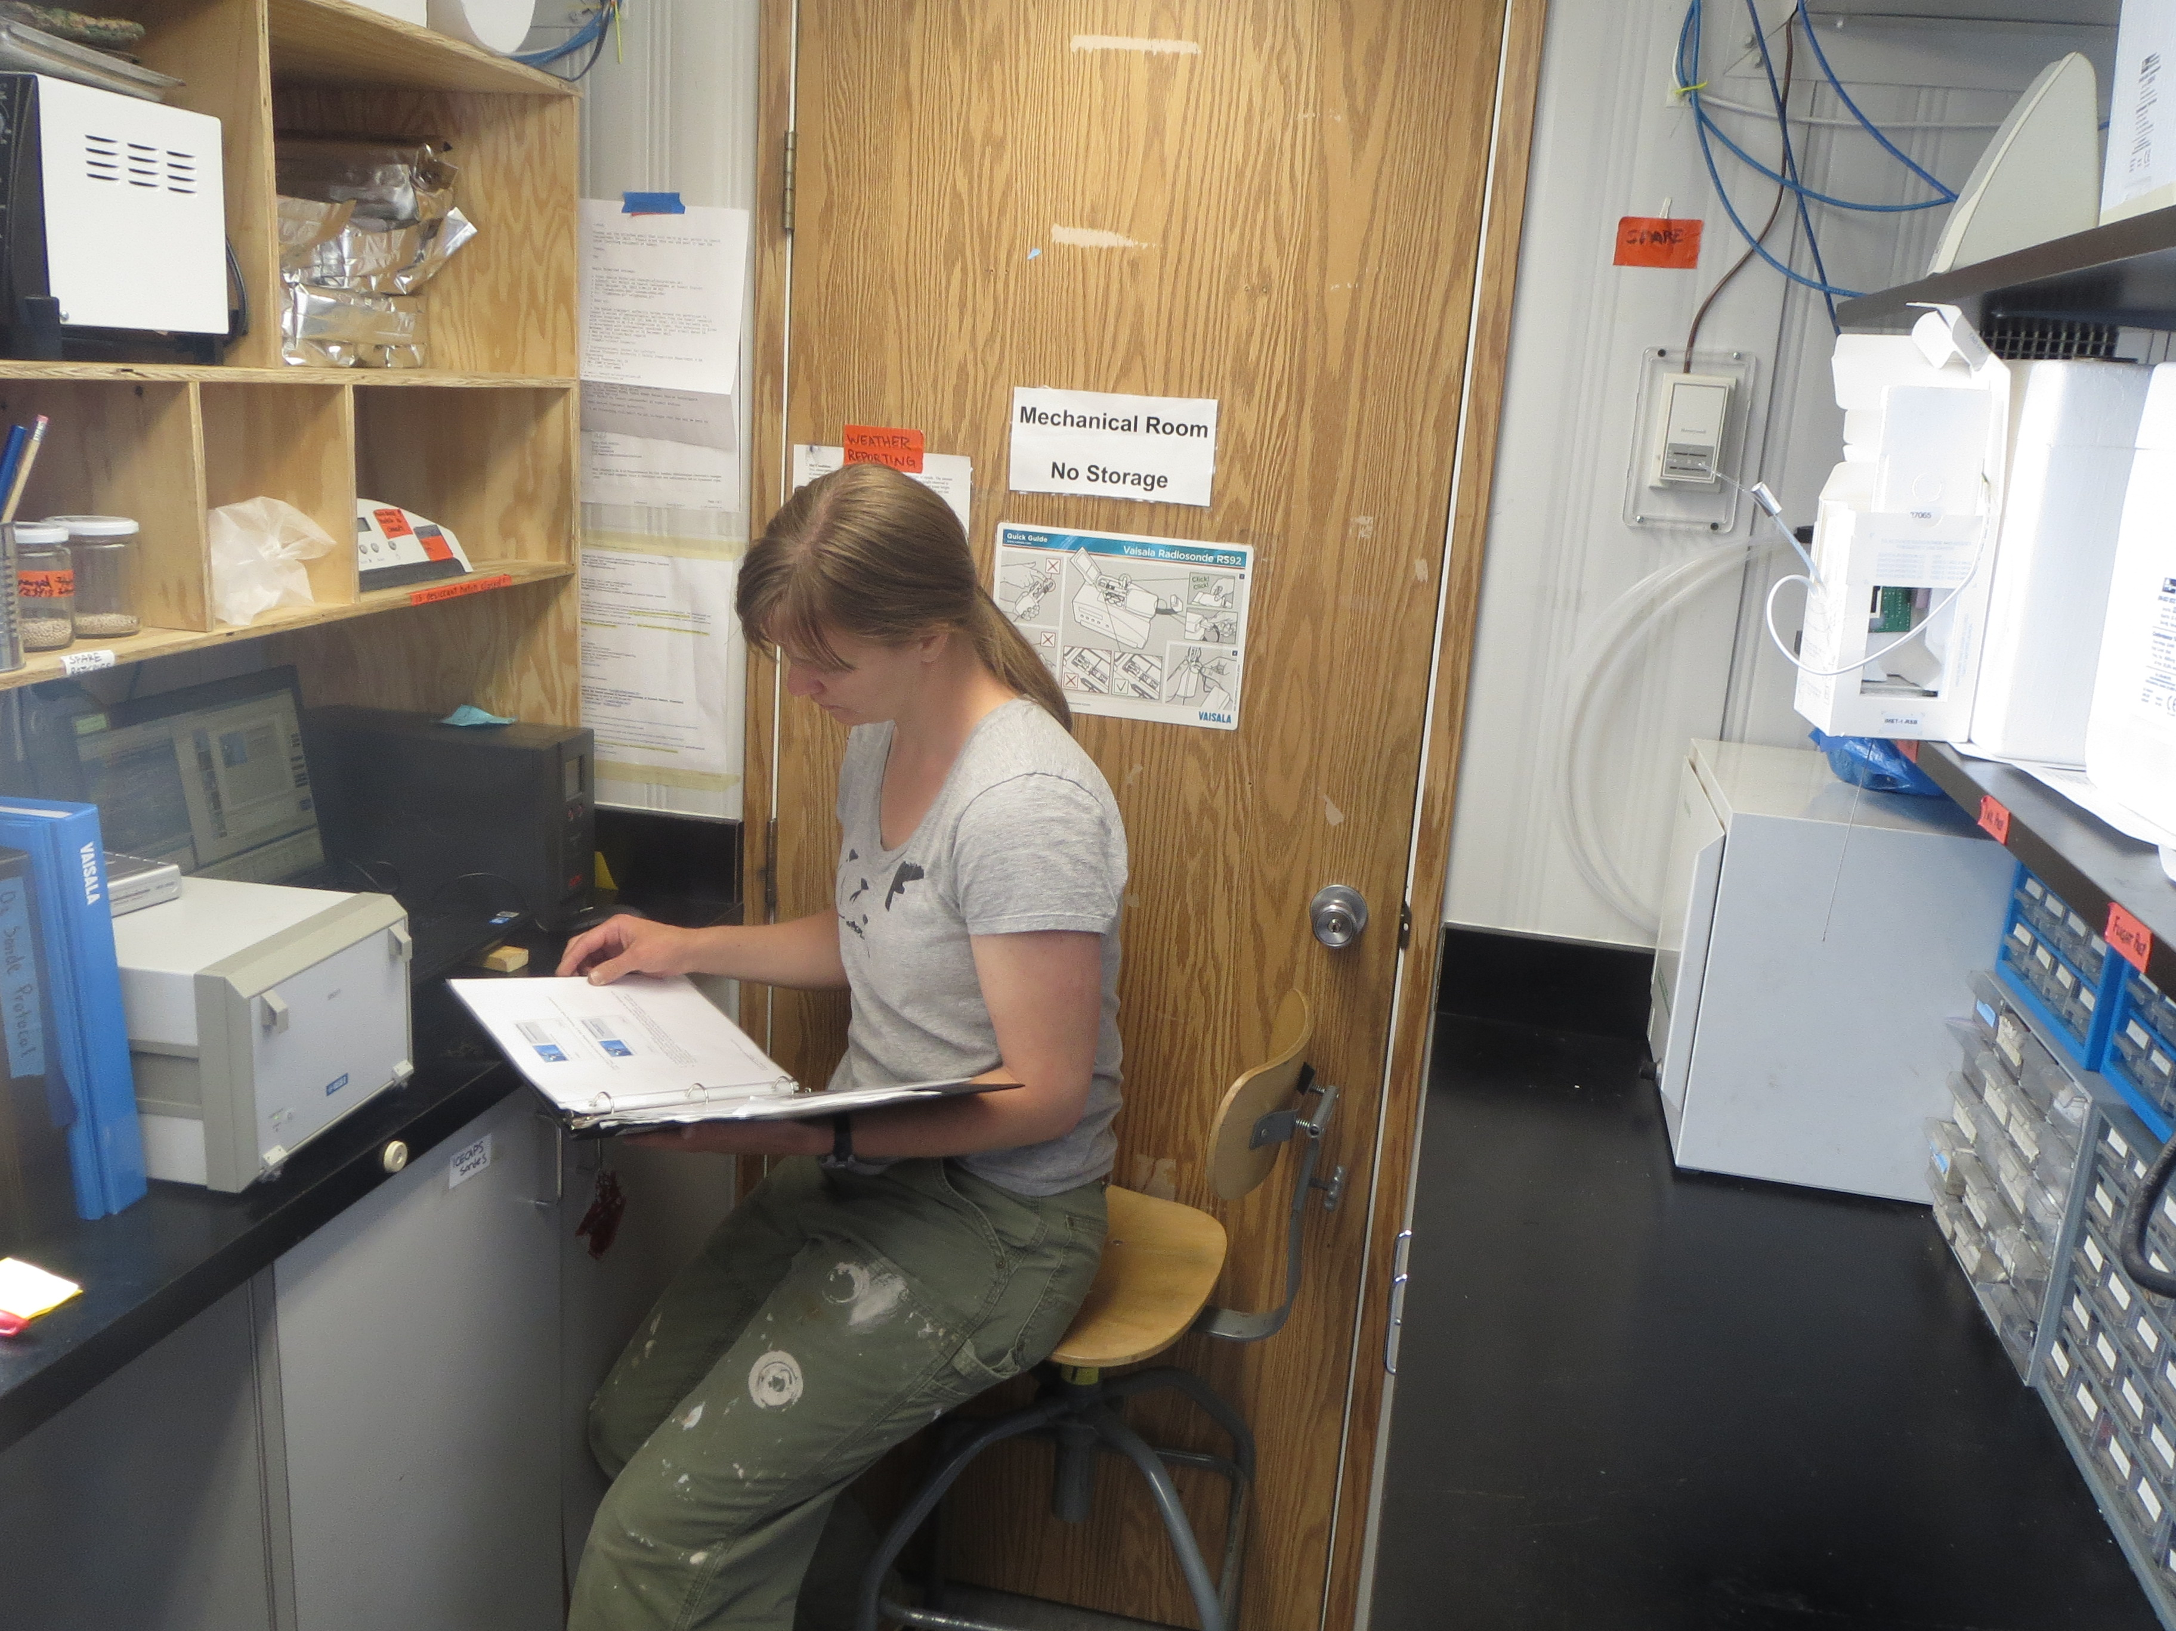

**Incoming ICECAPS tech Clair reviews radiosonde protocols. –SWD**

**General:**

* 6/1: Turnover crew arrives at Summit! Clair will be starting the extended ICECAPS turnover in about a week, after getting initially established in NOAA tasks.
* 6/1: Duane Hazen and Ryan Neely arrived on station.
* 6/3 – 6/7: Reoccurring errors (~8 / day) are appearing on PAERI and MWR that “NetWatch is experiencing a loss of communications with the Shutdown Server 192.168.1.32”. This error is typically followed ~ 7 minutes later with a message that communications have been restored. These errors typically have appeared 1/day on many machines, but this high incidence is unusual.

**Significant Weather Observations:**

* 6/1: Scattered stratus, 12 kts, -19C
* 6/2: Few altostratus, 16 kts, -18C
* 6/3: Few altostratus, 7 kts, -19C
* 6/4: Broken altostratus, parhelic circle, circumzenith arc, and Perry arc, 10 kts, -18C
* 6/5: Few altostratus, 3 kts, -18C
* 6/6: Few altostratus, 3 kts, -17C
* 6/7: Broken stratus, light snow, 0 kts, -16C

**Dataman Account:**

* Operating normally.
* 6/2 – 6/4, 6/6: CAPABL mount down during overnight transfers, due to ongoing computer work by PIs.
* 6/5 – 6/6, 6/8: MMCR mount down due to Duane Hazen maintenance project.
* 6/1, 6/3, 6/4, 6/5: Overnight uploads completing later than 12z.

**MWR:**

* HATPRO: operating normally.
* 150-90: operating normally.

**SODAR:**

* Operating normally.

**POSS:**

* Operating normally.

**MMCR:**

* Operating normally, with intermittent outages during Duane Hazen’s onsite activities.
* Duane Hazen has been performing maintenance and calibration of the MMCR. He replaced the GPIB board that was giving communication problems with the pulse controller. He also undertook calibrations of the forward power and RF attenuator: these are standard annual activities. The MMCR is good working condition.

**CAPABL:**

* 6/4: CAPABL started normal operations at 01:47z.
* Ryan Neely has been onsite, and has finished CAPABL testing.

**MPL:**

* Operating normally.

**VCEIL:**

* Operating normally.

**Hotplate:**

* Operating normally.

**IceCAM:**

* Operating normally.

**PAERI:**

* Operating normally.
* 6/3: A housekeeping-related error message was discovered on the PAERI Ingest window at 12:10z. In the 10 minutes as the tech prepared to document and report this issue, the PAERI resumed operation, and the error messages were shifted out of the terminal window history. During this automatic recovery time, the PAERI showed all warning flags in a blue status. Though the PAERI returned to normal operational status and passed daily checks, this event was reported to Von Walden and Dave Turner.

**ASIA-A:**

* Offsite for repair since 4/30.

**TSI:**

* Operating normally.

**IcePIC:**

* No photos taken

**Radiosonde:**

* Twice daily sondes.
* From 5/22 to 6/2 12z, radiosondes were prepared using rapid preparation work-around. During these flights, base station GPS data would become unavailable midflight. After that point, wind data was calculated in ‘autonomous’ mode—these data may be less accurate.
* 6/2: Vaisala provided a software patch designed to address the issue with the ground station GPS card. The incoming and outgoing techs worked together to apply this patch. The patch installation appeared successful, and radiosondes have since been launched without any irregularities.

**Doppler Wind Lidar:**

* Operating normally.
* The ESA mission is complete. The ICECAPS group should consider scan patterns for the next three weeks that address ICECAPS-specific questions.

**MASC:**

* Operating normally.