# ICECAPS Weekly Report

June 15 – 21, 2015

Sam Dorsi and Clair Von Handorf

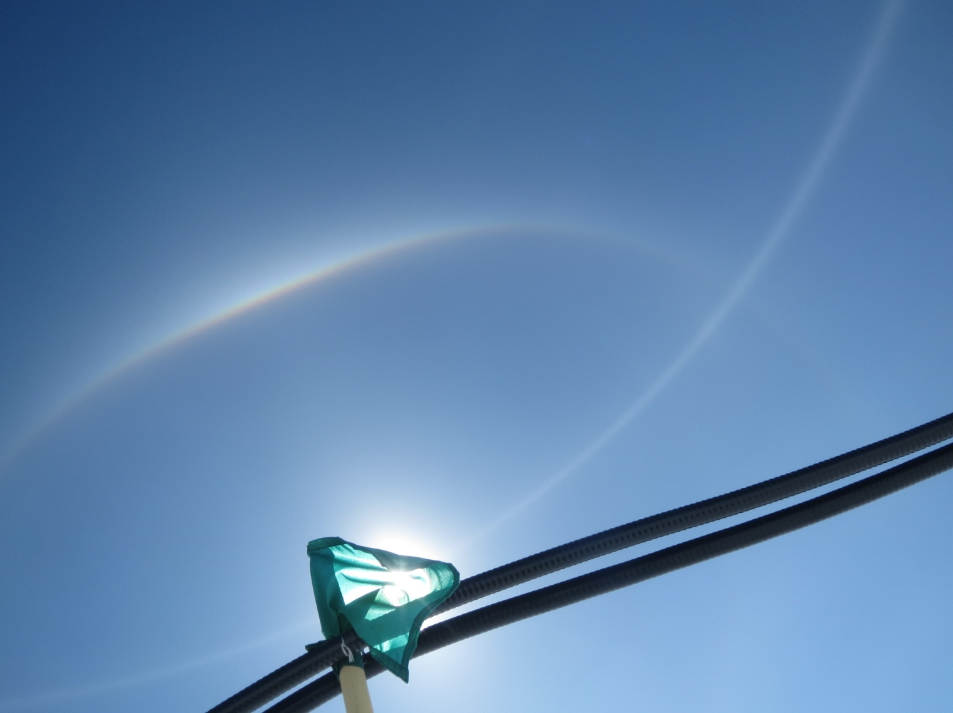

**Bands of light arc across the sky above the MSF power conduit. --SWD**

**General:**

* 6/21: Grounding strap improved on radio modem.

**Significant Weather Observations:**

* 6/15: Few altostratus, 9 kts, -21C
* 6/16: Scattered altocumulus, 12 kts, -16C
* 6/17: Scattered altostratus, 15 kts, -14C
* 6/18: Broken stratus, 10 kts, -11C
* 6/19: Broken altocumulus, 9 kts, -9C
* 6/20: Broken stratus, 12 kts, -9C
* 6/21: Scattered altocumulus, 5 kts, -8C

**Dataman Account:**

* Operating normally.
* 6/20: No data was transferred overnight (‘lost connection’ error messages in ArchiveToBoulder log). There may have been a (scheduled?) computer outage in Boulder.
* 6/21: No data was transferred overnight (‘No such file or directory’ error messages in ArchiveToBoulder log). This may be related to the extremely slow and intermittent local network connection that was experienced around this time at Summit.

**MWR:**

* HATPRO: operating normally.
* 150-90: operating normally.

**SODAR:**

* Operating normally.
* 6/16: SODAR rebooted for turnover training at 17:37z; data collection resumed at 17:58z.
* 6/16: SODAR speaker and microphone mounting plate leveled at 17:45z.

**POSS:**

* Operating normally.
* 6/16: POSS data acquisition rebooted for turnover training at 17:20z.

**MMCR:**

* Operating normally.
* 6/19: The MMCR LabView software shows a red status flag for “5v #1”. This value is ranging from 4.00 to 4.22 v, with the value usually near 4.10 v.
* 6/20: While the “+5v #1” error is still present (at 4.4 v), there is now additionally an error for “+5v #2” (at 4.7 v). This was observed at 12:01z. At approximately 03:00z, the forward power decreased by about 3 W.
* 6/20: At 00:21z, test point voltages were read off the back of the Radian interface box:

GND (reference point for other voltages)

5 v: 5.01 v

-5 v: -4.98 v

28 v: 28.04 v

5 v: 4.68 v

-15 v: -15.15 v

15 v: 15.19 v

And as read on the LabView radar monitor at roughly the same time:

+5v #1: 4.16 v

+5v #2: 4.67 v

* 6/21: Low voltages continue to appear on the 5 v buses (#1: 4.35 #2: 4.41 ).

**CAPABL:**

* Operating normally.
* Ryan Neely has been onsite.
* 6/17: Daily check tasks optimized after trial period.

**MPL:**

* Operating normally.
* 6/17: MPL rebooted for turnover training (18:34z).
* 6/17: Monthly afterpulse calibration and turnover training performed (18:54z).

**VCEIL:**

* Operating normally.

**Hotplate:**

* Operating normally.
* 6/17: The hotplate software was shut down and restarted for turnover training (16:58z).

**IceCAM:**

* Operating normally.

**PAERI:**

* Operating normally.
* 6/15: The housekeeping time series are absent (13:49z), replaced by a ‘data is null’ message. Von is aware of this issue.
* 6/17: The PAERI was discovered with the computer unresponsive and the monitor blank at 12:15z. This is similar to the situation observed on 29 May. This was reported to Von, who requested a reboot. This was performed at 15:30z, using the reset button on the CPU face.

Upon reboot, the Ingest window opened, and a full H-Z sequence of scans was performed. At the completion of the Z scan, there was a pause of about 30 seconds, followed by the appearance of an error message in the Ingest window, including these statements:

Housekeeping subsystem failure

Attempting housekeeping restart and re-ingest of current set.

Incomplete timeout response from housekeeping query

Signalling aerihk to exit

INFO:HOUSEKEEPING:killing hresd

INFO:HOUSEKEEPING:killing hresdd

As this appeared similar to previous errors that have self-corrected in the past, the PAERI was left in this error state. After about 5 minutes, the PAERI CPU automatically rebooted.

* 6/17: PAERI fan is making a high-pitched screetching noise. This seems very likely to be a failing bearing. The shelter fan (#2) was powered down and removed at 16:47z, the fan bearings replaced, and the fan reinstalled on the PAERI shelter.
* 6/18: During the night, Von noted that the PAERI was disconnected from the network. The PAERI was found unresponsive and with the monitor blank, as before (11:44z). The CPU was hard reset. The data directories were found to be nearly empty, and their names were changed. Upon a system reset, PAERI resumed operation successfully.
* 6/19: The PAERI ceased operation around 04:00z. It was rebooted multiple times (10:42z, 11:43z, 11:55z, 12:06z, 12:17z) without success. It was noted that the system clock is now considerably delayed, showing a time 17 minutes slow despite reporting synchronization with the time server only 40 minutes prior. This system clock lag was observed multiple times during the day. It was hard reset again at 16:16z, 19:32z, 23:34z, often with multiple attempts to get system to come up.
* 6/20: Continuing at MSF, at 00:05, hard reset PAERI in attempt to restore operations. Hard reset again at 00:11z, and again at 00:16z.
* 6/20: PAERI computer cannot be booted up. After a hard reset, the computer either has no response showing a dark screen, or briefly shows the BIOS screen before returning to blackness.
* 6/20: With the assistance of Mike O’Neill, and Von communicating over Skype, the PAERI was entirely powered down, with the exception of the Sterling cooler. The PAERI instrument rack was rolled into the room, the CPU was slid out and the case removed, the motherboard pulled out, and the CR2032 battery was swapped out. After reassembly, the computer clock operated well. However, the CPU appeared unable to communicate with the mirror controller. Diagnostics were performed on the mirror controller, but without success. Von will be tracking down his notes on mirror motor initialization.
* 6/20: At approximately 23:45z, Von sent control commands to the mirror motor driver, while the tech observed the mirror position from the MSF roof. No motion of the mirror was detected. After the 00:00z automatic computer reboot, the PAERI was left powered-up in its ready mode.

**ASIA-A:**

* Offsite for repair since 4/30.

**TSI:**

* Operating normally.

**IcePIC:**

* No photos taken

**Radiosonde:**

* Twice daily sondes.

**Doppler Wind Lidar:**

* Operating normally.

**MASC:**

* Operating normally.
* 6/16: The MASC was found non-operational (12:02z), possibly due to offsite software work.
* 6/17: The MASC requires re-focusing and a change in camera aperture setting. These will be undertaken when a specialized MASC focusing tool is located.
* 6/19: Clair, Neely and Sam undertook a MASC focusing and exposure testing project by PI request. MASC was shutdown at 17:09z. All three cameras were refocused at low f-stop, then adjusted back to high f-stops, with camera #0 being readjusted to f8.0 and cameras #1 and #2 at f5.6 (complete 18:35z). Configuration XML files were adjusted as requested, with tests performed of respective exposure and shutter values of 40 and 80 (18:44z), and 80 and 80 (18:58z).