# ICECAPS Weekly Report

June 29 – July 5, 2015

Clair Von Handorf

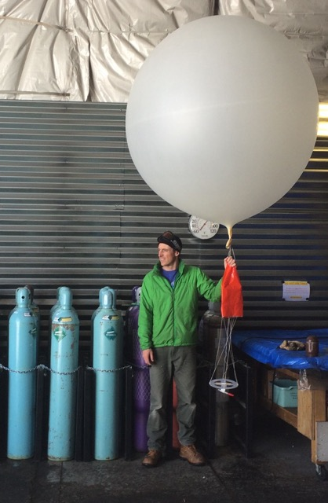

**Sam Dorsi, with one of his last balloon launches--SW**

**General:**

* 7/1: At 18:22z an unplanned power outage occurred. Upon arrival at the MSF, the UPS was running and all instruments were functioning normally. Power was restored at 18:27z. Instruments were checked again and all was operational. PIs were notified.

**Significant Weather Observations:**

* 6/29: few altostratus, 5kts, -9.6C
* 6/30: few cirrostratus , 6kts, -11.5C
* 7/1: few cirrostratus, 8kts, -10.2C
* 7/2: few cirrostratus, 10kts, -15.4C
* 7/3: few cirrostratus, 8kts, -9.9C
* 7/4: few cirrostratus, 7kts, -5.6C
* 7/5: freezing fog, few cirrostratus, 7kts, -10.6C

**Dataman Account:**

* 7/1: During daily rounds, current data backlog was caught up and the ToBoulder file was empty.
* 7/5: 11:49z, ToBoulder directory has 97 items in ‘data’ that did not transfer.
* 7/6: Data backlog transfer to Boulder was completed successfully.

**MWR:**

* HATPRO: operating normally.
* 150-90: operating normally.

**SODAR:**

* Operating normally.
* 6/30: During daily rounds at 11:58z, the JPG file was empty of images. This was reported to Matt Shupe. When check again at 12:59z, images were being recorded.

**POSS:**

* Operating normally.

**MMCR:**

* Operating normally.
* 6/29-7/1: During daily checks, in LabView, the +5V #1 and #2 red alarm lights were on, reading at ~+4.38V and ~+4.11V. The test point voltages read at +5V. This issue was reported to Duane Hazen and Matt Shupe.
* 7/1: 16:03z, per Duane Hazen’s instructions, the MMCR was shut down for maintenance. The back panel of the MMCR-Radar was removed and a grounding wire was installed—running from J1 pin 23 (GND) to the A/D Interface Board pin 27. After rebooting the instrument at 16:52z, the LabView +5V readings were reading #1 at +5.00V and #2 at +4.95V.

**CAPABL:**

* Operating normally.
* 6/29: Data was not transferring to Boulder. Ryan Neely was notified. A wrong configure file was being used and was fixed by Robert Stillwell remotely on 7/1.

**MPL:**

* Operating normally.

**VCEIL:**

* Operating normally.

**Hotplate:**

* Operating normally.
* 6/30: During daily checks at 12:25z, the program was found with an error dialog box, and had not recorded data since 6/29 at 21:36z. After starting up the program, it began working again. Matt Shupe was notified.

**IceCAM:**

* Operating normally.

**PAERI:**

* Operating normally.

**ASIA-A:**

* Offsite for repair since 4/30.

**TSI:**

* Operating normally.

**IcePIC:**

* No photos taken.

**Radiosonde:**

* Twice daily sondes.

**Doppler Wind Lidar:**

* Offsite on 6/29/15.

**MASC:**

* Operating normally.