# ICECAPS Weekly Report

June 8 – 14, 2015

Sam Dorsi and Clair Von Handorf

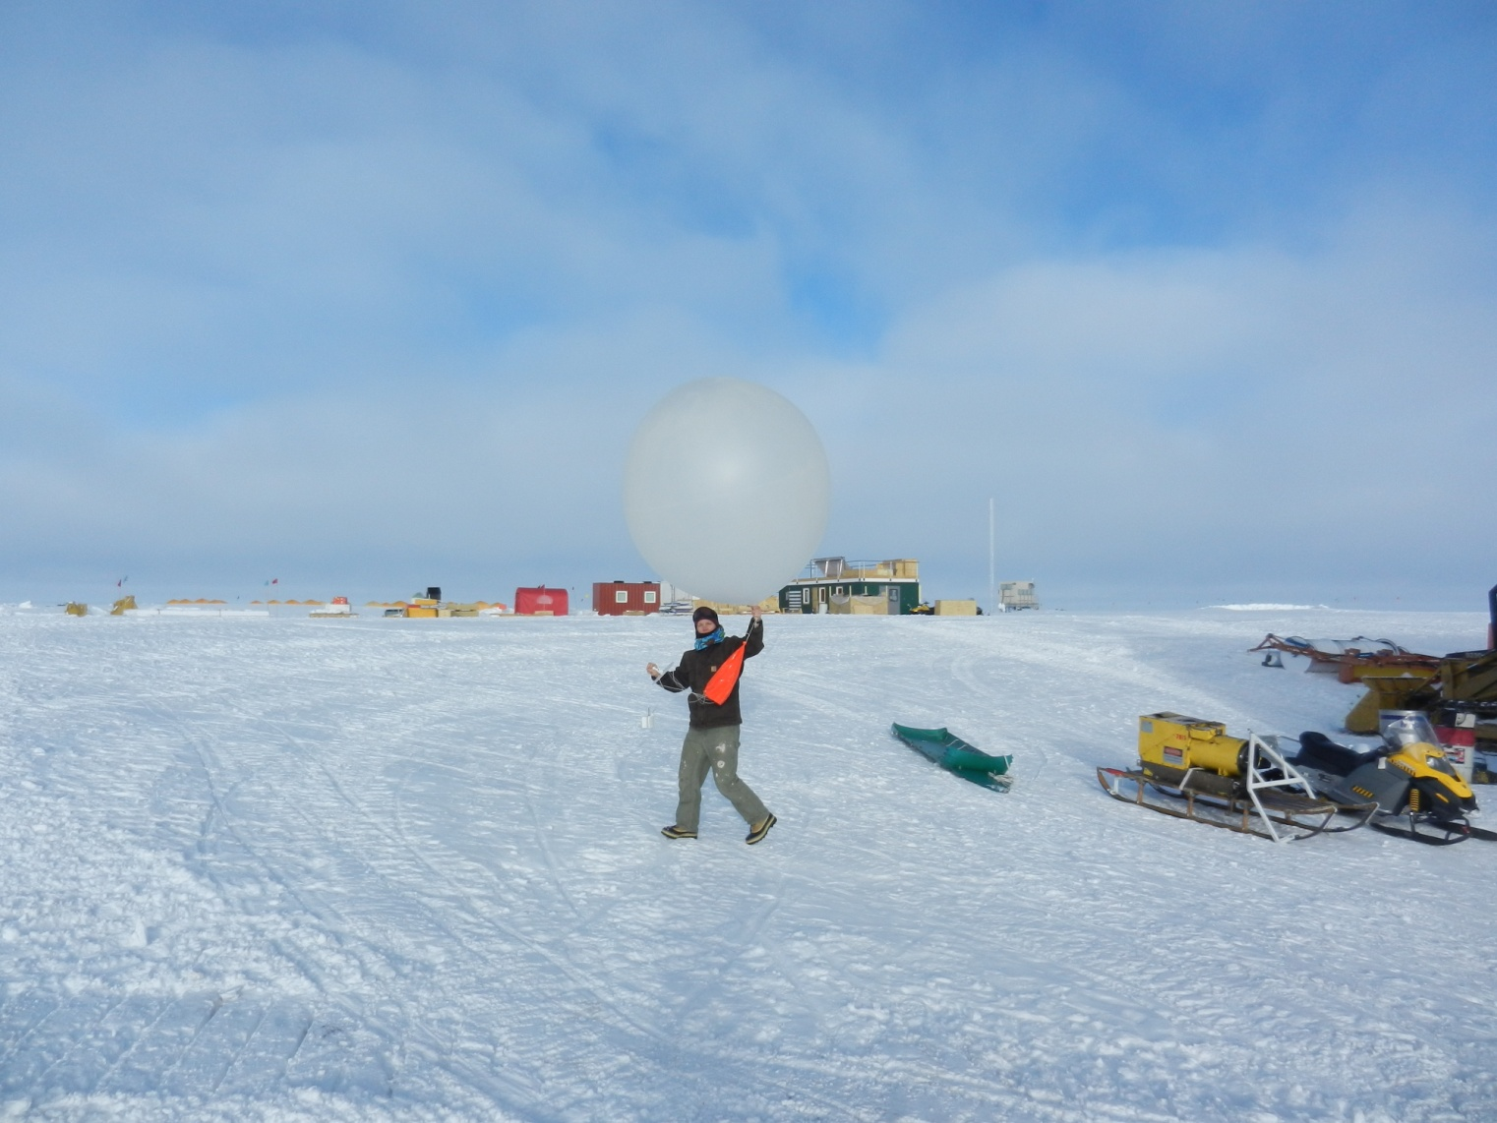

**Clair carries the evening radiosonde up to the launching area. –NS**

**General:**

* None.

**Significant Weather Observations:**

* 6/8: Broken stratus, 0 kts, -16C
* 6/9: Scattered altocumulus, drifting snow, 12 kts, -21C
* 6/10: Scattered altostratus, 11 kts, -18C
* 6/11: Few altostratus, 11 kts, -20C
* 6/12: Broken stratus, 12 kts, -18C
* 6/13: Few altocumulus, 11 kts, -19C
* 6/14: Few altostratus, 9 kts, -18C

**Dataman Account:**

* Operating normally.
* 6/9: No data was transferred overnight.
* 6/9: Swapped USB archival disk at 10:17z. This drive will be hand-carried to Boulder by Duane Hazen.
* 6/10: Data is being successfully transferred to the newly swapped USB archival disk.
* 6/10: The overnight data transfer initiated normally, with the addition of the un-transferred data from the previous day. A 'lost connection' error appeared partway, preventing the upload of hotplate data. The transfer resumed after this error.
* 6/11: The two hotplate files that had not been transferred due to a 'lost connection' error yesterday were successfully transferred today. However, the new data did not transfer. Instead, the log file reports 'No [Instrument Name] files to send' for all instruments. Of note, the queuing process initiated at 0100z, while the data transfer initiated at 0033z (normal time is 0205z). This may explain the lack of queued data at the time of transfer initiation.
* 6/12: Data upload is proceeding normally. Matt Shupe logged on the previous evening (6/11) to manually reinitiate the data transfer.

**MWR:**

* HATPRO: operating normally.
* 150-90: operating normally.

**SODAR:**

* Operating normally.

**POSS:**

* Operating normally.

**MMCR:**

* Operating normally.
* 6/8: The TWTA desiccant changed by Sam and Clair (16:05 – 16:12z). One set of desiccant pouches remain before recharging will be required.
* 6/10: MMCR computer was observed on 6/9 to have no connection to internet. Network connection was restored when cable was moved from port 20 to port 2 (known working port used by VOIP phone). VOIP phone was then reconnected at port 2, and MMCR network link was tested when Ethernet cable was connected to a range of empty ports. Existing empty ports were 8, 14, 17, 18 and 20. Two unattached patch cables were removed from switch at ports 1 and 7 to free up and test additional ports.

Port 1 is working.

Port 7 is working.

Port 8 is working.

Port 14 is not working.

Port 17 is not working.

Port 18 is working.

Port 20 is now working. It was the port to which the MMCR was connected pre-test.

After the test, the MMCR was reconnected to its original port: number 20. Though the network issue had occurred with the MMCR connected to port 20, the port appeared to function normally during the test, so this port choice was maintained. The MMCR mount is now available on Dataman (16:11z).

* 6/11: The MMCR mount stayed up overnight, and data was queued as normal.

**CAPABL:**

* Operating normally.
* Ryan Neely has been onsite.

**MPL:**

* Operating normally.

**VCEIL:**

* Operating normally.

**Hotplate:**

* Operating normally.

**IceCAM:**

* Operating normally.

**PAERI:**

* Operating normally.
* 6/14: Time series of housekeeping data were not displayed in main PAERI window (20:28z). Instead, the message “Data is null” appeared. Blue flags were present earlier in the day. Spectra are current and appear normal, and data files are being modified. PI was contacted.

**ASIA-A:**

* Offsite for repair since 4/30.

**TSI:**

* Operating normally.

**IcePIC:**

* No photos taken

**Radiosonde:**

* Twice daily sondes.
* 6/7 0z to 6/9 12z: Ground-truth humidity values are unavailable, due to failure of both NOAA humidity sensors. Mike O’Neill repaired sensors in time for 6/10 0z radiosonde preparation.

**Doppler Wind Lidar:**

* Operating normally.

**MASC:**

* Operating normally.
* 6/13: The Remote Desktop window on the MSF laptop was found frozen (11:55z), and the terminal output outdated. Data collection was uninterrupted: the error only affected the ability to monitor the instrument. The monitoring connection was restored by closing and reopening Remote Desktop.