# ICECAPS Weekly Report

March 16 - 22, 2015

Sam Dorsi

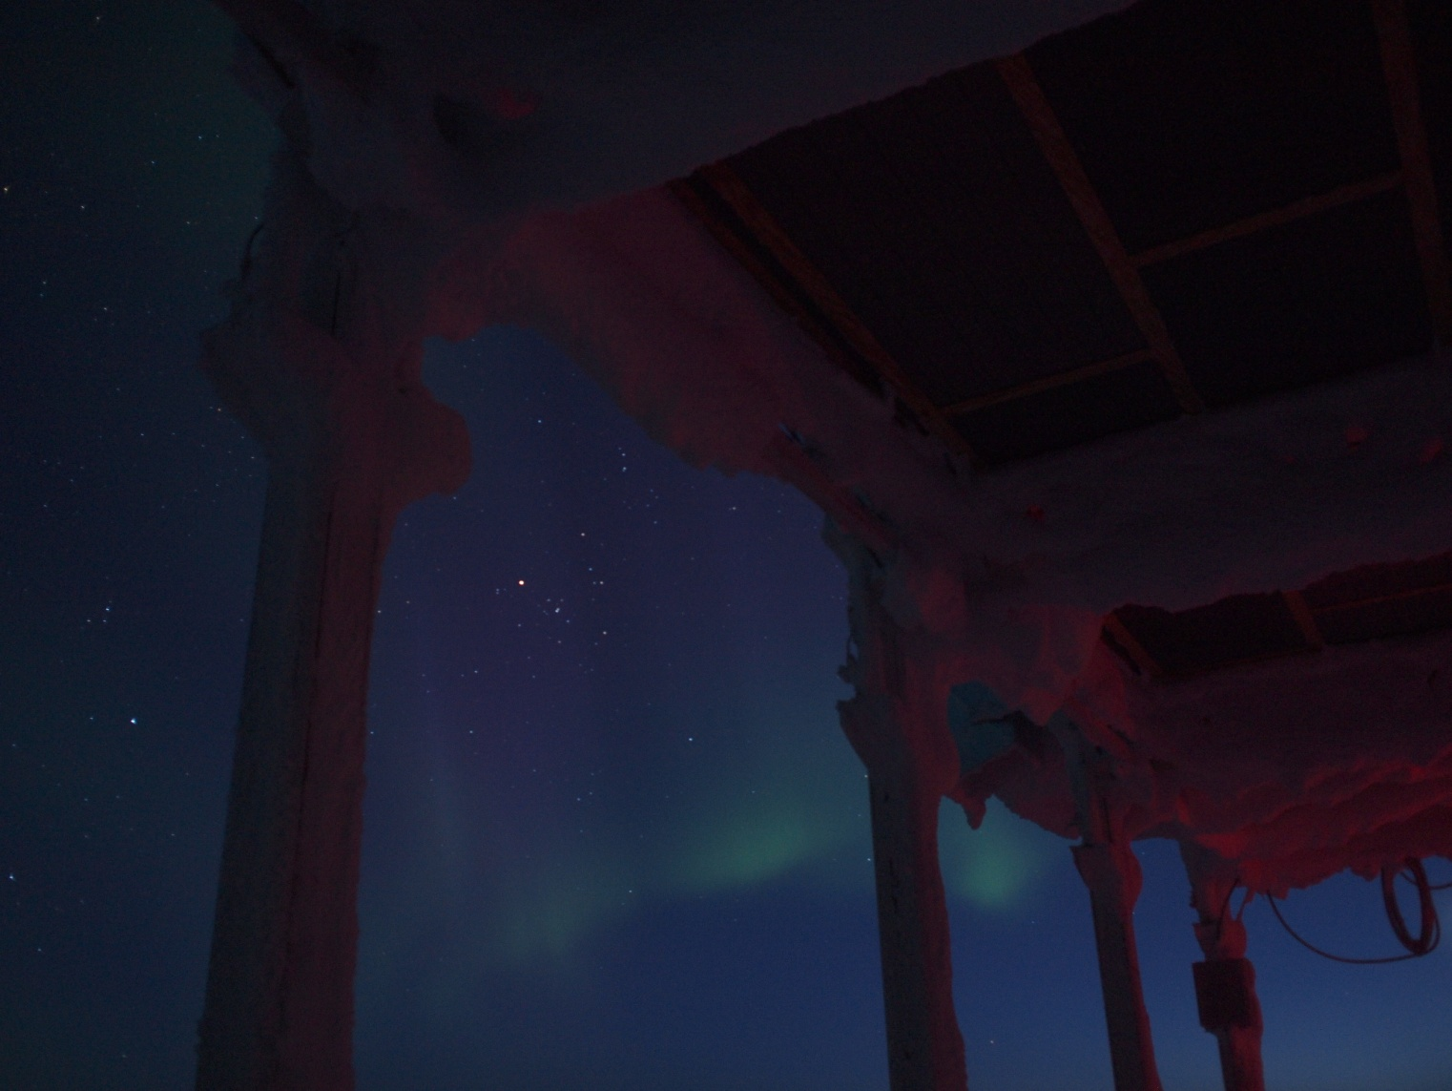

**Aurora in the long twilight of a spring evening. --SWD**

**General:**

* 3/16: Summit data bandwidth reduced to wintertime rate. Data transfers are completing ~ 18z, compared to ~10z before change.
* 3/18: Raised bamboo poles supporting cables to SODAR, hotplate and POSS where needed (18z).

**Significant Weather Observations:**

* 3/16: Scattered altostratus, 14 kts, -45C
* 3/17: Few altostratus. 6 kts, -41C
* 3/18: Blowing snow, 16 kts, -32C
* 3/19: Few stratus, 8 kts, -38C
* 3/20: Blowing snow, 14 kts, -25C
* 3/21: Overcast and snowing, 3 kts, -25C
* 3/22: Broken stratus, 5 kts, -35C

**Dataman Account:**

* Operating normally.
* 3/17: MPL data not transferred overnight.
* 3/18: MPL data from previous day transferred.

**MWR:**

* HATPRO: operating normally.
* 150-90: operating normally.

**SODAR:**

* Operating normally.

**POSS:**

* Operating normally.

**MMCR:**

* Operating normally.

**CAPABL:**

* Offsite as of 8/19.
* Continuing to monitor water storage system during winter.

**MPL:**

* Operating normally.
* 3/16: Monthly MPL afterpulse calibration performed from 14:45z to 15:13z.
* 3/16: MPL reported AMCS card error at 16:12z, just after the afterpulse calibration. Data collection restarted 16:19z.

**VCEIL:**

* Operating normally.

**Hotplate:**

* Operating normally.

**IceCAM:**

* Operating normally.

**PAERI:**

* Operating normally.

**ASIA-A:**

* Offline until summer due to broken radio component.

**TSI:**

* Offline and stored in MSF for winter.

**IcePIC:**

* 3/21: Photos taken during snowfall. Particles were largely bullet rosettes, with some columns, needles and simple plates. A possible frozen droplet was photographed.

**Radiosonde:**

* Twice daily sondes, with additional releases for SNPP-2, as described below.

**SNPP-2 campaign:**

* 3/17: BAe-146 overflights at approximately 14:30z (27 kft) and 15:00z (1 kft).
* 3/19: ER-2 and BAe-146 flight activities. Launched additional radiosondes (14z and 17z) and ozone sonde (14z).