# ICECAPS Weekly Report

March 2 - 8, 2015

Sam Dorsi

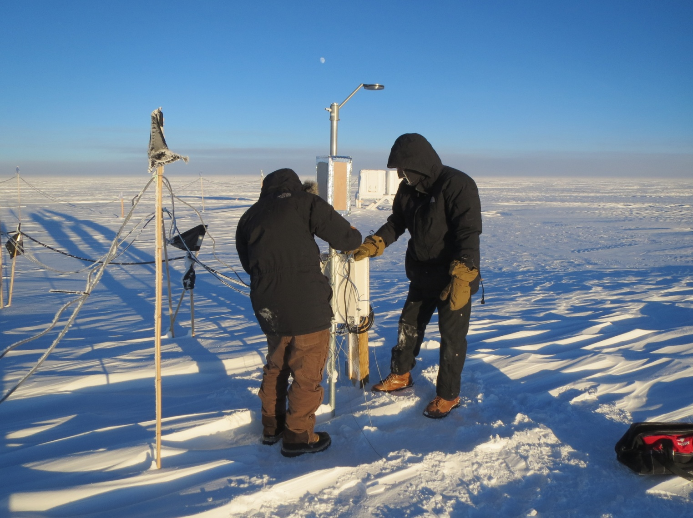

**Sam and Jason reinstall the hotplate on its external stand. Up and running! Photo YT.**

**General:**

* 3/6: Two cages of used ICECAPS He cylinders were swapped with fresh cylinders from the cargo berm. This will carry us through mid-May.

**Significant Weather Observations:**

* 3/2: Few altostratus, 8 kts, -52C
* 3/3: Overcast, freezing fog, 8 kts, -35C
* 3/4: Overcast, freezing fog, 10 kts, -43C
* 3/5: Blowing snow, 14 kts, -33C
* 3/6: Few stratus, 10 kts, -46C
* 3/7: Broken altostratus, 3 kts, -47C
* 3/8: Scattered altostratus, 0 kts, -45C

**Dataman Account:**

* Operating normally.
* 3/7: No data was transferred overnight due to scheduled maintenance of NOAA server.
* 3/8: Overnight, most of two days’ data were uploaded to Boulder. However, data from the PAERI, IceCam, SODAR and POSS failed to transfer.

**MWR:**

* HATPRO: operating normally.
* 150-90: operating normally.

**SODAR:**

* Operating normally.

**POSS:**

* Operating normally.
* 3/4: POSSACQ window was found closed during daily checks (12:45z). Restarted at 12:50z.

**MMCR:**

* Operating normally.

**CAPABL:**

* Offsite as of 8/19.
* Continuing to monitor water storage system during winter.

**MPL:**

* Operating normally.

**VCEIL:**

* Operating normally.

**Hotplate:**

* Operating normally.
* 3/2: Reinstalled hotplate on external stand, and data collection resumed as of 19:23z.
* 3/4: Hotplate registered ‘undecipherable string’ error (12:08z). Data collection resumed when error cleared (13:08z).

**IceCAM:**

* Operating normally.

**PAERI:**

* Operating normally.
* 3/2: PAERI continues to operate with shelter fan removed.
* 3/3: PAERI shelter fan reinstalled (16:37z).

**ASIA-A:**

* Offline until summer due to broken radio component.

**TSI:**

* Offline and stored in MSF for winter.

**IcePIC:**

* No pictures taken.

**Radiosonde:**

* Twice daily sondes.