# ICECAPS Weekly Report

March 23 - 29, 2015

Sam Dorsi

**Science technicians Jason and Yuki contemplate the universe. --SWD**

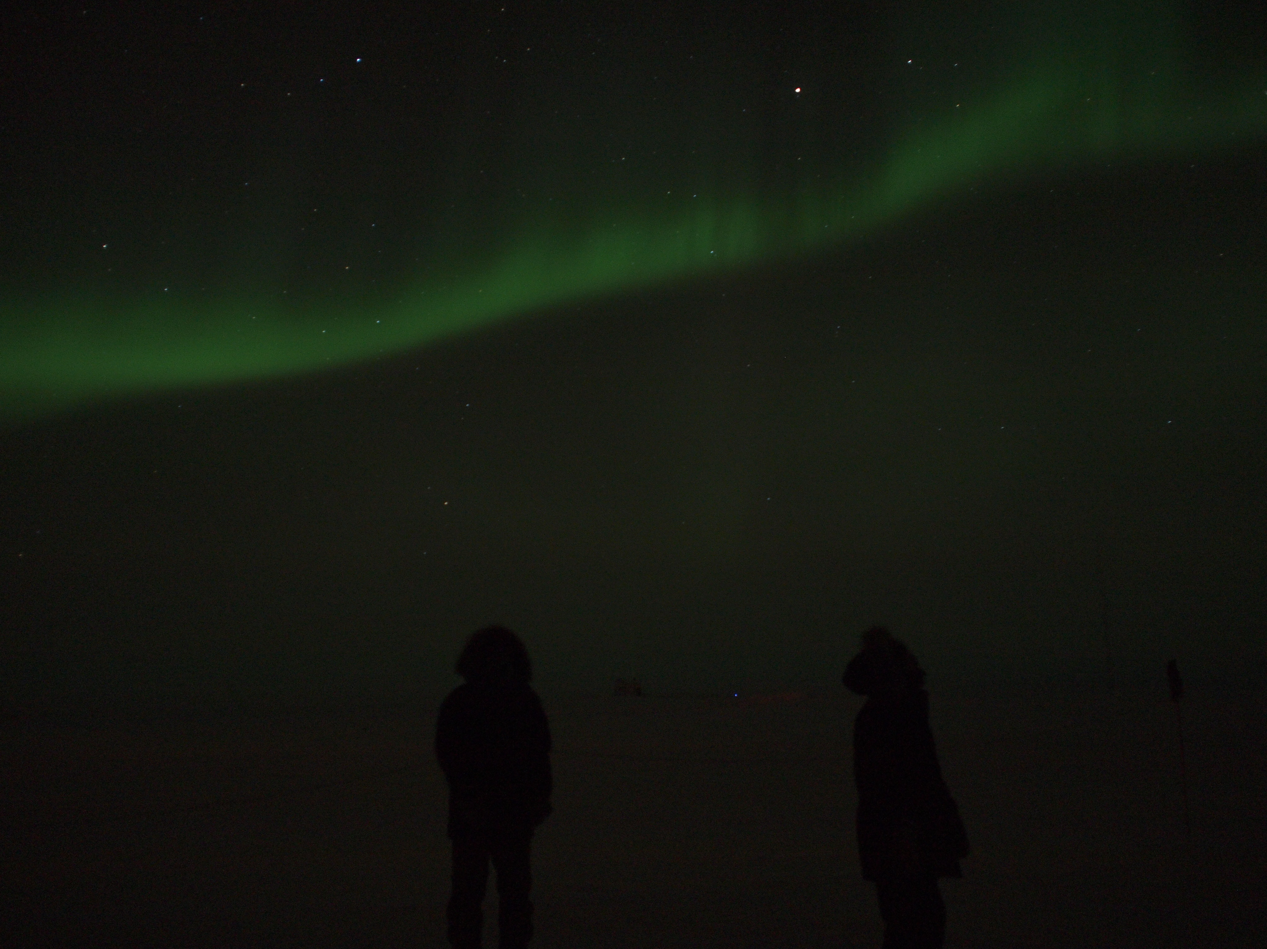

**General:**

* 3/23: Unexpected loss of UPS power in MSF at 13:11z. UPS was restarted at 13:14z. Instruments were restarted individually after consultation with respective PIs.
* 3/29: Local time at Summit Station changes to UTC-2 for daylight savings time (00z).

**Significant Weather Observations:**

* 3/23: Broken altostratus, 5 kts, -40C
* 3/24: Blowing snow, 17 kts, -30C
* 3/25: Drifting snow and overcast, 15 kts, -30C
* 3/26: Broken stratus, 12 kts, -39C
* 3/27: Few stratus, 9 kts, -43C
* 3/28: Few altostratus, 11 kts, -47C
* 3/29: Scattered stratus, 14 kts, -43C

**Dataman Account:**

* 3/23: Hard shutdown at 13:11z; daily upload of data interrupted.
* 3/24: Did not queue data from SODAR, PAERI, MPL, hotplate or ceilometer. The data transfer that had been interrupted on the previous day was completed, but new data was not transferred.
* 2/25: Data did not transfer overnight. Data appeared in the queue, but linked files were missing and were not transferred. Matt diagnosed this as an issue with the mount for the backup USB drive being inaccessible. Data upload restarted.
* 2/26: Backup USB drive power-cycled, SODAR computer reconnected to network and data directory re-mounted. Nightly download script executed manually.
* 2/27: Dataman has returned to normal operation, and is making progress through data backlog.

**MWR:**

* HATPRO: operating normally.
* 150-90: operating normally.
* 3/23: Hard shutdown at 13:11z. Power cycled to radiometers and computer at 15:05z per Dave Turner’s request. Data collection resumed at 15:10z.

**SODAR:**

* Operating normally.
* 3/23: Hard shutdown at 13:11z. Data collection resumed 16:58z.
* 3/26: The SODAR computer is not connected to the network, preventing its daily data uploads. Network connection reports ‘network cable disconnected,’ despite physically reseating connectors and rebooting. Moved Ethernet cable on network switch from port 17 to port 13, and network connection was successfully made.

**POSS:**

* Operating normally.
* 3/23: Hard shutdown at 13:11z. Data collection resumed at 15:52z.

**MMCR:**

* Operating normally.

**CAPABL:**

* Offsite as of 8/19.
* Continuing to monitor water storage system during winter.

**MPL:**

* Operating normally.
* 3/23: Hard shutdown at 13:11z. Data collection resumed at 15:49z.

**VCEIL:**

* Operating normally.
* 3/23: Hard shutdown at 13:11z. Data collection resumed at 15:15z.

**Hotplate:**

* Operating normally.
* 3/23: Hard shutdown at 13:11z. Data collection resumed at 16:10z.

**IceCAM:**

* Operating normally.

**PAERI:**

* Operating normally.
* 3/23: Hard shutdown at 13:11z. Restarted in coordination with Von Walden; data collection resumed 19:11z.
* 3/29: Intermittent yellow warning flag appears for ‘Cooler Compressor Temperature’ starting roughly 06:30 UTC. Von reports this is due to colder indoor temperatures in MSF (-56 F).

**ASIA-A:**

* Offline until summer due to broken radio component.
* 3/23: Hard shutdown at 13:11z. Had been in standby mode. Re-powered to ensure dew blowers active, and left again in standby mode.
* 3/29: Heater not operational: rime accumulating on heating element itself. Pierre has sent diagnostic instructions.

**TSI:**

* Offline and stored in MSF for winter.

**IcePIC:**

* No photos taken.

**Radiosonde:**

* Twice daily sondes, with additional releases for SNPP-2, as described below.
* 3/25: Error (‘PTU analysis’) occurred with K-sonde at 00z sounding. Data were collected and saved throughout sounding, however Vaisala software considered the sounding to have ended near the time of launch, and standard output could not be produced. Data were recovered from database file using Vaisala software (sent to PIs and SNPP-2 representives), but WMO message was not sent out to Met Office.

**SNPP-2 campaign:**

* 3/23: ER-2 flight activities. Radiosondes were released during launch windows at 12z (GPS-sonde), 15z (GPS-sonde), 18z (K-sonde) and 00z (K-sonde). An ozone sonde was released at 15z.
* 3/24: ER-2 flight activities Radiosondes were released during launch windows at 12z (GPS-sonde), 15z (GPS-sonde), 18z (K-sonde) and 00z (K-sonde). An ozone sonde was released at 15z.
* 3/25: ER-2 flight activities. Radiosondes were released during launch windows at 12z (GPS-sonde), 15z (GPS-sonde), 18z (K-sonde) and 00z (K-sonde). An ozone sonde was released at 15z.
* 3/28: ER-2 flight activities. Radiosondes were released during launch windows at 12z (GPS-sonde), 15z (GPS-sonde), 18z (K-sonde) and 00z (K-sonde). An ozone sonde was released at 15z.
* 3/29: ER-2 flight activities. Radiosondes were released during launch windows at 12z (GPS-sonde), 15z (GPS-sonde), 18z (K-sonde) and 00z (GPS-sonde). An ozone sonde was released at 15z.