# ICECAPS Weekly Report

March 30 – April 5, 2015

Sam Dorsi

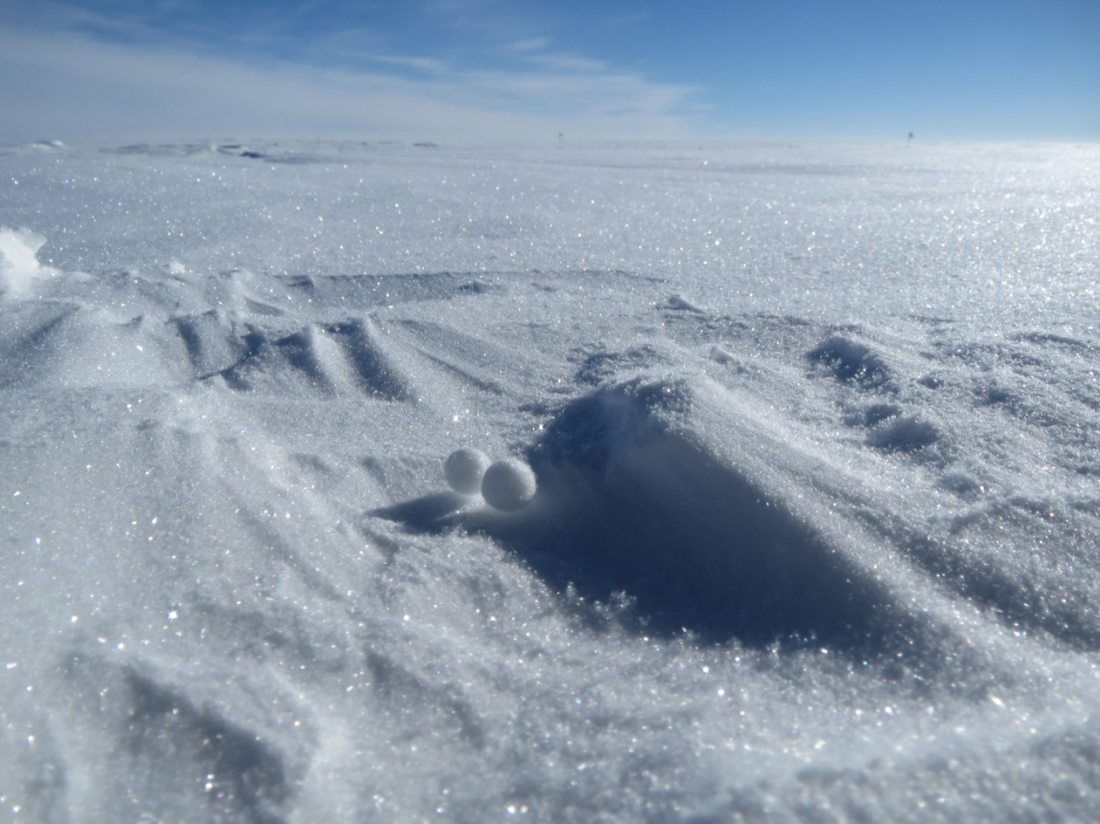

**A pair of Yukimarimo are gathered in a protected depression. --SWD**

**General:**

* 3/30: Yukimarimo observed during moderate winds in the morning. Spheres and disc-like shapes were found, with diameters from 0.75 to 2.5 cm.

**Significant Weather Observations:**

* 3/30: Drifting snow and scattered stratus, 16 kts, -40C
* 3/31: Drifting snow and scattered altostratus, 16 kts, -33C
* 4/1: Scattered altostratus, 11 kts, -41C
* 4/2: Few stratus, 9 kts, -47C
* 4/3: Overcast low stratus, light snow, 9 kts, -33C
* 4/4: Scattered altostratus, 9 kts, -37C
* 4/5: Clear skies, 0 kts, -42C

**Dataman Account:**

* Operating normally.
* 3/30 to 4/4: Data upload process continues to catch up with backlog of queued data.
* 4/4: As of about 16:00z, data uploads to Boulder have been completed up to current day.

**MWR:**

* HATPRO: operating normally.
* 150-90: operating normally.

**SODAR:**

* Operating normally.

**POSS:**

* Operating normally.

**MMCR:**

* Operating normally.

**CAPABL:**

* Offsite as of 8/19.
* Continuing to monitor water storage system during winter.

**MPL:**

* Operating normally.
* 4/3: AMCS card error occurred at 12:05z. Rebooted. Data collection resumed at 12:18z.

**VCEIL:**

* Operating normally.

**Hotplate:**

* Operating normally.

**IceCAM:**

* Operating normally.

**PAERI:**

* Operating normally.
* 3/31: PAERI shelter fan removed to clean rime from enclosed cavity above fan, 16:23z to 16:26z.

**ASIA-A:**

* Offline until summer due to broken radio component.
* 3/31: The dew blower heating on ASIA-A is not functioning. At the transformer, the heating element resistance registers as an open circuit. Pierre will be shipping this component back to manufacturer for repair when he is on-site in late April.

**TSI:**

* Offline and stored in MSF for winter.

**IcePIC:**

* 4/3: Photos were collected of small columns, simple prisms, and lightly rimed crystals.

**Radiosonde:**

* Twice daily sondes.
* 3/31: GPS data was not produced during 12z sounding.