# ICECAPS Weekly Report

March 9 - 15, 2015

Sam Dorsi

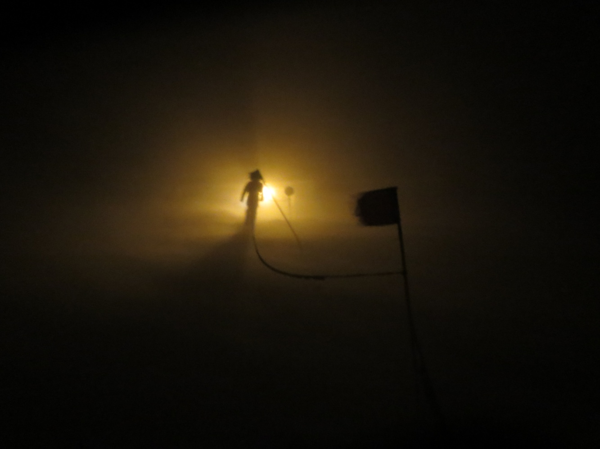

**Yuki leans into the wind while making his way to the Green House.**

**General:**

* 3/10: Shoveled snow from stubborn areas of MSF roof, secured cables where vulnerable.

**Significant Weather Observations:**

* 3/9: Few altostratus, 16 kts, -47C
* 3/10: Scattered altostratus, 12 kts, -49C
* 3/11: Blowing snow and freezing fog, 18 kts, -37C
* 3/12: Scattered stratus, 10 kts, -44C
* 3/13: Blowing snow, 20 kts, -36C. Evening winds of 32 kts.
* 3/14: Blowing snow, 15 kts, -28C
* 3/15: Blowing snow, 19 kts, -35C

**Dataman Account:**

* Operating normally.
* 3/9: Remaining data files from previous day successfully transferred.
* 3/10: A subset of files was not transferred last night: SODAR netCDF file and IceCam photos.
* 3/11: During overnight data upload, a ‘lost connection’ error occurred. This interfered with the transfer of one of the PAERI data files.
* 3/12: PAERI data file from previous day transferred successfully. MPL and MMCR mounts were down overnight; likely due to both instruments being rebooted on 3/11.
* 3/13: MPL and MMCR data from previous day transferred successfully. Discovered that the reason for the SODAR and IceCam transfer issues is simply that they are transferring after I perform my daily checks: the data transfer is taking about 12 hours.

**MWR:**

* HATPRO: operating normally.
* 150-90: operating normally.

**SODAR:**

* Operating normally.

**POSS:**

* Operating normally.
* 3/14: Found no power at external power pole outlet during morning rounds due to tripped breaker. Cleared packed snow at outlet, and reset breaker. Data collection resumed at 13:57z.

**MMCR:**

* Operating normally.
* 3/9: MMCR registered an error during 0z auto-calibration. Error discovered during daily rounds (13:19z) and reported to Matt Shupe and Duane Hazen. Radar data collection continued upon clearing the error.
* 3/11: MMCR registered an error during 0z auto-calibration. Discovered at 13:47z. Rebooted, with normal operation as of 14:40z.
* 3/12: An incidence of TWTA voltage out of spec recorded in Health log file (13:00z).

**CAPABL:**

* Offsite as of 8/19.
* Continuing to monitor water storage system during winter.

**MPL:**

* Operating normally.
* 3/11: MPL registered AMCS card error at 04:17z. Rebooted at 14:04z.
* 3/13: MPL registered AMCS card error at 18:27z. Rebooted at 18:34z. After 18 sec of operation, registered same error, so rebooted again. Data collection resumed at 18:40z. Error reappeared again at 19:47z; data collection resumed at 20:19z.
* 3/14: MPL registered AMCS card error at 21:03z

**VCEIL:**

* Operating normally.

**Hotplate:**

* Operating normally.
* 3/14: Found no power at hotplate during morning rounds. Breaker was tripped. Cleared snow packed at external power pole outlet, and reset breaker. Data collection resumed at 13:56z.

**IceCAM:**

* Operating normally.

**PAERI:**

* Operating normally.

**ASIA-A:**

* Offline until summer due to broken radio component.

**TSI:**

* Offline and stored in MSF for winter.

**IcePIC:**

* No pictures taken.

**Radiosonde:**

* Twice daily sondes.
* 3/14: In high winds, 12z sonde contacted surface after release.

**SNPP-2 campaign:**

* 3/15: ER-2 flight performed. Two meteorology radiosondes (14z, 17z) and a NOAA ozone sonde (14z) were released.