# ICECAPS Weekly Report

May 18 – 24, 2015

Sam Dorsi

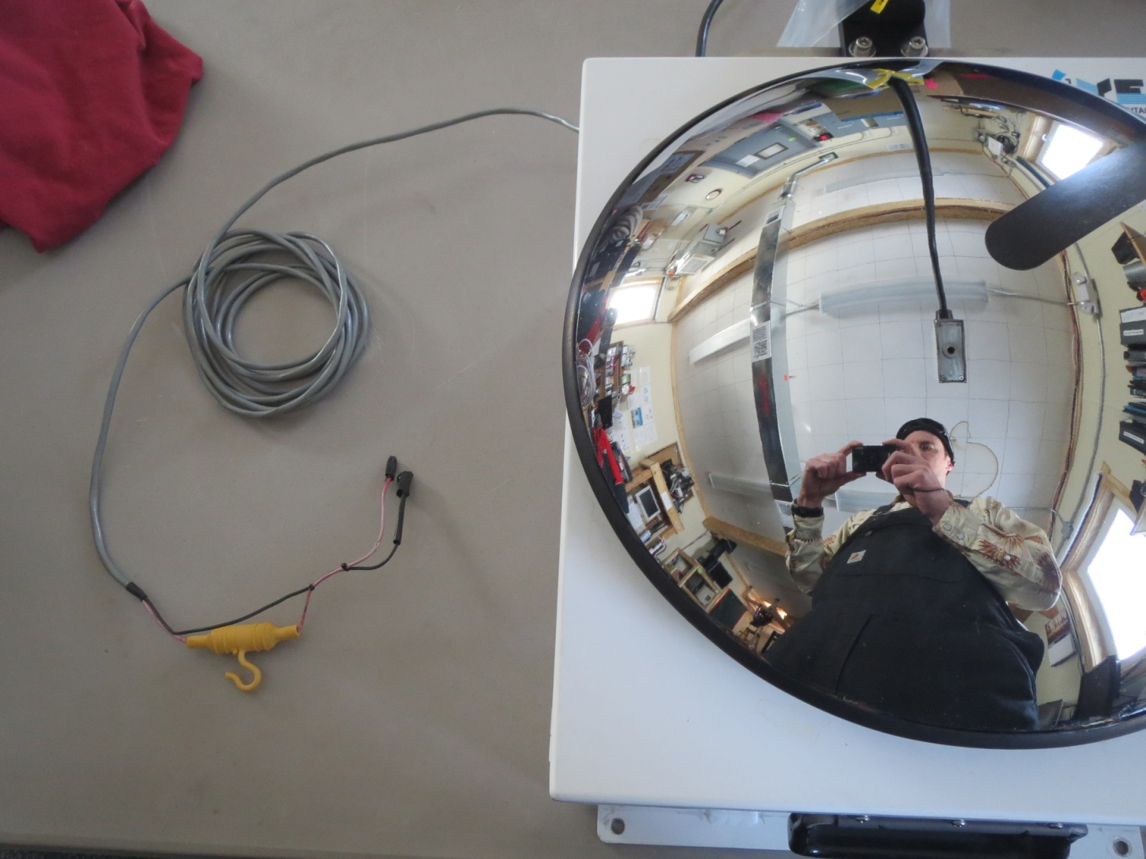

**The all-seeing TSI captures the science tech and MSF interior during   
pre-installation testing. –SWD**

**General:**

* 5/19: Removed GPS antenna from GPS timer server at 16:50z.
* 5/20: Reconnected GPS antenna to GPS time server at 17:00z.
* 5/22: DLR Falcon overflight of Summit for ESA project at roughly 0z to 1z.
* 5/22: Steffen research party arrived and started work near Swiss Tower and radiation stands.

**Significant Weather Observations:**

* 5/18: Blowing snow, 20 kts, -14C
* 5/19: Broken altostratus, 7 kts, -19C
* 5/20: Scattered altostratus, 13 kts, -23C
* 5/21: Few altostratus, 6 kts, -23C
* 5/22: Few stratocumulus, 10 kts, -24C
* 5/23: Broken stratus, 5 kts, -18C
* 5/24: Few altostratus, 9 kts, -23C

**Dataman Account:**

* Operating normally.

**MWR:**

* HATPRO: operating normally.
* 150-90: operating normally.

**SODAR:**

* Operating normally.

**POSS:**

* Reported ‘no good POSS packets’ from time of power pole upgrade on 5/16 to 5/21.
* 5/21: POSS instrument boxes (on exterior pole) were opened up at 13:37z. Fuses and light bulb are still good. A tripped circuit breaker was found and reset to ‘on’. POSS data collection restored at ~13:42z.

**MMCR:**

* Operating normally.

**CAPABL:**

* CAPABL operating in test configuration.

**MPL:**

* Operating normally.
* 5/23: Afterpulse calibration performed from 12:05z to 12:24z.

**VCEIL:**

* Operating normally.

**Hotplate:**

* Operating normally.

**IceCAM:**

* Operating normally.

**PAERI:**

* Operating normally.

**ASIA-A:**

* Offsite for repair since 4/30.

**TSI:**

* Offline and stored in MSF for winter.

**IcePIC:**

* No photos taken

**Radiosonde:**

* Twice daily sondes.
* 5/18 12z to 5/21 12z: Soundings performed without wind data due to ongoing GPS issue at ground station. This alternate work-around was accomplished by selecting “Wind type: None” instead of “GPS-DCC” during radiosonde preparation.
* 5/18: Issue during 12z radiosonde preparation prevented radiosonde release. DigiCora did not consistently receive GPS data from Sounding Processing Subsystem (SPS) unit. A joint effort among the three techs and several hours was made to diagnose the issue. The antenna cable was excavated through its length, the modular cards in the SPS were removed and reseated, the Ethernet cabling was replaced, and many reboot variations were performed, all with no success.
* 5/19: Radiosonde base station diagnostics occupied entire day. Climbed Green House tower to inspect antenna and cable run. Connected to Vaisala GPS card over serial, but did not find any transmitted signal. Replaced cable run and antenna with known working equipment from other instruments, but encountered identical errors.
* 5/20: Removed Vaisala GPS card from SPS. Using 200 proof alcohol and soft paintbrush, loosened and flushed unknown white deposits. Replaced card in SPS, but no change in GPS issue was found.
* 5/21: Heard from Vaisala representative that many similar cards manufactured before 2012 began experiencing this issue on 5/18. They indicated that card is functional for a few brief minutes after SPS reboot, and that given several attempts, it may be possible to prepare a sonde during this window. This technique was rehearsed, and a protocol was formed to minimize preparation delays. This involves reconditioning the radiosonde directly through the ground check station, before powering on the SPS with the faulty GPS card, so as to avoid a 5-minute delay during the critical preparation time.
* 5/22 0z: NOAA and PFS science techs arranged to release weekly ozone sonde during late evening hours in order to provide wind data during DLR Falcon overflight.
* From 5/22 0z onward: Sonde prepared using rapid preparation work-around, resulting in wind data being collected during DLR Falcon overflight and subsequent synoptic time launches.

**Doppler Wind Lidar:**

* Operating normally.

**MASC:**

* Operating normally.