# ICECAPS Weekly Report

May 25 – 31, 2015

Sam Dorsi

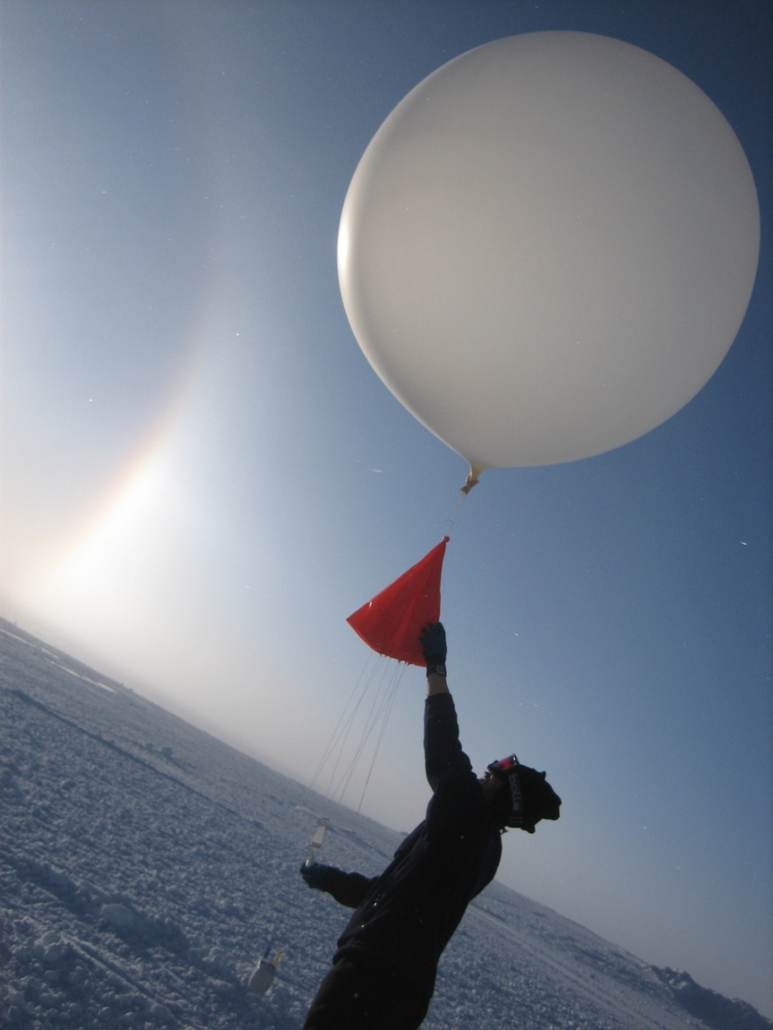

**A solar halo graces the sky as Yuki prepares to release the evening radiosonde. –Dwight**

**General:**

* 5/27: Cables threatened by drifting (to SODAR and precipitation suite) were raised, cable-protection sleeve was secured in many spots, and additional bamboo poles were placed.

**Significant Weather Observations:**

* 5/25: Broken stratus, drifting snow, 13 kts, -18C
* 5/26: Few stratus, 4 kts, -19C
* 5/27: Few altostratus, 5 kts, -24C
* 5/28: Scattered altostratus, 12 kts, -20C
* 5/29: Scattered stratus, 8 kts, -22C
* 5/30: Few altostratus, 11 kts, -21C
* 5/31: Few altostratus, 4 kts, -24C

**Dataman Account:**

* Operating normally.

**MWR:**

* HATPRO: operating normally.
* 150-90: operating normally.

**SODAR:**

* Operating normally.

**POSS:**

* Operating normally.
* 5/25: The POSS was raised by approximately 0.5 meter. Accumulation at the base of the POSS had just reached the lower cables—about 0.4 m up from the base. The POSS was powered down at 19:00z, temporarily shifted to the side, and a compacted pad was built with 0.1 m height above surrounding surface. The POSS was shifted back to the original, now-elevated site, and the extended guy lines were tensioned. Data collection was restored at 19:54z.
* 5/27: Guy lines retightened.

**MMCR:**

* Operating normally.

**CAPABL:**

* CAPABL operating in test configuration.

**MPL:**

* Operating normally.

**VCEIL:**

* Operating normally.

**Hotplate:**

* Operating normally.
* 5/27: Guy lines retightened.

**IceCAM:**

* Operating normally.

**PAERI:**

* Operating normally.
* 5/29: At 15:40z, the PAERI computer monitor was discovered to be blank and reporting ‘no signal’. PAERI quicklook data were only updated on the web through 15:30z on 5/28 (the previous day). This issue and basic diagnostic information were reported to Von, at his ship-based field campaign email, and to Dave Turner, the secondary contact.
* 5/30: The PAERI computer was reset using the button on front plate of CPU. When computer booted up normally, directory names were changed and the computer was restarted through the normal system process. Data collection was resumed at 12:17z.

**ASIA-A:**

* Offsite for repair since 4/30.

**TSI:**

* 5/29: After indoors testing, the TSI was reinstalled on the MSF roof. With the TSI installed and functioning, the shadowband was found to be close, but not quite centered over the sun position, resulted in excess glare. Using the TSI laptop and a USB-to-serial adapter, a connection was made to TSI instrument. The TSI time was 6 minutes and 51 seconds slow, relative to the GPS time server, and the time was updated. The shadowband ‘home’ position was also realigned. The TSI resumed normal operation at 18:35z.

**IcePIC:**

* No photos taken

**Radiosonde:**

* Twice daily sondes.
* Since 5/22, radiosondes have been prepared using rapid preparation work-around. This enables wind data to be collected; however, ongoing issues with radiosonde base station (SPS311 GPS card) cause base station GPS data to become unavailable midflight. After that point, wind data is calculated in ‘autonomous’ mode—these data may be less accurate.

**Doppler Wind Lidar:**

* Operating normally.

**MASC:**

* Operating normally.