# ICECAPS Weekly Report

May 4 – 10, 2015

Sam Dorsi

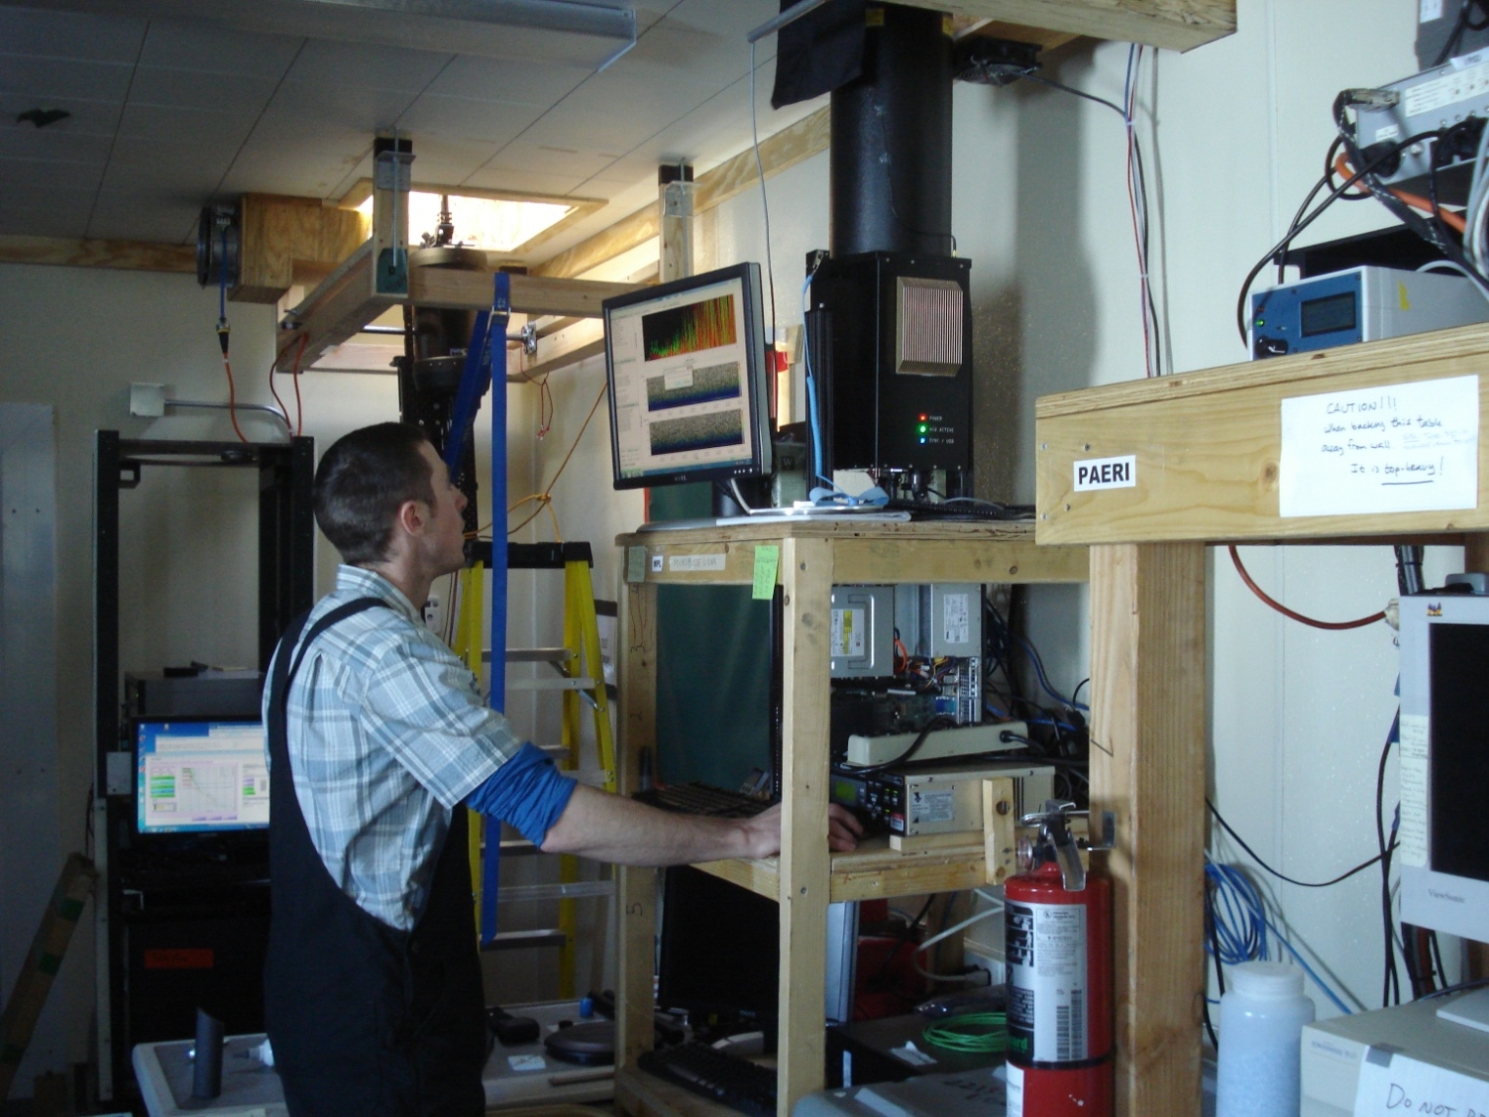

**The MPL is shut down as Sam and Robert prepare for the USB bulkhead replacement. --RS**

**General:**

* None.

**Significant Weather Observations:**

* 5/4: Scattered stratus, 10 kts, -33C
* 5/5: Scattered stratus and cirrus, 10 kts, -30C
* 5/6: Broken stratus, 11 kts, -26C
* 5/7: Few stratus, 7 kts, -26C
* 5/8: Broken altostratus, 6 kts, -27C
* 5/9: Broken stratocumulus, 11 kts, -20C
* 5/10: Scattered stratus, 13 kts, -22C

**Dataman Account:**

* Operating normally.
* 5/5: Error during overnight data transfer: directory /home/summit/ not accessible. Data transfer completed late, at 20z.
* 5/6: MASC-related errors in overnight data transfer.
* 5/6-5/9: Data transfer is taking over 24 hours to complete.
* 5/10: Data transfer once again completing within 24 hours (12:37z), with transfers from MASC and DWL on hold.

**MWR:**

* HATPRO: operating normally.
* 150-90: operating normally.

**SODAR:**

* Operating normally.

**POSS:**

* Operating normally.

**MMCR:**

* Operating normally.
* 5/8: An error was reported in the 12:30z receiver calibration. The error was cleared and data collection resumed at 13:10z.

**CAPABL:**

* Stillwell working night hours on re-installation.
* CAPABL operating in test configuration.

**MPL:**

* Operating normally.
* 5/4: AMCS card error at 13:20z on 5/3. Data collection resumed at 22:00z on 5/4.
* 5/8: Replaced USB bulkhead from 13:21z to 16:32z, in an effort to eliminate frequent AMCS card errors. The replacement was undertaken by Sam Dorsi and Robert Stillwell and was successful. During the repair, an abraded cable (detector output signal) with exposed ground braid was discovered, patched with electrical tape, and re-routed with a 90-degree BNC connector to prevent future damage.

**VCEIL:**

* Operating normally.

**Hotplate:**

* Operating normally.

**IceCAM:**

* Operating normally.

**PAERI:**

* Operating normally.

**ASIA-A:**

* Offsite for repair since 4/30.

**TSI:**

* Offline and stored in MSF for winter.

**IcePIC:**

* No photos taken

**Radiosonde:**

* Twice daily sondes.
* 5/7 0z: ‘Connection to server’ error during sounding caused early termination.
* 5/7 12z: Sounding processing station and sounding laptop rebooted to address GPS error and inability to connect to Vaisala cards. Sounding proceeded normally after reboot.
* 5/10: Sounding at 12z was missed due to tech illness.

**Doppler Wind Lidar:**

* Operating normally.
* 5/9: Data transfer temporarily curtailed.

**MASC:**

* Operating normally.
* 5/10: Data transfer temporarily curtailed.