# ICECAPS Weekly Report

November 02-November 08, 2015

Mike Finnegan

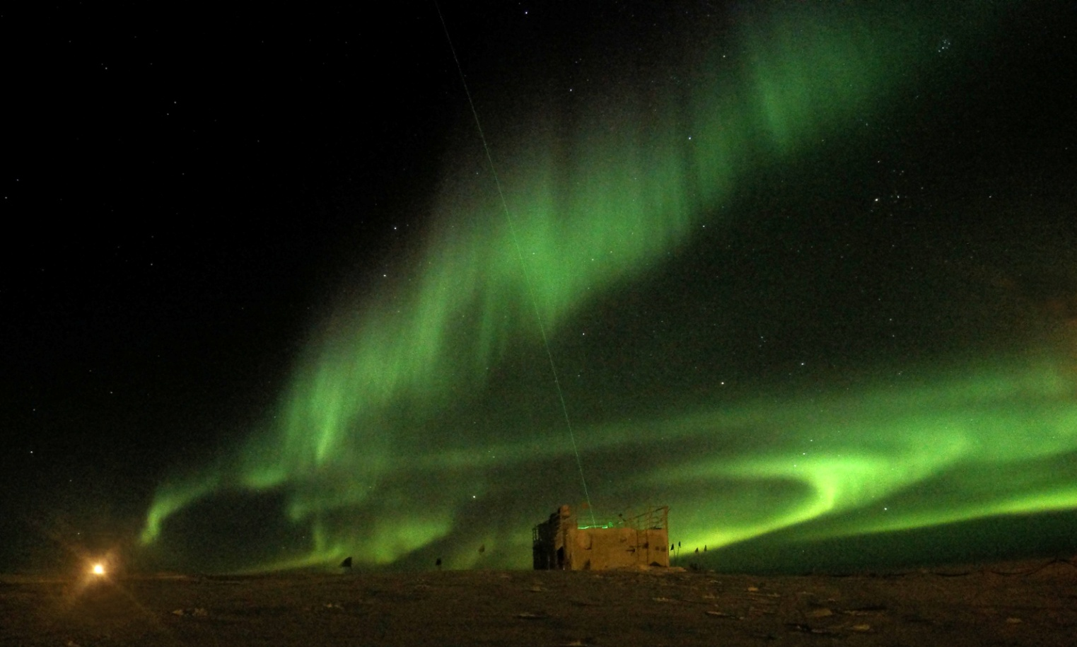

MSF, Moonrise, Orion, and Auroras, 03Nov2015. - MOF

**General:**

**Significant Weather Observations:**

* 11/02: bkn altocumulus, bkn cirrus, 4.6kts, -36.4C
* 11/03: few altostratus, 9.2kts, -46.2C
* 11/04: few cirrus, 5.6kts, -49.9C
* 11/05: mist, few cirrus, 12.4kts, -47.7C
* 11/06: fzfg, blsn, ovc altostratus, 21.8kts, -27.5C
* 11/07: fzfg, blsn, ovc stratus, 17.8kts, -25.1C
* 11/08: few cumulus, sct stratocumulus, 11.0kts, -50.7C

**Dataman Account:**

* Operating normally.
* MMCR Mount down in log files morning after reboot of MMCR. *su mount –a* did not fix. Suspect it will work fine tomorrow, as it has in the past. (11/6) It did. (11/7)

**MWR:**

* HATPRO: operating normally.
* 150-90: operating normally.

**SODAR:**

* Operating normally.

**POSS:**

* Operating normally.
* Reported at DC Offset fault at 14:13 on 11/8. May correspond to time when I cleaned some snow off the center divider? Log file entries before and after this time seem normal.

**MMCR:**

* Operating normally.
* Checked voltages on back in Radian interface and receiver/modulator (11/02). All reporting expected values vdc.
* Checked connectivity and resistance between the two J1 connectors. Also noticed a grey wire had slipped off one of the MPP9 leads (top right lead when looking from wires to leads). I slid this one to the lead it most naturally wanted to connect to. Upon restart, indoor/outdoor temp, +5v measurements, pitch, and roll, all came back into reasonable values. (11/05)

**CAPABL:**

* Operating normally.

**MPL:**

* Operating normally

**VCEIL:**

* Operating normally.
* INHEATER OFF reported in Status Message on morning of 11/02. By 1830Z, it had turned back to INHEATER ON. Checked inside of ceilometer and everything looks normal.

**Hotplate:**

* Operating normally.

**IceCAM:**

* Operating normally.

**PAERI:**

* Operating normally.
* Hit power strip powering the hatch enclosure on 11/02, which caused it to come back online with LW HBB NEN, SW HBB NEN, LW Responsitivity, and SW Responsitivity all read and Encoder Scene Confirm Blue. PAERI software rebooted at 1335Z, but errors persisted. Tried clearing errors on Hatch Controller and setting it to open/close, but this did nothing. Power cycled the hatch enclosure, which solved the problems. Rebooted PAERI software at 1542Z to have only good data output. Data between 1335 and 1542Z is bad.
* Fan struggling a bit 11/4 and 11/5. Temps warmed and fan sounds normal as of 11/6.

**TSI:**

* Shutdown and removed from the roof for the winter.

**IcePIC:**

* Slides out from 11/07 at 1920Z to 11/08 at 1520Z. Too much blowing snow covered the slides for good pictures.

**Radiosonde:**

* Twice daily sondes.
* Sonde on night of 11/07 failed due to sonde hitting the ground after launch because of high, turbulent winds.

**MASC:**

* Operating normally.