# ICECAPS Weekly Report

November 09-November 15, 2015

Mike Finnegan

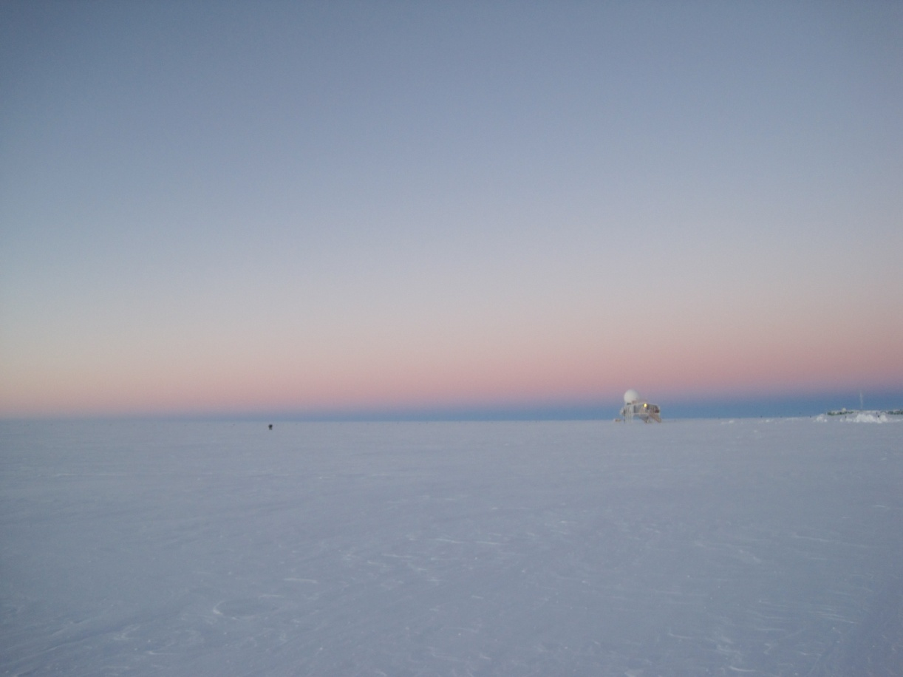

John and Nate Leaving the Big House, 11Nov2015. - MOF

**General:**

* Leveled MSF on 11/12 – completed at 1649Z.

**Significant Weather Observations:**

* 11/09: few altocumulus, 4.5kts, -44.9C
* 11/10: few cirrus, 9.0kts, -37.7C
* 11/11: sct cirrostratus, 8.8kts, -41.1C
* 11/12: freezing fog, 6.6kts, -32.1C
* 11/13: mist, bkn060 bkn120, ovc200, altostratus, cirrostratus, 7.0kts, -42.6C
* 11/14: fzfg, ovc006, 10.0kts, -39.6C
* 11/15: sct altocumulus, 7.2kts, -44.5C

**Dataman Account:**

* Operating normally.

**MWR:**

* HATPRO: operating normally.
* 150-90: operating normally.
* Cleared rime from both MWRs on 11/14 at ~1340Z. Pictures uploaded to server.

**SODAR:**

* Operating normally.
* Cleaned transmitter dish of snow on 11/9 at 1730Z. Could not open receiver bay.

**POSS:**

* Operating normally.

**MMCR:**

* Operating normally.
* After leveling MSF, pitch improved from +0.10 to +0.04, Roll improved from -0.32 to between -0.02 and +0.03.

**CAPABL:**

* Operating normally.

**MPL:**

* Operating normally

**VCEIL:**

* Operating normally.

**Hotplate:**

* Operating normally.

**IceCAM:**

* Operating normally.

**PAERI:**

* Operating normally.
* Cleaned PAERI enclosure of snow on 11/9 and some snow likely hit the optical path causing LW/SW Responsivities to go red. Data bad from ~12Z on 11/9 to record 1039 on 11/10.

**TSI:**

* Shutdown and removed from the roof for the winter.

**IcePIC:**

* No Photos Taken

**Radiosonde:**

* Twice daily sondes.

**MASC:**

* Operating normally.
* Removed rime from flashes on 11/12 and 11/14