# ICECAPS Weekly Report

November 16-November 22, 2015

Mike Finnegan

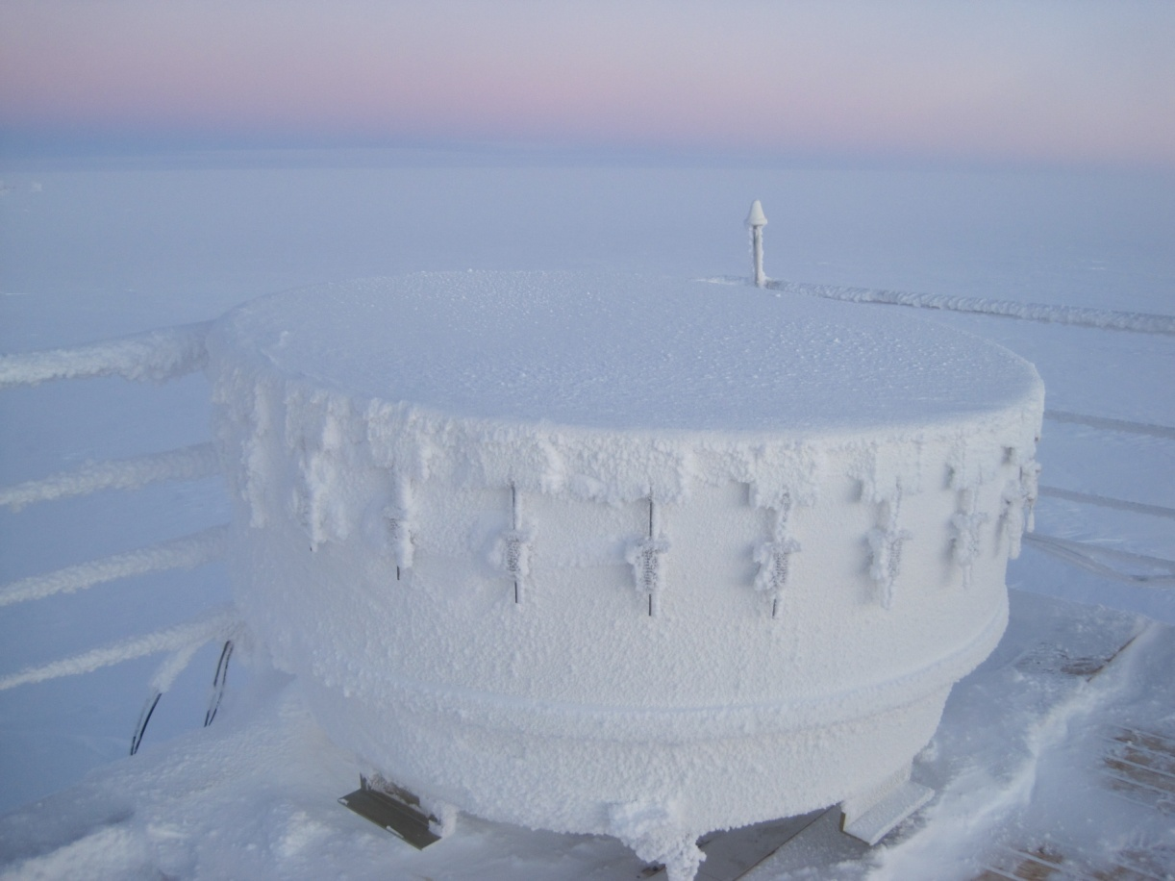

A Well-behaved Instrument, 18Nov2015. - MOF

**General:**

**Significant Weather Observations:**

* 11/16: few altocumulus, 2.6kts, -48.9C
* 11/17: few altocumulus, 4.4kts, -38.4C
* 11/18: few cumulus, 15.0kts, -46.3C
* 11/19: freezing fog, 6.6kts, -32.1C
* 11/20: freezing fog, blowing snow, stratus, 23.4kts, -24.3C
* 11/21: freezing fog, blowing snow, stratus, 29.0kts, -14.9C
* 11/22: freezing fog, blowing snow, stratus, 19.8kts, -14.5C

**Dataman Account:**

* Operating normally.

**MWR:**

* HATPRO: operating normally.
* 150-90: operating normally.

**SODAR:**

* Operating normally.
* Transmitter and Receiver dishes cleared – 1620 – 1650z, 11/16. Shaved a bit off the bottom of the transmitter door to enable it to open with one person.
* Cleaned receiver dish of snow at 1445z, 11/22. Transmitter dish was good.

**POSS:**

* Operating normally.

**MMCR:**

* Operating normally.

**CAPABL:**

* Robert noticed the signal strength was low starting around 1000Z on 10/13. Perhaps due to the significant fog and blowing snow we have been having in the first 50 meters?

**MPL:**

* Operating normally

**VCEIL:**

* Operating normally.

**Hotplate:**

* Operating normally.
* Red blinking ‘fault’ light on 11/16 daily check. Cleared some rime from cables and it resumed normal operation. Taped exposed wires.
* After cleaning wires of rime on 11/17, I noticed an elevated precip rate/total precip during daily checks, concerning because it was not precipitating. I brushed the wires and hotplate off again and whatever was wrong became fixed. Data bad from 684:35:00 – 685:30:00 on 11/17.

**IceCAM:**

* Operating normally.

**PAERI:**

* Operating normally.
* Found the graphs not updating during daily checks on 11/18. It appears they had not updated since ~0030Z. Rebooted PC at 1357Z and everything began functioning as expected.

**TSI:**

* Shutdown and removed from the roof for the winter.

**IcePIC:**

* No Photos Taken

**Radiosonde:**

* Twice daily sondes.
* Sonde on evening of 11/17 terminated immediately after release – all checks had been successful prior. Second sonde of the night had intermittent telemetry issues at the upper reaches, but was closed down successfully. Sonde on morning of 11/18 went off fine.
* Sonde launches on night of 11/20 and morning of 11/21 failed. The sonde itself was bad on 11/20 and on 11/21 it hit the ground on launch, causing it to report bad data and terminate.

**MASC:**

* Operating normally.