# ICECAPS Weekly Report

November 23-November 29, 2015

Mike Finnegan

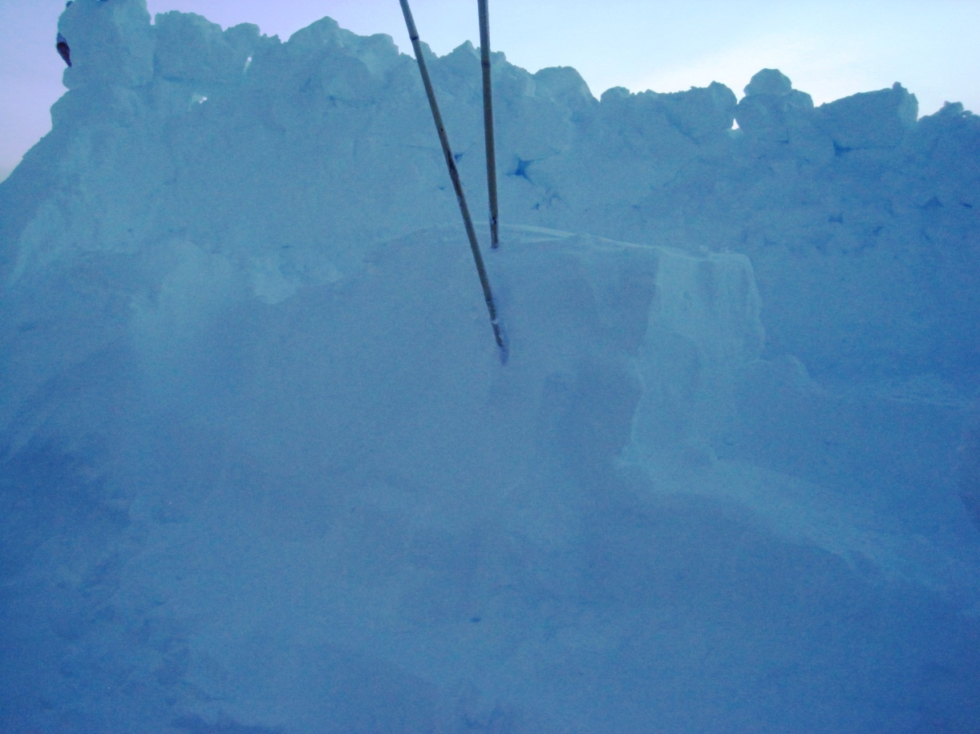

PAERI Snow Fort, 29Nov2015. - MOF

**General:**

* MSF Temp Trackers downloaded – 11/28

**Significant Weather Observations:**

* 11/23: freezing fog, blowing snow, 16.2kts, -29.0C
* 11/24: sct cirrocumulus, 10.6kts, -46.6C
* 11/25: few altocumulus, 11.0kts, -46.4C
* 11/26: blowing snow, bkn altostratus, 18.0kts, -45.7C
* 11/27: freezing fog, blowing snow, 18.8kts, -49.3C
* 11/28: blowing snow, bkn cirrostratus, 19.0kts, -41.7C
* 11/29: bkn altostratus, 11.4kts, -45.5C

**Dataman Account:**

* Operating normally.
* Drive running out of space error caused by too many files in a directory (archive/mwr) (11/26). Made subdirectories and this solved the problem (11/27)

**MWR:**

* HATPRO: operating normally.
* 150-90: operating normally.

**SODAR:**

* Operating normally.

**POSS:**

* Operating normally.

**MMCR:**

* Operating normally.
* Temperature near top of tube between +/- 5C.

**CAPABL:**

* Operating normally.

**MPL:**

* Operating normally
* AP Calibration completed on 11/26

**VCEIL:**

* Operating normally.

**Hotplate:**

* Operating normally.

**IceCAM:**

* Operating normally.

**PAERI:**

* Operating normally.
* Found LW/SW Responsivities red due to snow on mirror. Cleared mirror (1435z on 11/23) and they improved to green.
* Found LW/SW Responsivities red due to snow on mirror (1820z on 11/27). Too little light to safely clear the snow away, but it sublimated by 0z on 11/28, reporting all green responsivities.

**TSI:**

* Shutdown and removed from the roof for the winter.

**IcePIC:**

* No Photos Taken

**Radiosonde:**

* Twice daily sondes.
* Three sondes in a row would not report TPU during calibration – likely a bad batch (11/27)
* Used a K-sonde on the evening launch of 11/27.

**MASC:**

* Operating normally.