# ICECAPS Weekly Report

October 12-18, 2015

Clair Von Handorf, Mike Finnegan, Matt Okraszewski

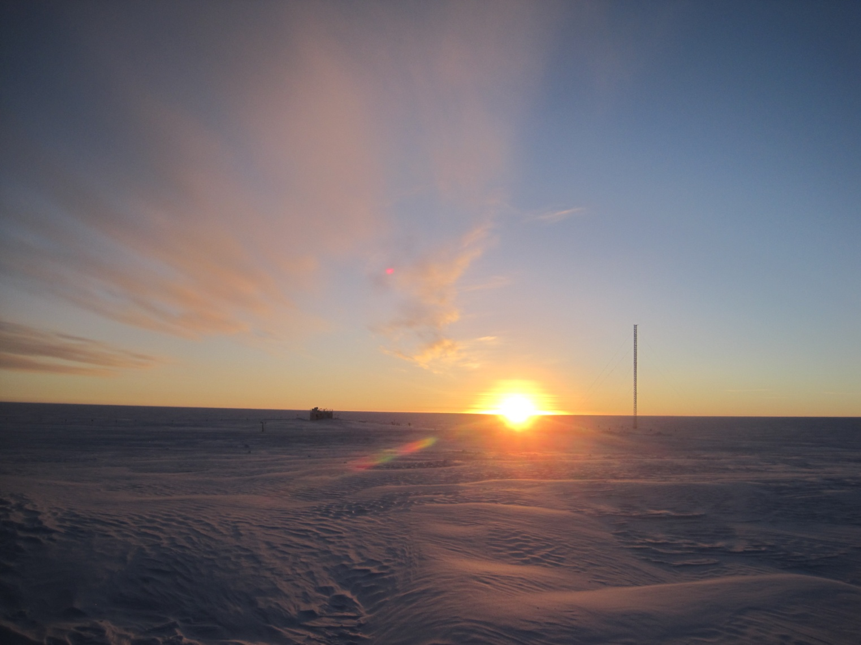

MSF at Sunrise, 19Oct2015. - MOF

**General:**

* Two Twin Otters left Summit on 10/16 with Phase II crew, Matt, and Martin.
* Power outage at 1530Z on 10/13 for two minutes. Gen swap test.
* Leveled the MSF on 10/15, completed at 1545Z. Pitch ranges from -0.01 to +0.04 and roll readings are still unreliable.

**Significant Weather Observations:**

* 10/12: light snow, broken stratus, overcast cirrostratus, 3.4kts, -28.8C
* 10/13: ice crystals, freezing fog, 7kts, -27.9C
* 10/14: broken stratus, 22kts, -18.9C
* 10/15: freezing fog, blowing snow, 15kts, -19.2C
* 10/16: freezing fog, blowing snow, 26kts, -13.1C
* 10/17: few stratus, bkn cirrostratus, 3kts, -19C
* 10/18: overcast, blowing snow, 25kts, -28.2C

**Dataman Account:**

* Operating normally.
* Dataman not responding on 10/16. Swapped out keyboard, rebooted the KVM, and finally rebooted Dataman, which achieved success.
* Data did not seem to transfer via cron preceding 10/17 daily checks. Executed manual transmission. Cause was Denver servers down for maintenance.

**MWR:**

* HATPRO: operating normally.
* 150-90: operating normally.

**SODAR:**

* Operating normally.
* Cleaned SODAR dishes on 10/17 from 1345-1355Z

**POSS:**

* Operating normally.

**MMCR:**

* Operating normally.
* Decision made not to check the terminals and continue daily checks (10/12)
* File Not Found error and “Receiver Cal Running” error found. Clicking “Continue” on the message box allowed it to self correct (10/15, 10/17-10/19). Seems to happen primarily around 1230Z calibration check.

**CAPABL:**

* Operating normally.
* Switched from Laser 2 to Laser 1 – successful. (10/12)
* Changed the flash lamp on laser 2 successfully. (10/14)
* Had an issue mounting the drive on 10/15 – self corrected by 10/16

**MPL:**

* Sent screen shot of VantageVue Communication Error to Von.

**VCEIL:**

* Operating normally.

**Hotplate:**

* Operating normally.

**IceCAM:**

* Operating normally.
* 10/18 – Pictures not acquired after 0800Z and unable to ping camera. Found port 19 on switch as faulty and moved to port 11. Taped off faulty port.

**PAERI:**

* Operating normally.
* 10/18 – LW/SW Responsivity had gone red due to blowing snow – self corrected to yellow status.

**TSI:**

* Shutdown and removed from the roof for the winter.

**IcePIC:**

* No photos taken.

**Radiosonde:**

* Twice daily sondes.
* 12Z sonde on Sunday, 10/18 did not transfer even though it was closed out. Additionally, a K-sonde was used due to high winds.

**MASC:**

* “# dropped images <Bad frames>” climbed from 3 to 25 and “# of camera bus resets” showed 14. Suggested stopping the runMASC program and performing a warm restart. (10/13). This has continued and decision just to let it run has been made.