# ICECAPS Weekly Report

October 19-25, 2015

Mike Finnegan

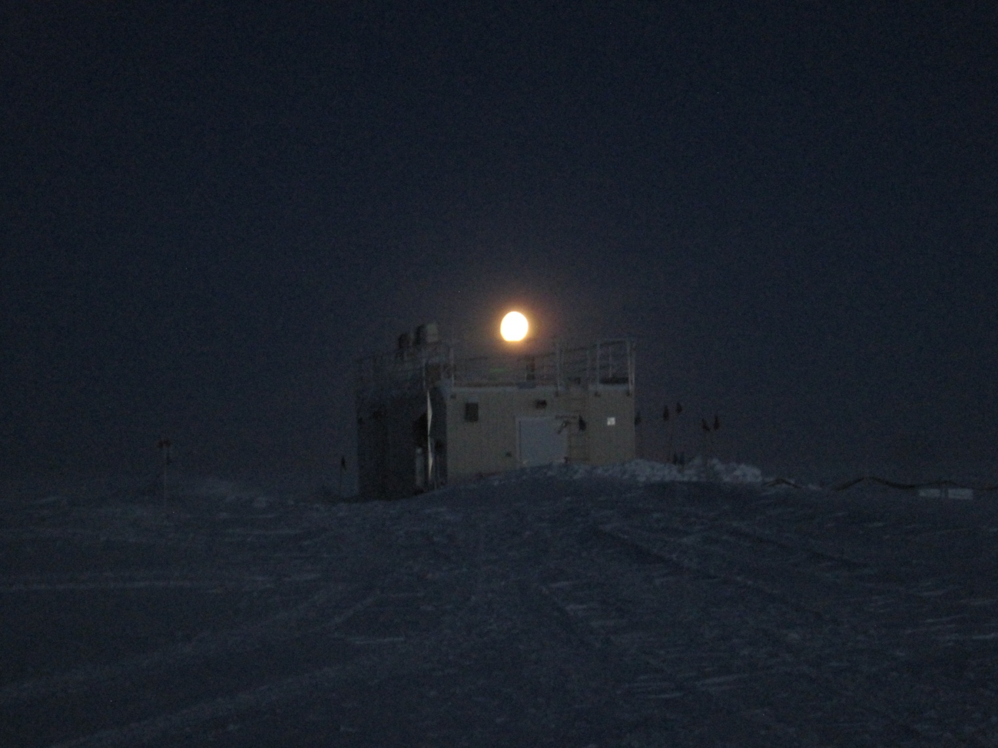

Moonrise over MSF, 24Oct2015. - MOF

**General:**

**Significant Weather Observations:**

* 10/19: bkn cirrostratus, 9.6kts, -43.6C
* 10/20: few cirrus, 5.8kts, -46.3C
* 10/21: few cirrus, 5.4kts, -42.6C
* 10/22: few cirrus, 7.0kts, -50.6C
* 10/23: bkn altostratus, 2.0kts, -48.5C
* 10/24: few altocumulus, 8.2kts, -39.9C
* 10/25: few altostratus, sct cirrus, 12.2kts, -44.6C

**Dataman Account:**

* Operating normally.

**MWR:**

* HATPRO: operating normally.
* 150-90: operating normally.

**SODAR:**

* Operating normally.

**POSS:**

* Operating normally.
* Shoveled area beneath POSS on 10/23

**MMCR:**

* Operating normally.
* 10/23 at 1245Z – Began reboot of MMCR. Had found “Missing file” error again, but this time there were no MOM or MOMSpec files in /ARM. After three reboots and a bunch of Reset/Operate sequences on the TWTA panel, it came back online successfully.
* Noticed a red flashing light on the Pulse Controller labeled “Added Loss” and also a warning in the ELog file, "TWTA Power On LED is lit but Warmup LED is not!". This warning stopped being reported on 10/25, although it is still seemingly under the same condition.

**CAPABL:**

* Operating normally.

**MPL:**

Operating normally

**VCEIL:**

* Operating normally.

**Hotplate:**

* Operating normally.
* Leveled on 10/19 at 1735Z
* Found error 85 on 10/20 daily checks saying the input string was not in the expected format. I pressed “continue”, went through the startup procedure, and data began feeding in. Solid blue, solid yellow, and flashing green LEDs were present on the device.
* Shoveled are beneath Hotplate on 10/23.

**IceCAM:**

* Operating normally.

**PAERI:**

* Operating normally.
* The fan seemed to be struggling a bit on 10/25. It was still drawing 0.41 – 0.45 amps, but sounded different. My best comparison is making cream of broccoli soup with an immersion blender. It goes from sounding like the blender is in the smooth part of the soup (regular), to having to work harder to blend a floret (struggling). On 10/26, it was sounding normal again.

**TSI:**

* Shutdown and removed from the roof for the winter.

**IcePIC:**

* No photos taken.

**Radiosonde:**

* Twice daily sondes.

**MASC:**

* Operating normally.
* Cleaned windows on 10/19 at 1640Z
* Shoveled area beneath MASC on 10/23