# ICECAPS Weekly Report

October 26-November 01, 2015

Mike Finnegan

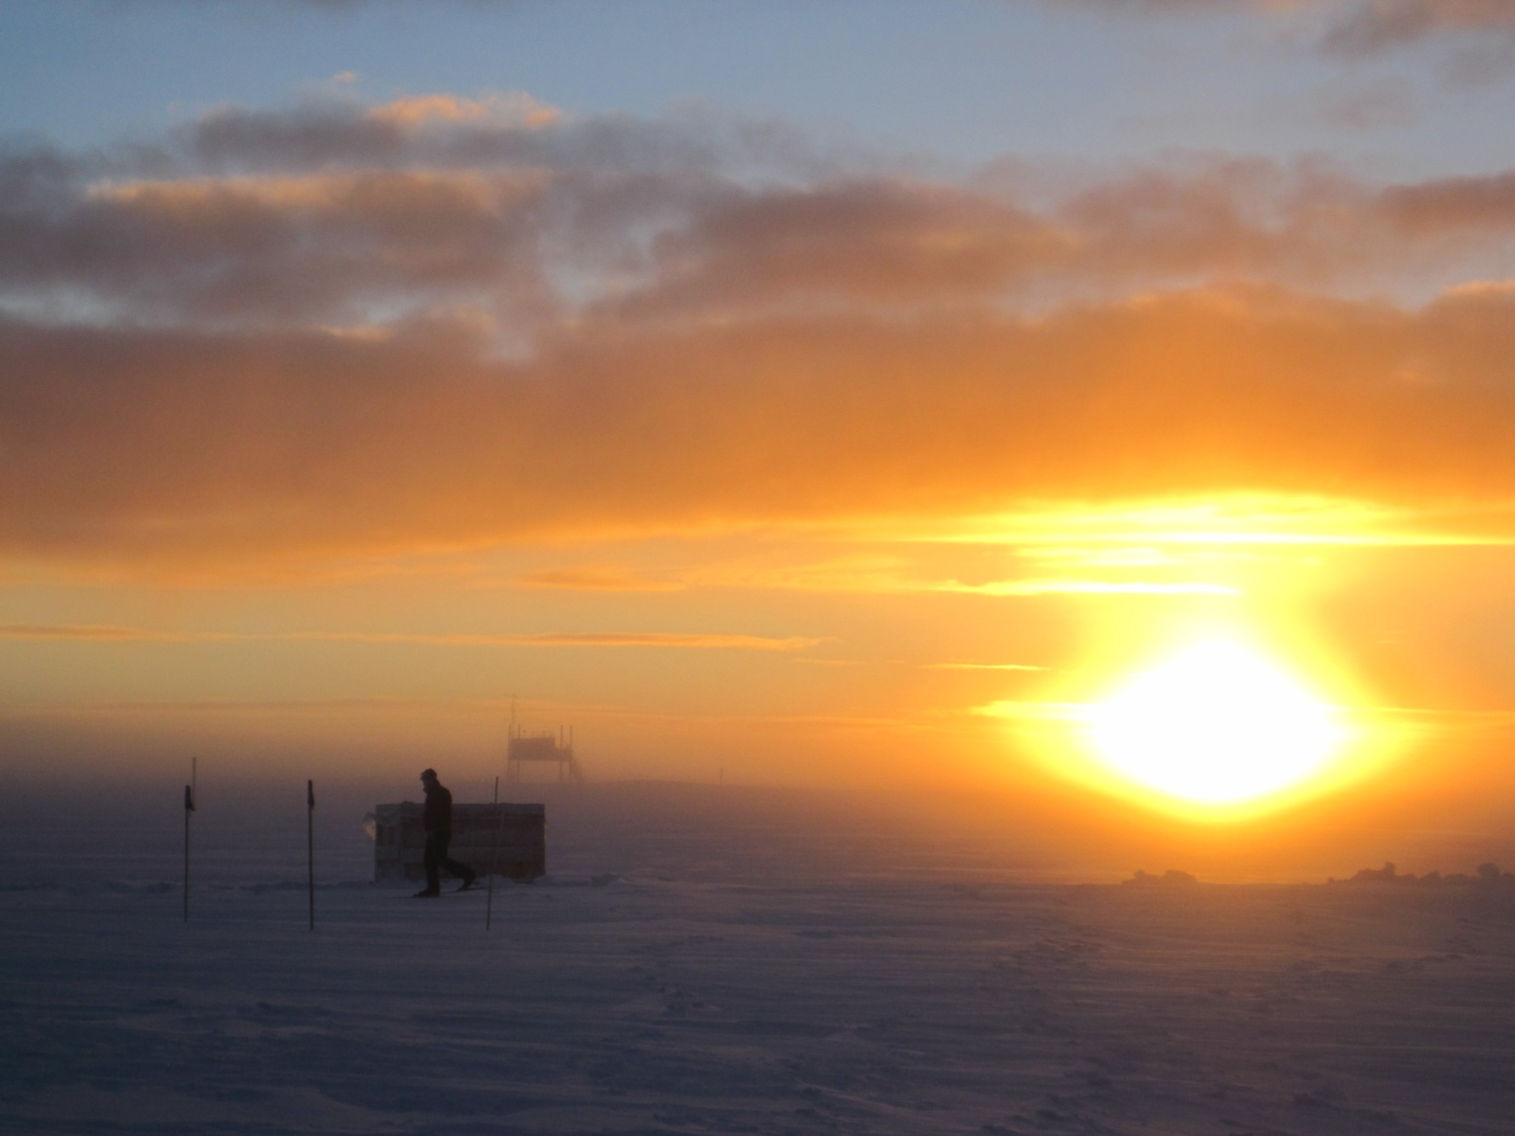

John Out for a Sunset Ski, 01Nov2015. - MOF

**General:**

**Significant Weather Observations:**

* 10/26: ovc cirrostratus, 19.0kts, -29.2C
* 10/27: ovc altostratus, 12.0kts, -30.3C
* 10/28: stratus, blowing snow, 31.8kts, -18.4C
* 10/29: overcast, snow, blowing snow, 18.6kts, -17.7C
* 10/30: blsn, ovc altostratus, 21.0kts, -16.2C
* 10/31: ovc stratus, 10.2kts, -20.1C
* 11/01: stratus, 16.0kts, -21.6C

**Dataman Account:**

* Operating normally.
* Showed MMCR as mounted, but spot_check_archive.sh reported it not mounted. Also, it did not send quicklooks to Boulder. (10/29) Corrected itself by 10/30.

**MWR:**

* HATPRO: operating normally.
* 150-90: operating normally.
* Cleared light rime from 150-90 on 10/26 and uploaded picture to ftp

**SODAR:**

* Operating normally.
* Cleared drifted snow from receiver on 10/29 ~1300Z

**POSS:**

* Operating normally.

**MMCR:**

* Operating normally.
* Tightened and made sure metal-to-metal contact was made on both J1 connectors on back panel of MMCR on 10/28. System shut down at 1408Z, back online successfully at 0527Z. Roll now around -0.2 while pitch is up around 11.
* Inside temperature in Health.txt reported as Out = 30 on 10/29 onward
* Roll now back to around 5 as of 10/30. Pitch remains around 11.

**CAPABL:**

* Operating normally.

**MPL:**

* Operating normally
* After-pulse calibration performed successfully on 10/26 from 1410-1435z.

**VCEIL:**

* Operating normally.

**Hotplate:**

* Operating normally.

**IceCAM:**

* Operating normally.

**PAERI:**

* Operating normally.
* Cleared a bit of snow from the enclosure – 11/01 1415Z

**TSI:**

* Shutdown and removed from the roof for the winter.

**IcePIC:**

* No photos taken.

**Radiosonde:**

* Twice daily sondes.

**MASC:**

* Operating normally.
* Tried to remove icing with cotton cloth on 10/29 ~1250. Suggested to come back with warm water and soap.
* Tried cleaning with warm, soapy water as suggested, but this froze instantly – used isopropyl alcohol, which worked. (10/31, 1245 – 1300Z)