# ICECAPS Weekly Report

October 12-18, 2015

Clair Von Handorf, Mike Finnegan, Matt Okraszewski

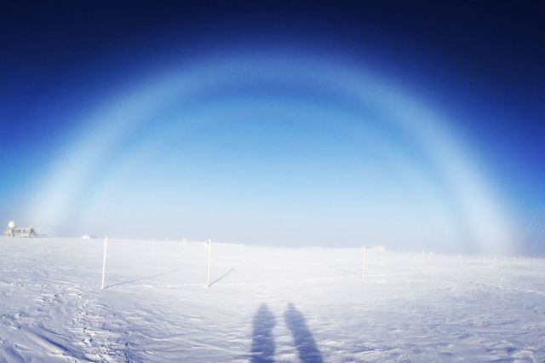

Double Fog Bow at Summit with Matt O and Mike F in shadow. - MAO

**General:**

* Two Twin Otters arrived at Summit on 10/8 and turnover began. Clair departs.
* MattO conducting turnover of ICECAPS tech tasking with Mike Finnegan.
* Adjustments made to the SOLO air handler in an attempt to level out the temperature swings within the MSF. All changes recorded in the MSF temperature monitoring spreadsheet.

**Significant Weather Observations:**

* 10/12: light snow, broken stratus, overcast cirrostratus, 3.4kts, -28.8C
* 10/6: broken stratus, 15kts, -29.3C
* 10/7: broken stratus, 22kts, -18.9C
* 10/8: scattered cirrocumulus, 10kts, -33.7C
* 10/9: broken stratus, 0kts, -30.1C
* 10/10: broken stratus, 7kts, -27C
* 10/11: broken stratus, 10kts, -29C

**Dataman Account:**

* Operating normally.

**MWR:**

* HATPRO: operating normally.
* 150-90: operating normally.

**SODAR:**

* Operating normally.
* 10/8: 12:15z-12:26z Cleaned and leveled dishes.

**POSS:**

* Operating normally.

**MMCR:**

* Operating normally.
* Ongoing issue with display of Outdoor Temperature not reading accurately. Duane and Matt are aware of this.
* 10/5: During daily checks, the +5V #1 was reading at ~+4.5V, in the red. Duane and Matt were notified.
* 10/6: 12:01z Desiccant replaced.
* 10/7: During daily checks, both +5V #1 and #2 were reading at ~+3.8/+4.2V respectively, in the red. Duane and Matt were notified.
* 10/10: Duane notified that the antenna level roll reading has gone out of range again (up to 5.x degrees). It had been reading ~ 0.2 degrees upon arrival of MattO/Mike. Communicating with Matt about strategy for re-leveling the MSF in the absence of a reliable roll reading.

**CAPABL:**

* Operating normally.

**MPL:**

* Operating normally.

**VCEIL:**

* Operating normally.

**Hotplate:**

* Operating normally.

**IceCAM:**

* Operating normally.

**PAERI:**

* Operating normally.

**TSI:**

* Shutdown and removed from the roof for the winter.

**IcePIC:**

* No photos taken.
* Microscope stage brought inside MSF for warming to allow for cleaning of lower objective lens as per protocol direction. Cleaning to be completed today and stage put back in photo booth.
* Awaiting precipitation events to demonstrate IcePIC procedure. In absence of precip, we will practice using me-cipitation.

**Radiosonde:**

* Twice daily sondes.
* Sonde conditioner was left open on evening of 10/10. Desiccant still within range but will monitor closely. Reiterated need to keep conditioner closed.
* Reboot of laptop necessary on 10/12 due to the software not recognizing the sonde for conditioning. Reboot fixed the problem.

**MASC:**

* Operating normally.