# ICECAPS Weekly Report

September 14-20, 2015

Clair Von Handorf

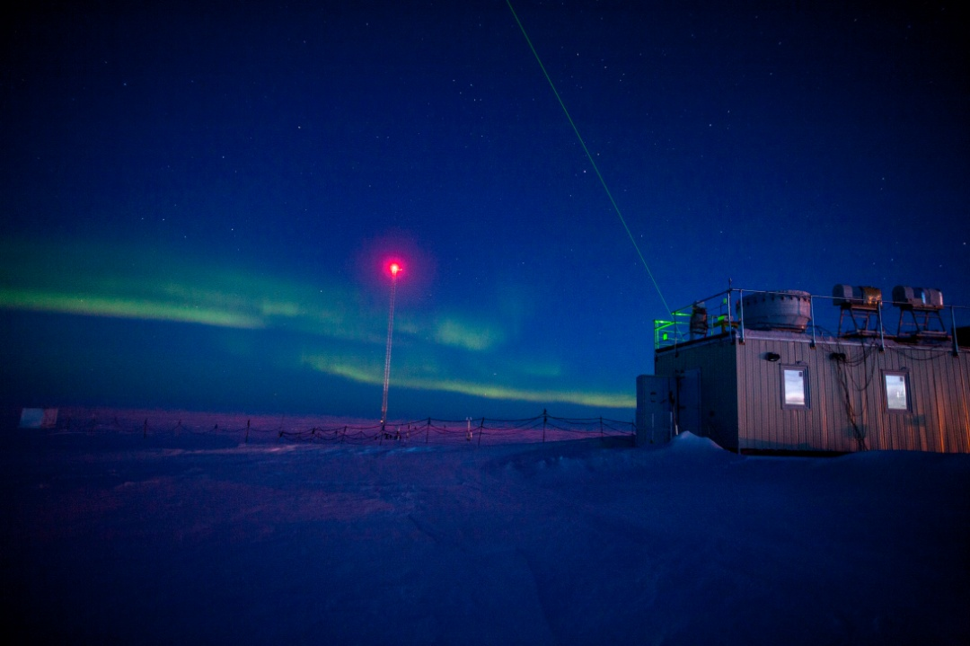

Auroras and CAPABL on 9/15–CVH

**General:**

* None.

**Significant Weather Observations:**

* 9/14: scattered cirrus, 0kts, -31C
* 9/15: scattered cirrocumulus, 15kts, -25.5C
* 9/16: freezing fog, few cirrus, 3kts, -28.3C
* 9/17: broken cirrus, 7kts, -26.0C
* 8/18: freezing fog, broken stratus, 5kts, -23.5C
* 8/19: broken stratus, 14kts, -21.3C
* 8/20: drifting snow, broken stratus, 11kts, -13.4C

**Dataman Account:**

* Operating normally.
* 9/17-20: 11:45z during daily checks, approximately 160 items (17th), 181 items (18th), and 168 items (19th), 183 items (20th) did not transfer to Boulder, but was slowly being sent.

**MWR:**

* HATPRO: operating normally.
* 150-90: operating normally.

**SODAR:**

* Operating normally.

**POSS:**

* Operating normally.

**MMCR:**

* Operating normally.
* 9/17: MMCR shut down at 11:50z. 470 ohm resistor removed from J1-14 to J1-16. Instrument restarted at 12:03z. +5V #1 and #2 both reading ~+5V. Outdoor Temperature still at ~+208C. Information was reported back to Duane and Matt. At Duane’s request, MMCR restarted at 17:23z to see how readings might differ. There was no change to monitor readings.
* 9/18-20: Both +5V back in the red, reading at ~+3.0V.

**CAPABL:**

* Operating normally.

**MPL:**

* Operating normally.

**VCEIL:**

* Operating normally.

**Hotplate:**

* Operating normally.

**IceCAM:**

* Operating normally.

**PAERI:**

* Operating normally.

**TSI:**

* Operating normally.
* 9/17: 1740z TSI powered down and moved inside the MSF for the winter.

**IcePIC:**

* No photos taken.

**Radiosonde:**

* Twice daily sondes.
* 9/16: Issues with intermitted GPS data transfer observed. GPS data is usually being read while radiosonde is conditioning outside pre-flight, but stops transmitting GPS data after launch.
* 9/17: On the evening flight, DigiCora did not close out balloon normally and only one file was created, instead of three. This information was reported back to Von and Matt.

**MASC:**

* Operating normally.