# ICECAPS Weekly Report

September 21-27, 2015

Clair Von Handorf

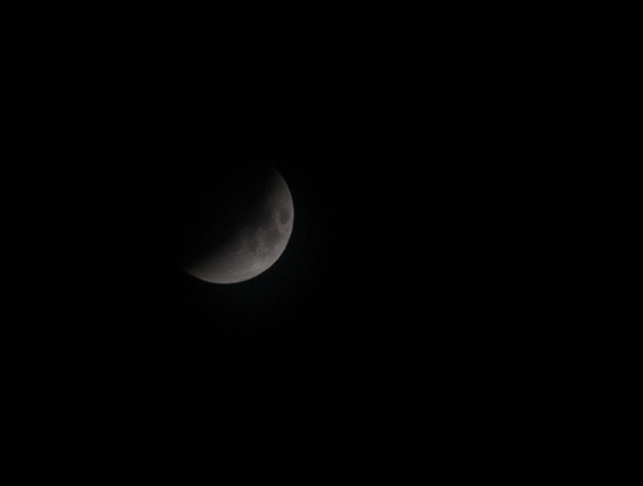

9/27 Total Lunar Eclipse –CVH

**General:**

* None.

**Significant Weather Observations:**

* 9/21: broken altostratus, 11kts, -17.6C
* 9/22: broken stratus, 20kts, -15.8C
* 9/23: broken altostratus, 13kts, -23.2C
* 9/24: broken altostratus, 15kts, -22.2C
* 9/25: broken cirrocumulus, 12kts, -23.4C
* 9/26: broken cirrocumulus, 16kts, -20.2C
* 9/27: blowing snow, broken stratus, 34kts, -16.4C

**Dataman Account:**

* Operating normally.

**MWR:**

* HATPRO: operating normally.
* 150-90: operating normally.

**SODAR:**

* Operating normally.

**POSS:**

* Operating normally.

**MMCR:**

* Operating normally.
* Ongoing issue with display of Outdoor Temperature not reading accurately. Duane and Matt are aware of this.
* 9/26: 11:45z Health file showed ~3600 out of tolerance counts for “roll”. Duane and Matt were informed.
* 9/27: MMCR was shut down at 15:35z. A 10k ohm resistor was installed from J1-14 to J1-16. It was restarted at 15:54z. Current readings were +5V #1 and #2 reading at ~+5V, Outdoor temperature at -14.16C, and roll at -0.18deg. Findings were reported back to Duane and Matt.

**CAPABL:**

* Operating normally.

**MPL:**

* Operating normally.
* 9/26: 12:04z-12:20z Performed Afterpulse calibration

**VCEIL:**

* Operating normally.

**Hotplate:**

* Operating normally.
* 9/24 and 9/28: Hotplate had stopped collecting data for unknown reason. It was restarted successfully. This information was reported back to Matt.

**IceCAM:**

* Operating normally.

**PAERI:**

* Operating normally.

**TSI:**

* Shutdown and removed from the roof for the winter.

**IcePIC:**

* No photos taken.

**Radiosonde:**

* Twice daily sondes.
* GPS/wind data not transmitting on many of the sondes. Quality control check of sonde preparations procedures reviewed.
* 9/24: 8:30z The Vaisala Ashtech firmware upgrade was installed. All balloons since this upgrade have had GPS/wind data.

**MASC:**

* Operating normally.