# ICECAPS Weekly Report

September 28-October 4, 2015

Clair Von Handorf

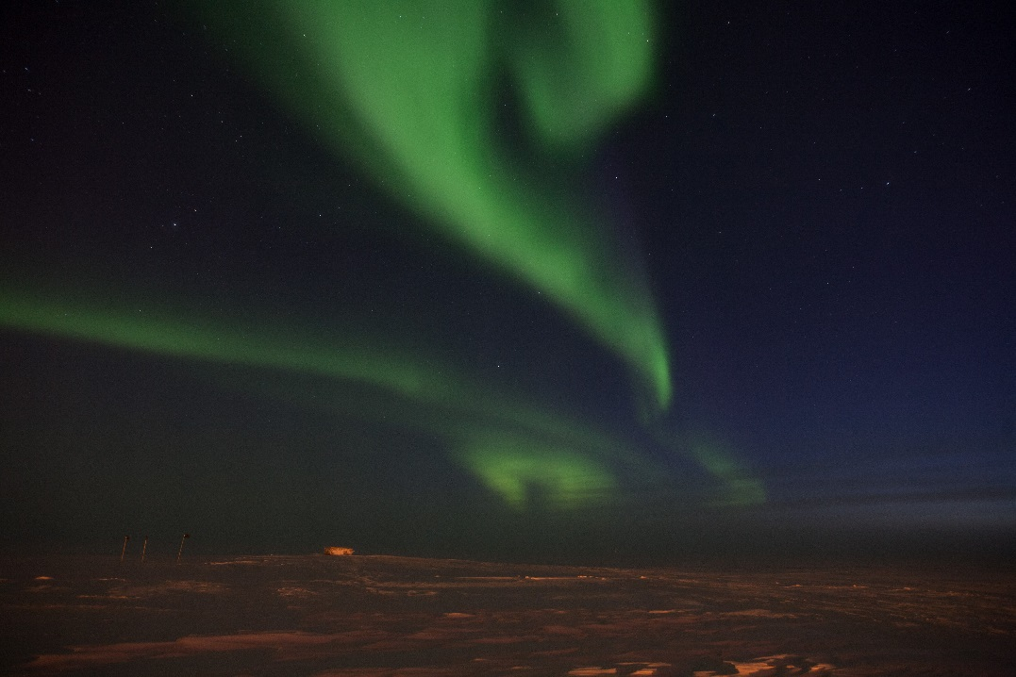

Auroras in the southwest, on 10/4/15–CVH

**General:**

* None.

**Significant Weather Observations:**

* 9/28: broken altostratus, 17kts, -26C
* 9/29: broken stratus, 14kts, -24.0C
* 9/30: broken stratus, 12kts, -28.3C
* 10/1: scattered cirrus, 12kts, -40.9C
* 10/2: scattered cirrocumulus, 10kts, -35.8C
* 10/3: scattered cirrocumulus, 8kts, -35.8C
* 10/4: broken stratus, 15kts, -32.1C

**Dataman Account:**

* Operating normally.

**MWR:**

* HATPRO: operating normally.
* 150-90: operating normally.

**SODAR:**

* Operating normally.

**POSS:**

* Operating normally.

**MMCR:**

* Operating normally.
* 9/28: During daily checks, the pulse controller error lights SW 1 TX, SW 2-3 TX, and Erfdioxide were on. Duane and Matt were notified. After restarting it on 9/27, Labview did not initialize the pulse controller. Duane was able to work on this remotely and fix the issue.
* 10/1: During daily checks, Outdoor Temperature is again reading +200C. Duane and Matt were notified.
* 10/4: During daily checks, in the 1000zHealth text file, the Transmitted RF Power showed 2 out of tolerance values. Duane and Matt were notified.

**CAPABL:**

* Operating normally.

**MPL:**

* Operating normally.

**VCEIL:**

* Operating normally.

**Hotplate:**

* Operating normally.

**IceCAM:**

* Operating normally.

**PAERI:**

* Operating normally.

**TSI:**

* Shutdown and removed from the roof for the winter.

**IcePIC:**

* No photos taken.

**Radiosonde:**

* Twice daily sondes.
* 10/3: 1200z flight, sonde malfunctioned and reported “reason for termination: PTU analysis”. Von and Matt were notified.

**MASC:**

* Operating normally.
* 9/30: MASC was turned off from 12:37z to 16:58z. MASC instrument and electronics box were raised out of accumulating snow. SOP for this procedure was written.
* 10/2: Completed drift and snow accumulation maintenance around instrument suite of MASC and Hotplate. Readjusted wires and poles in this area.