Loss of UPS power in MSF, Summit Station

Time of power loss: 23 March 2015, 13:11z  
ICECAPS tech: Sam Dorsi

**Setup:**

At roughly 12:45z, the station manager at Summit asked me to check the condition of the AC power in MSF using an oscilloscope. He had noticed irregularities in the power in the Big House, and wanted to have observations from an oscilloscope to help in the diagnosis. He asked if I was comfortable performing the test, and I replied that I was. I moved test equipment to the MSF workbench, where I planned to test at the power-strip mounted on the right-hand side of the workbench (Fig 1).

**Fig 1. MSF workbench, with power strip used for MSF power test indicated with red arrow.**

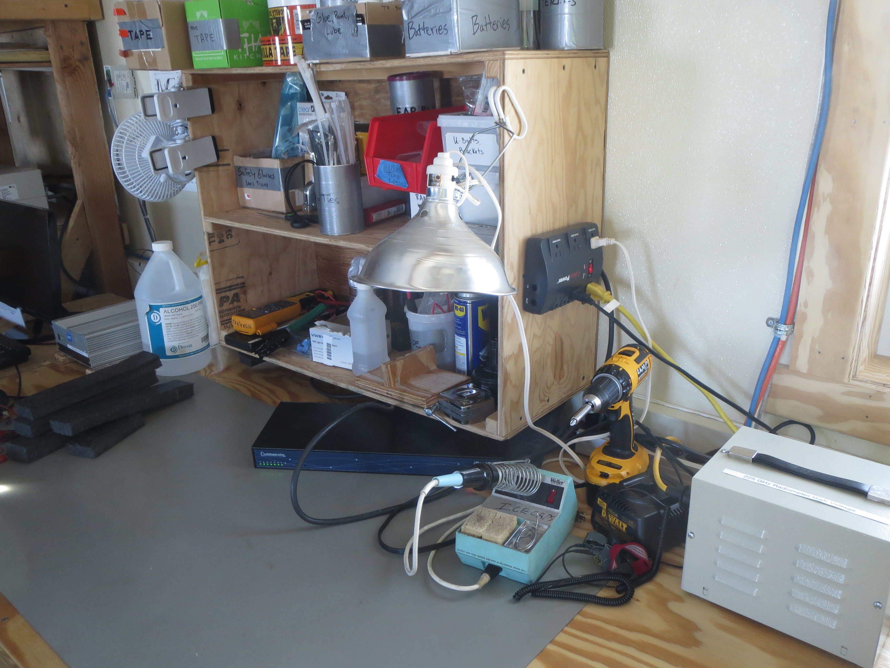

This power-strip is plugged into an outlet underneath the workbench shelving unit (Fig 2). Behind the DC transformer that shares the outlet, a label reads ‘UPS CKT 3’, indicating that it is powered by the UPS (Fig 3). This label is visible with an inspection mirror.

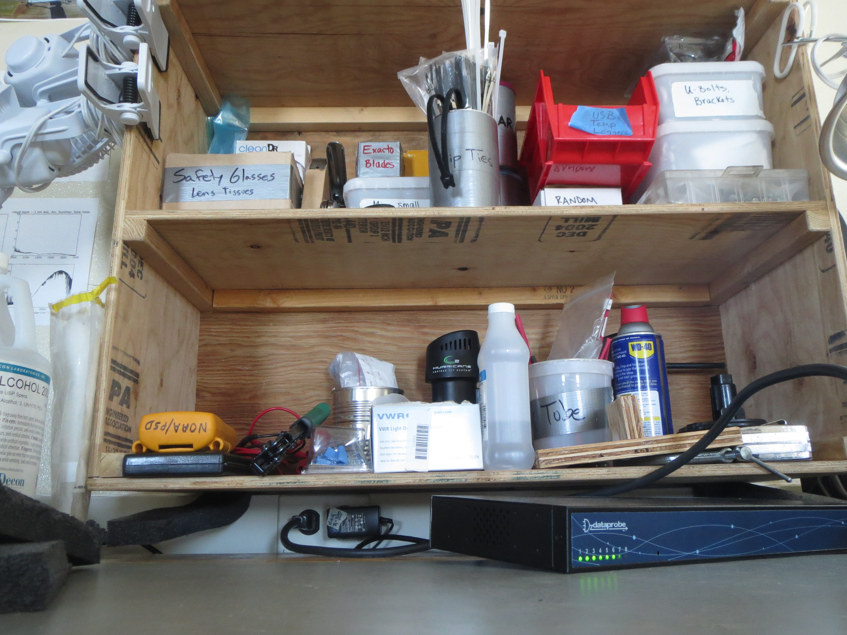

**Fig 2. MSF workbench, with red arrow indicating outlet ‘UPS CKT 3’ to which the workbench power-strip is connected.**

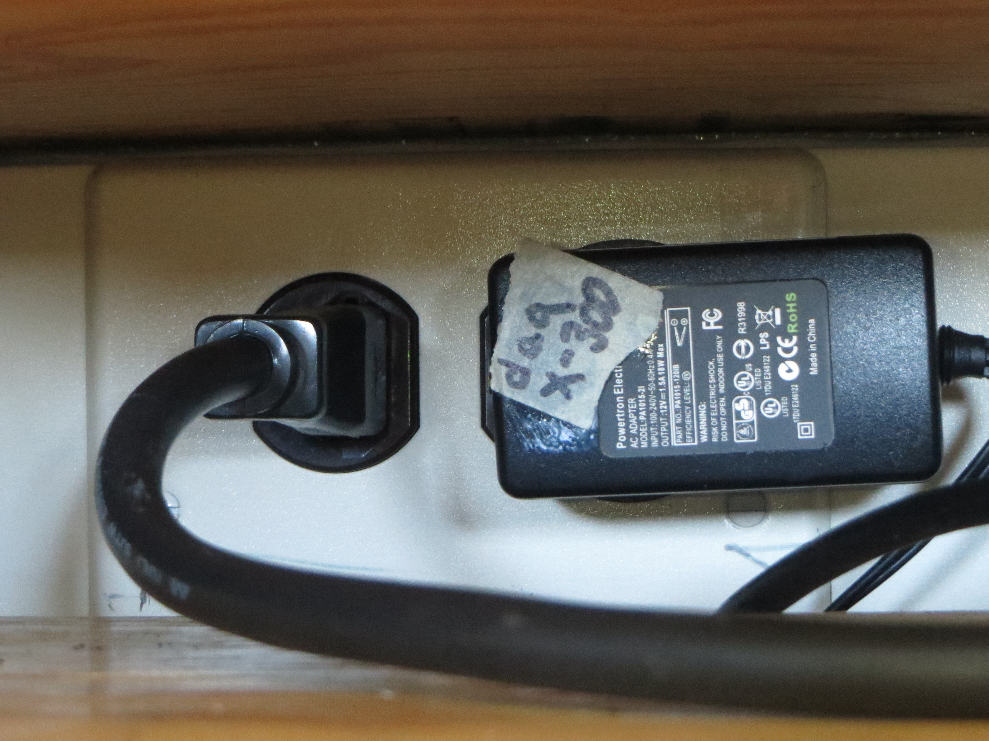

**Fig 3. Outlet ‘UPS CKT 3’**

Also plugged into this power-strip are:

* Charger for cordless drill
* Clip-on utility light
* Second power-strip with:
  + Electric tea kettle
  + Microwave

I first checked the line voltage at the power-strip outlet with a Fluke multimeter, which reported 119 vAC @ 59.95 Hz. I set up the oscilloscope on the MSF workbench, and confirmed that it was rated for US-standard line voltages (expected line voltage 120 v, rating, <400 v).

I plugged in the oscilloscope power cord, and connected a BNC-to-banana-plug adapter to the CH1 test port. I powered on the oscilloscope, set CH1 to AC mode and to maximum vertical voltage divisions (5v). To ensure that only a single AC lead was exposed at a time, I planned to complete the connections for the first lead before starting the connections on the second. I attached a banana plug test lead to one pole of the BNC-to-banana plug connector.

**Power-loss event:**

I inserted the probe end of the connected lead into one pole of an outlet in the same power-strip (connected to ‘UPS CKT 3’). A solenoid click and loss of fan noise in the room were immediately heard. The other pole of the BNC connector was still open, and uncontacted, at the time of the incident. No arcing or incidental contact was observed.

**Response actions:** I removed the probe from the outlet and turned off power to the oscilloscope. I walked around the roof, and confirmed that power was off to most instruments in the building. I checked the wall breakers, and found none tripped. I then checked the UPS status screen, which indicated that the UPS had automatically turned off outgoing power due to a short. As I suspected the short had occurred within the oscilloscope during my test, and this element had been removed from the circuit, I reset the UPS power to ‘on’ at 13:14z. I then sent an email to all ICECAPS PIs and Matt Okraszewski at 13:31z.

Instruments were restarted as appropriate PIs sent instructions. Specific instrument-by-instrument notes follow:

Dataman: Computer system operational. Daily upload of data from 3/22 interrupted.  
MMCR: Runs on independent UPS, data collection uninterrupted.  
MWR: Power lost. Power cycled to radiometers and computer at 15:05z per Dave Turner’s request. Data collection resumed at 15:10z.   
Ceilometer: Power lost. Matt Shupe requested power-up. Data collection resumed at 15:15z.  
MPL: Power lost. Matt Shupe requested power-up. Data collection resumed at 15:49z.  
POSS: Power lost. Matt Shupe requested power-up. Data collection resumed at 15:52z.  
Hotplate: Power lost. Matt Shupe requested power-up. Data collection resumed at 16:10z.  
SODAR: Power lost. Matt Shupe requested power-up. Data collection resumed 16:58z.  
PAERI: Power lost. Restarted in coordination with Von Walden; data collection resumed 19:11z.

Instruments in standby:  
ASIA-A: Power lost. Had been in standby mode. Re-powered to ensure dew blowers active, and left again in standby mode.  
CAPABL: Unsure if power lost. Instrument offsite. Communicating with Ryan Neely about cooler status checks.