# ICECAPS Weekly Report

April 11, 2016 – April 17, 2016

Sam Dorsi

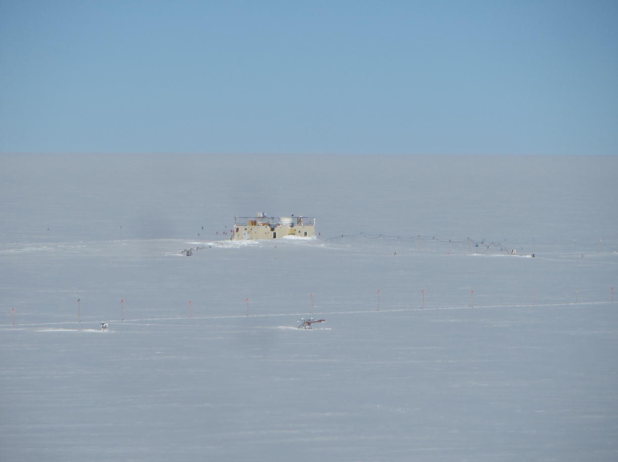

Work activities high on the TAWO tower provide a new perspective on the MSF. SWD.

**General:**

* None.

**Significant Weather Observations:**

* 4/11: Broken stratocumulus, 12 kts, -18C
* 4/12: Blowing snow, 28 kts, -6C
* 4/13: Blowing snow, 29 kts, -18C
* 4/14: Overcast altostratus, 10 kts, -23C
* 4/15: Broken stratus, drifting snow, 20 kts, 35 kts in afternoon, -17C
* 4/16: Scattered altostratus, drifting snow, 12 kts, -33C
* 4/17: Scattered stratus, 11 kts, -38C

**Dataman Account:**

* Operating normally.
* 4/11: Transfer did not occur, due to disk space errors that occurred during MASC data queuing. Transfer re-initiated at 23:24z and files were uploaded before the end of day kill cron.
* 4/12: Transfer completed at 20:39z.
* 4/13: Transfer completed at 12:36z.
* 4/14: Transfer completed at 20:06.
* 4/15: The queuing issue of 4/11 was repeated, with MASC disk space errors occurring during the GetData.bash script. Transfer to Boulder only took place after re-initiation at 23:58z.
* 4/16: Transfer completed at 19:25z.
* 4/17: Transfer completed at 12:05z.

**MWR:**

* HATPRO removed for repairs.

**SODAR:**

* Operating normally.

**POSS:**

* Operating normally.
* 4/13: At 13:39z, posacq was closed. At the external power pole, POSS was powered down for one minute, then reconnected to power and posacq restarted at 13:50z.
* 4/14: Matt requested information about the POSS support elements, and the POSS was excavated to gather details. This opportunity was taken to raise the POSS (completed 17:54z).

**MMCR:**

* Operating normally.
* Measurements of roll, pitch and outdoor temperature appear erroneous.
* 4/12: Labview reports out-of-spec voltage (4.4 V) on the Interface +5 V bus.
* 4/16: A discrepancy has been identified (12:51z): the out-of-spec voltage value continues to appear in LabView, while the voltage read on the Interface test points are within spec.

**CAPABL:**

* Operating normally.
* 4/15: Service equipment identified in MSF.

**MPL:**

* Operating normally.

**VCEIL:**

* Operating normally.

**Hotplate:**

* Operating normally.

**IceCAM:**

* Operating normally.

**PAERI:**

* Operating normally.
* 4/13: Scene mirror cleaned 11:53z due to SW and LW Responsivity yellow flags. Repeat cleanings at 13:43z, and 14:04z, after installation of replacement fan.
* 4/13: PAERI shelter fan discovered seized at 11:57z and removed for indoor replacement. Fan 7 was removed and disassembled for inspection and testing. Fan 1, which in the previous phase had been removed after 1 day of operation due to a ticking noise, was disassembled. The bearing seats were cleaned, and the fan was mounted and tested for 40 minutes inside. No ticking or irregularities were detected. Fan 1 was then reinstalled on the PAERI shelter at 14:01z.
* 4/13: Round of inventory and maintenance on PAERI fans. All used fans were disassembled, inspected, cleaned, bearings swapped if needed, reassembled and tested alongside a new fan. An outlet plug was installed on one new fan as a ready-to-swap unit. Logs were updated.
* 4/16: The PAERI scene mirror was cleaned at 18:27z, due to the presence of yellow SW / LW responsivity flags.

**TSI:**

* Stored in MSF and awaiting warmer temperatures for redeployment.

**IcePIC:**

* 4/11: Slides placed for collection from 13:15z to 14:12z. Hexagonal plates, triangular forms, and rimed building hoar collected. Some interesting depositional growth patterns around crystals.

**Radiosonde:**

* Twice daily soundings.
* 4/11 0z: Sounding showed data spikes and dropouts, and automatically terminated early (461.1 hPa). These issues self-resolved above 333.1 hPa, and data with normal appearance were collected up to 23.3 hPa.
* 4/16 12z: Humidity sensor failed after sonde checkout.

**MASC:**

* Operating normally.
* 4/11: ‘Startup disk has no more space’ errors continue to be displayed on MASC laptop.
* 4/11: As of 12:40z, the MASC remote desktop connection is very sluggish, and reporting Firewire BUS resets.
* 4/11 and 4/15: Errors related to MASC disk space appeared during ICECAPS data uploads. In both instances, Marty responded by deleting files from the MASC computer.
* 4/15: A hard reset of the MASC was performed at 19:25z.