# ICECAPS Weekly Report

April 18, 2016 – April 24, 2016

Sam Dorsi

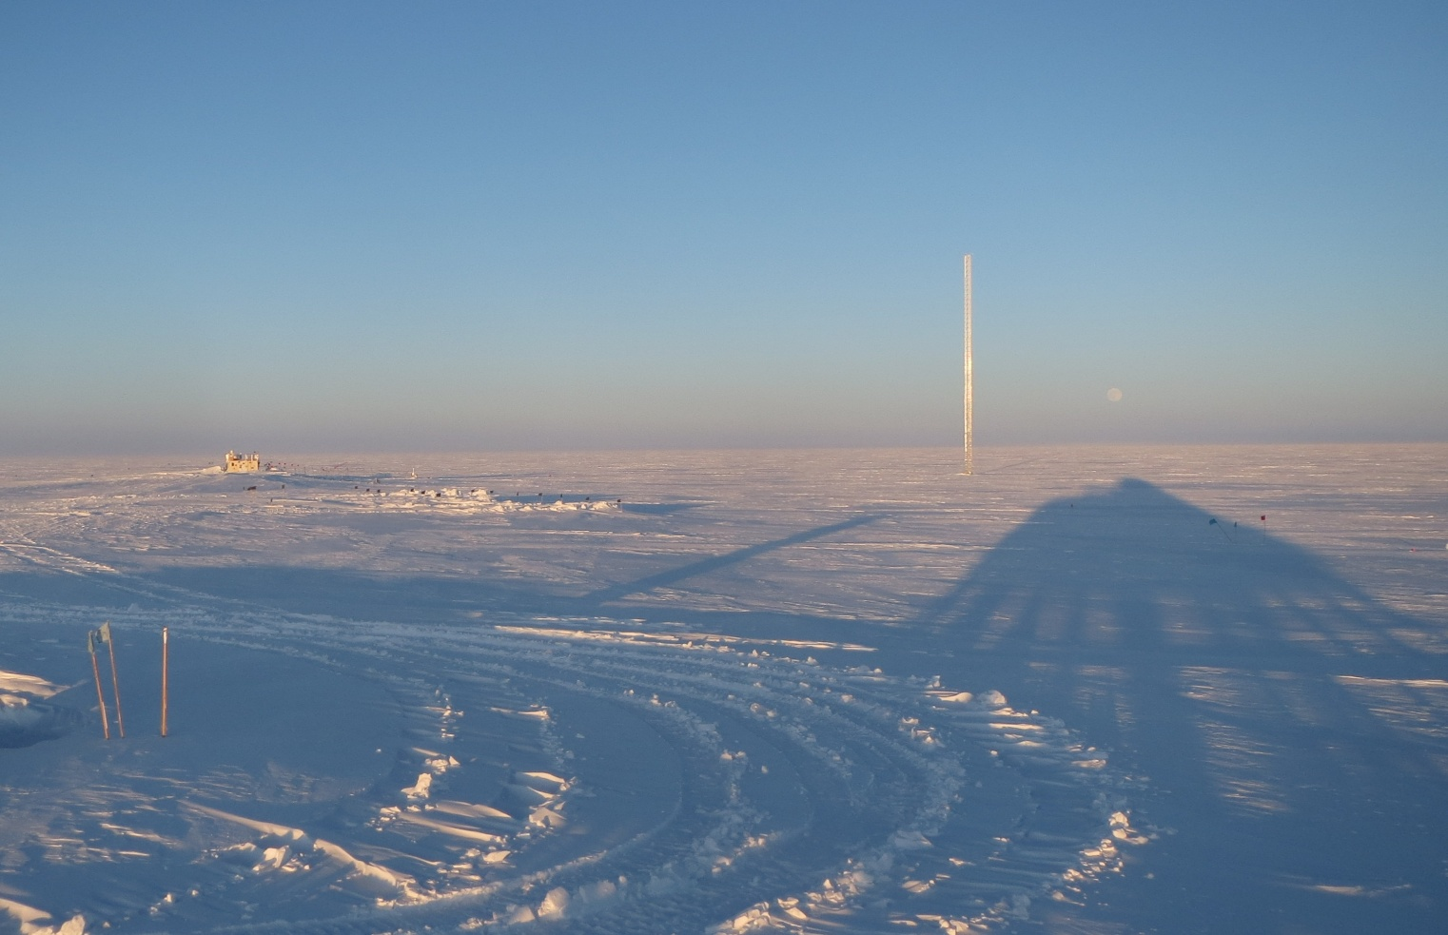

On spindly legs, the shadow of the Big House stetches towards the moon. SWD.

**General:**

* None.

**Significant Weather Observations:**

* 4/18: Scattered altostratus, 12 kts, -42C
* 4/19: Overcast stratus, blowing snow, 21 kts, -30C
* 4/20: Overcast stratus, drifting snow, 12 kts, -31C
* 4/21: Clear, 6 kts, -38C
* 4/22: Blowing snow, 26 kts, -15C
* 4/23: Blowing snow, strong static buildup, 37 kts, -18C
* 4/24: Blowing snow, 29 kts, -15C

**Dataman Account:**

* Operating normally.
* 4/18: Transfer completed at 11:14z.
* 4/19: Transfer completed at 10:50z.
* 4/20: Transfer completed at 12:20z.
* 4/21: Transfer completed at 11:22z.
* 4/22: Transfer completed at 10:00z.
* 4/23: Transfer completed at 13:19z.
* 4/24: Transfer completed at 15:01z.

**MWR:**

* HATPRO removed for repairs.

**SODAR:**

* Operating normally.
* 4/19: SODAR shut down at 18:20z to prevent hearing damage during especially thorough cleaning. Data collection resumed 18:38z.

**POSS:**

* Operating normally.

**MMCR:**

* Operating normally.
* Measurements of roll, pitch and outdoor temperature appear erroneous.
* 4/18: Labview continues to report of out-of-spec voltage (4.4 V) on the +5 V #1 Interface bus.
* 4/19: A calibration error resulted in data collection halting from approximately 18 Apr 15:00z to 19 Apr 12:32z. Data collection resumed upon clearing the error.
* 4/19: By Duane’s request the MMCR was shutdown at 16:28z. The MP8 connector was detached, and the radar rebooted. Six reboot attempts were needed. The MMCR resumed operation at 19:32z. This did resolve the erroneous voltage for +5 V #1 Interface in Labview.

**CAPABL:**

* Operating normally.
* 4/22: Mount for CAPABL on ICECAPS machine was down overnight. An error “Disk boot failure. Insert system disk and press enter” was discovered at 12:13z. By PI request, CAPABL was fully powered down (13:34z) then restarted, both following the ‘long-duration’ protocols. CAPABL resumed operation at 13:43z.

**MPL:**

* Operating normally.
* 4/24: Warm blowing snow continuously creates droplets of moisture on outside of MPL viewing pane. This was cleaned off and dried at 13:22z, but re-accumulates in these conditions.

**VCEIL:**

* Operating normally.

**Hotplate:**

* Operating normally.
* 4/23: The hotplate reported a communication error around the time of intense static activity at MSF. Data collection was restarted at 12:53z.

**IceCAM:**

* Operating normally.

**PAERI:**

* Operating normally.
* 4/23: PAERI Responsivity flags showed a need for scene mirror cleaning (13:10z), but strong winds prevented safe access to the roof to perform this service.
* 4/24: Scene mirror cleaned at 13:20z.

**TSI:**

* Stored in MSF and awaiting warmer temperatures for redeployment.

**IcePIC:**

* 4/18: Slides placed for collection from 16:50 – 16:54z in blowing snow. Particles photographed included hexagonal plates, hollow columns, isolated bullets, and irregulars.

**Radiosonde:**

* Twice daily soundings.
* 4/23: High winds, k-sonde used for 0z and 12z launches.

**MASC:**

* MASC does not appear to be recognizing particles in the sample volume (particle events are not triggered). PIs have requested removal of MASC to the United States for diagnostics.