# ICECAPS Weekly Report

April 25, 2016 – May 1, 2016

Sam Dorsi and Hannah James

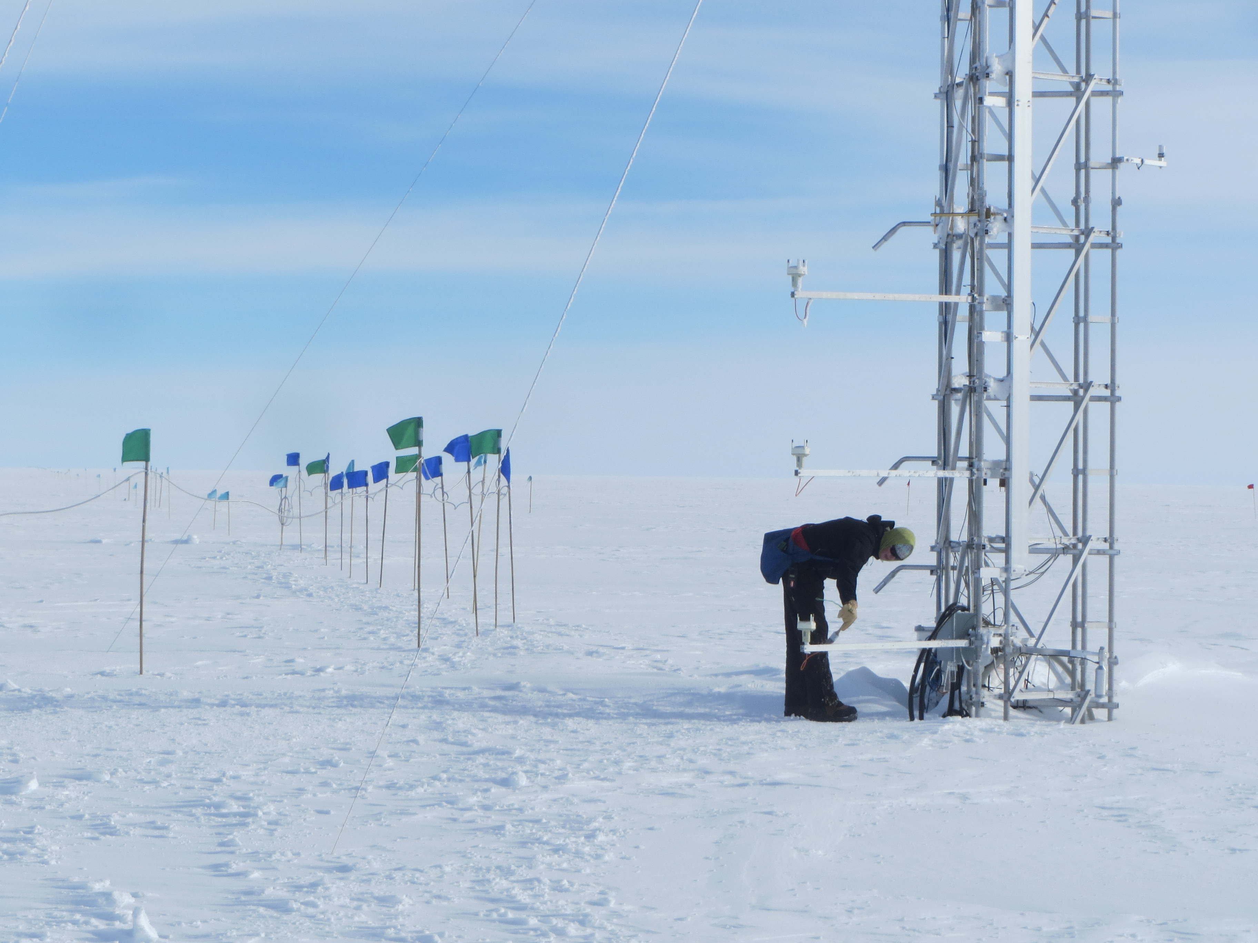

Hannah cleans 50-meter tower components before heading to the MSF. SWD.

**General:**

* 4/26: Incoming ICECAPS tech Hannah James arrives on station!

**Significant Weather Observations:**

* 4/25: Overcast stratus, 17 kts, -12C
* 4/26: Scattered altostratus, 4 kts, -19C
* 4/27: Scattered altocumulus, evening fogbow, 8 kts, -16C
* 4/28: Scattered cirrostratus, 10kts, -18C
* 4/29: Few stratus, broken altocumulus with fall streaks. Halo present at 12:00z, 10 kts, -19C. Winds picked up to ~20kts in afternoon.
* 4/30. Broken altostratus, halos present throughout day, 7kts, -25C. Fogbow observed at 0900z.
* 5/1. Scattered stratus, 12kts, -21C, diamond dust at 1200z. Parhelic circle observed 1538z.

**Dataman Account:**

* Operating normally.
* 4/25: Transfer completed at 12:28z.
* 4/26: Transfer completed at 13:13z.
* 4/27: Transfer completed at 18:05z.
* 4/28: Transfer completed at 18:57z.
* 4/29: Transfer completed at 14:30z.
* 4/30: Data were queued normally, but no transfers occurred. Dataman was able to ping stateside servers, but reported ‘lost connection’ errors to NOAA.
* 5/01. Same issue as yesterday: data were queued normally, but no transfer to Boulder occurred. Dataman still able to ping stateside servers, but no connection to NOAA.

**MWR:**

* HATPRO removed for repairs.

**SODAR:**

* Operating normally.
* 4/29: SODAR fully shut down and rebooted for turnover training at 16:31z.

**POSS:**

* Operating normally.
* 4/29: POSS rebooted for turnover training at 16:59z.

**MMCR:**

* Operating normally.
* Cable MPP8 disconnected (roll, pitch and outdoor temperature sensors) since 4/19.
* 4/29: The +5 V (#1 and #2) interface buses are reported as out-of-spec in the Labview display. However, the physical test points on the interface unit show these buses to be near the specified 5 V.
* 4/30: Changed TWTA desiccant.

**CAPABL:**

* 4/26: CAPABL window cleaned at 10:23z. This reduced the received signal strength. A number of diagnostic checks were performed, with the result that a degradation of laser alignment is suspected.
* 4/27: An alignment of the CAPABL laser was performed starting at 12:20z. Data collection resumed at 14:16z.
* 4/27: The alignment was repeated at 20:40z with the aperture set at 4 mm.
* 4/29: Aperture adjusted and Laser 2 activated (22:00z) in order to test effect on signal strength.
* 5/1: A new flashlamp (#5) was installed in Laser 1 (19:10z), with data collection (Laser 1 ops) resuming at 20:43z.

**MPL:**

* Operating normally.
* 4/27: Afterpulse calibration performed 15:48 to 16:15z.

**VCEIL:**

* Operating normally.
* 4/29: Software restarted for turnover training at ~19:30z.

**Hotplate:**

* Operating normally.
* 4/29: Hotplate rebooted for turnover training at 17:01z.

**IceCAM:**

* Operating normally.

**PAERI:**

* Operating normally.
* 4/30: Simulated cleaning of PAERI scene mirror at 20:35z.

**TSI:**

* Stored in MSF and awaiting warmer temperatures for redeployment.

**IcePIC:**

* 5/1: Slides placed for collection from 1900-1945z. Particles photographed include irregulars, bullet forms, and broken plates.

**Radiosonde:**

* Twice daily soundings.
* 4/30: Inventoried radiosonde supplies for upcoming orders.

**MASC:**

* MASC does not appear to be recognizing particles in the sample volume (particle events are not triggered). PIs have requested removal of MASC to the United States for diagnostics.
* 5/1: Removed MASC from sample site. Packed for shipment at the end of FP1 (scheduled 5/3/2016).