# ICECAPS Weekly Report

April 4, 2016 – April 10, 2016

Sam Dorsi

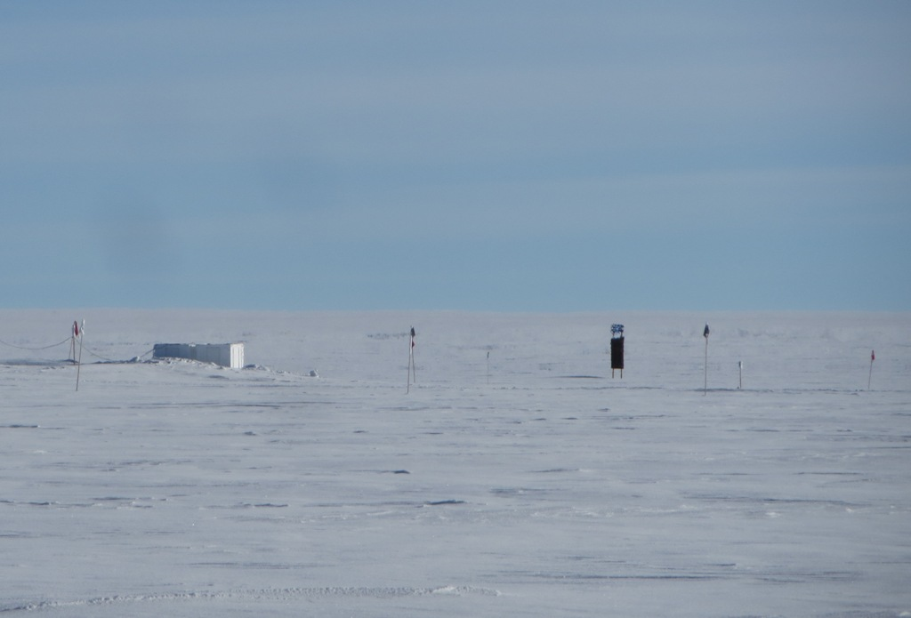

Beyond the SODAR, a fata morgana mirage stretches and inverts the squat ½-mile marker. SWD.

**General:**

* 4/6: Scheduled power outage at 15:10z for emergency generator testing.

**Significant Weather Observations:**

* 4/4: Few altostratus, 3 kts, -23C
* 4/5: Few altostratus, fogbow, 10 kts, -37C
* 4/6: Few altostratus, 14 kts, -36C
* 4/7: Few altostratus, 16 kts, -37C
* 4/8: Few altostratus, 14 kts, -33C
* 4/9: Few altostratus, 10 kts, -35C
* 4/10: Broken stratocumulus, 14 kts up to 42kts at night, -17C

**Dataman Account:**

* Operating normally.
* 4/4: Transfer completed at 12:02z.
* 4/5: Transfer completed at 12:31z.
* 4/6: Transfer completed at 11:55z.
* 4/7: Transfer completed at 11:02z.
* 4/8: Transfer completed at 10:55z.
* 4/9: Transfer completed at 12:15z.
* 4/10: Transfer completed at 11:18z.

**MWR:**

* HATPRO removed for repairs.

**SODAR:**

* Operating normally.

**POSS:**

* Operating normally.

**MMCR:**

* Operating normally.
* Measurements of roll, pitch and outdoor temperature appear erroneous.

**CAPABL:**

* Operating normally.

**MPL:**

* Operating normally.

**VCEIL:**

* Operating normally.

**Hotplate:**

* Operating normally.

**IceCAM:**

* Operating normally.

**PAERI:**

* Operating normally.

**TSI:**

* Stored in MSF and awaiting warmer temperatures for redeployment.

**IcePIC:**

* 4/4: Slides placed for collection from 13:02z to 14:08z. Radiating plates and hollow columns collected.

**Radiosonde:**

* Twice daily soundings.
* 4/11 0z: Sounding showed data spikes and dropouts, and automatically terminated early (461.1 hPa). These issues self-resolved above 333.1 hPa, and data with normal appearance were collected up to 23.3 hPa.

**MASC:**

* Operating normally.
* Errors ‘startup disk has no more space’ and ‘you may be a victim of software counterfeiting’ continue to be displayed on MASC laptop.