# ICECAPS Weekly Report

August 1, 2016 – August 8, 2016

Hannah James

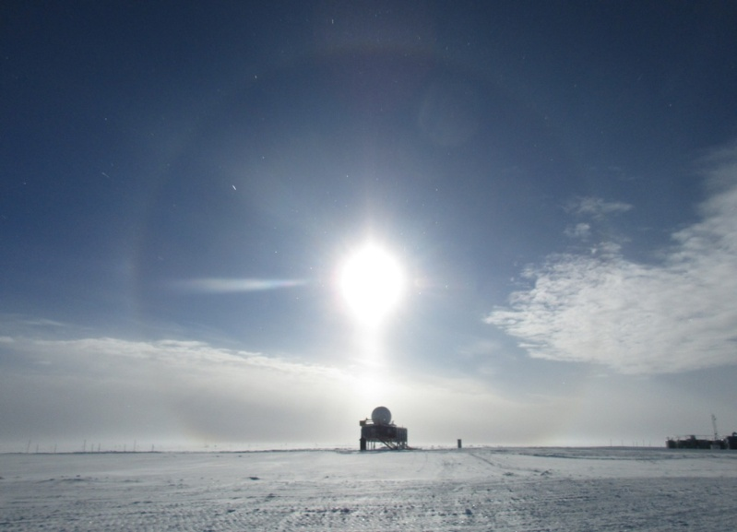

Halo and column over the Big House -HJ

**General:**

* Nothing to report.

**Significant Weather Observations:**

* 8/1: Few stratus, few altocumulus, few cirrus. -16C, 6kts. Visibility unlimited. 1215z: corona.
* 8/2: Sct altostratus, bkn cirrostratus, bkn cirrus. -16C, 13kts. Visibility unlimited. 1100-1600z: 22 degree halo
* 8/3: Few cirrostratus, few cirrus. -16C, 9 kts. Visibility unlimited.
* 8/4: Sct stratus, sct altocumulus, sct cirrus. -16C, 7 kts. Visibility 5000m. 1100-1200z: cornoa. 1300z: IC 1500-1800z: 22 degree halo
* 8/5: Sct stratocumulus, bkn cirrostratus. -12.3C, 9 kts. Visibility unlimited. 1100-1400z: 22 degree halo. 1849z: altostratus undulatus clouds.
* 8/6: Sct stratus, bkn altostratus, bkn cirrus. -12C, 10 kts. Visibility unlimited. 2035z: 22 degree halo, column, 46 degree halo, circumzenial arc. –Sn throughout evening.
* 8/7: Bkn nimbostratus, ovc cirrostratus. -7C, 9kts. Visibility 1600m. –SG throughout the entire day, lots of accumulation.

**Dataman Account:**

* 8/1: Data transfer complete 1057z.
* 8/2: Data transfer complete 1119z.
* 8/3: Data transfer complete 1158z.
* 8/4: Data transfer complete 1139z.
* 8/5: Data transfer complete 1108z.
* 8/6: CAPABL mount down overnight. Remounted 1935z. Data transfer complete 1106z.
* 8/7: No CAPABL data to grab, see specifics below. Data transfer complete 1054z.

**MWR:**

* Operating normally.

**SODAR:**

* Operating normally.
* 8/5: Checked SODAR level. The north side is ever so slightly tipping forward, but all other sides are perfectly level.

**POSS:**

* Operating normally.

**MMCR:**

* Operating normally.
* Roll bouncing between 0.32 and 0.43 degrees, pitch bouncing between 0.00 and -0.10.

**CAPABL:**

* Operating normally.
* 8/6: Disk boot error discovered. Skyped with Robert, replaced the USB power strip with a controlled outlet power strip. The computer needed a hard reset to get everything working again. 1700z-laser off. 1840- hard computer shutdown, 1841- computer powered back on and safely brought back online. 1851z- all systems running normally again.
* 8/7: Event log reading “A USB communications error has occurred” was present upon daily rounds. This did not allow any interface with the computer, so the lasers were shut of manually and the system was force quit. This occurred again as soon as the computer went into hibernate mode, with the Licel and Meadowlark also turning off. After talking with Robert, the power strips were switched back. However, the system was not easily brought back up. After much troubleshooting, it was discovered that the Licel controller was reading out of the wrong memory (B instead of A), but could not be switched. Robert is contacting Licel about this. The system is currently running without fault.

**MPL:**

* Operating normally.

**VCEIL:**

* Operating normally.

**Hotplate:**

* Off site for repairs since 6/9/2016.

**IceCAM:**

* Operating normally.

**PAERI:**

* Operating normally.

**TSI:**

* Operating normally.
* Due to decreasing angle of the sun, false low cloud coverage is reported during the early morning and late evening hours, and there are no raw or processed photos from ~0000z-0530z (time increasing each day).
* 8/4: Frost covering camera from 0326-0830z, creating false cloud coverage.

**IcePIC:**

* 8/7 Slides placed for collection all day, photographed at 2035z. Images photographed cups, bullet rosettes, split plates, stellar plates, simple plates, sectored plates, radiating plates, isolated bullets, capped bullets, rimed plates, rimed dendrites.

**Radiosonde:**

* Twice daily soundings.
* 8/4: Successful RS41 test launch
* 8/7: No morning balloon due to early ANG arrival.

**MASC:**

* Offsite for repairs since 5/3/2016.