# ICECAPS Weekly Report

August 15, 2016 – August 22, 2016

Elissa Barris, Travis Guy, Hannah James

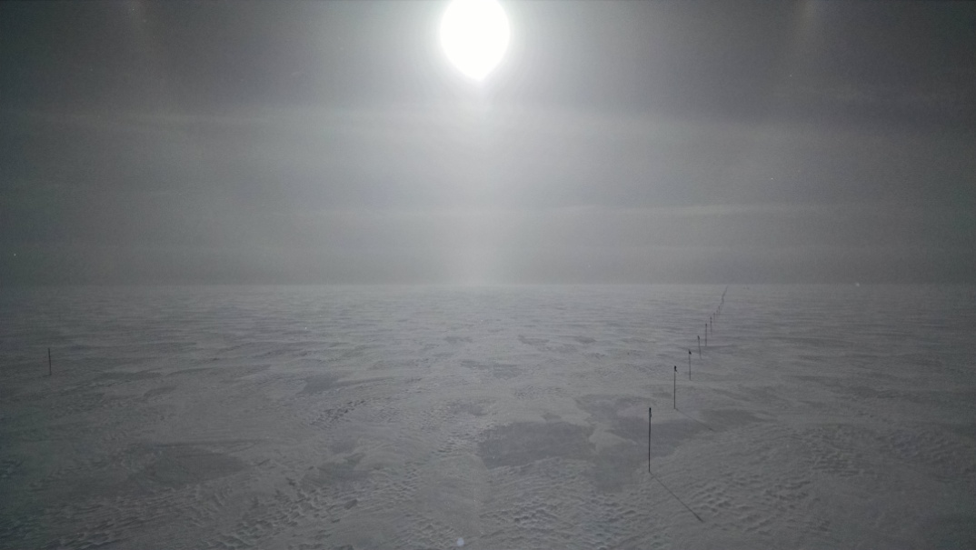

Halo, column, and lots of blowing snow. –Elissa Barris, 8/19

**General:**

* Reveleveled the MSF on 8/15, both roll and pitch are now bouncing between 0.00 and -0.11. Elissa and Travis took over officially on 8/17 with the departure of Hannah on the last C-130 flight.

**Significant Weather Observations:**

* 8/15: Bkn FZFG. -18C, 11kts. Visibility 400m. Parhelia 2255z.
* 8/16: Bkn Stratus. -9C, 7.2 kts. Visibility unlimited shifting to 3200m.
* 8/17: Sct Cumulous. -IC, -10C, 8kts. Visibility unlimited.
* 8/18: Ovc Stratus. -SN, -10C, 11kts. Visibility 0800m.
* 8/19: Bkn Stratus. -SN, BLSN, -11C, 17kts. Visibility 1600m. Halo at 1902z.
* 8/20: Ovc Stratus shifting to Few Cirrus. SN, BLSN, -8C, 15kts. Visibility 700m shifting to unlimited. Halo at 1425z.
* 8/21: Bkn Cirrus. -13C, 7kts. Visibility unlimited. Parhelia 2137z.

**Dataman Account:**

* 8/15: Data transfer complete 1241z.
* 8/16: Data transfer complete 0619z.
* 8/17: Data transfer complete 0631z.
* 8/18: Data transfer complete 0612z.
* 8/19: Data transfer complete 0620z.
* 8/20: Data transfer complete 0627z.
* 8/21: Data transfer complete 0607z.

**MWR:**

* Operating normally.
* 8/15: Reinstalled the insulation blanket on the HATPRO.
* 8/16: RPG-150-90 time off by ~1 min. from MSF time server. Contacted D. Turner regarding this.

**SODAR:**

* Operating normally.
* 8/16: C-130 on ground 1455-1608z. Heavy equipment (Case Tractor) grooming 1603z-1618z.
* 8/17: C-130 on the ground 1237-1205z.

**POSS:**

* Operating normally.

**MMCR:**

* Operating normally.
* Reveled MSF on 8/15. Pitch 0.02, roll -0.04 as of 8/21.
* 8/16: Replaced desiccant
* 8/21: MMCRMom, MMCRSpecMom, Health file, and Elog file not written in last hour. 0505z was last time files were written. Radar Errors “see log” message.

**CAPABL:**

* Operating normally.

**MPL:**

* Operating normally.

**VCEIL:**

* Operating normally.

**Hotplate:**

* Off site for repairs since 6/9/2016.

**IceCAM:**

* Operating normally.

**PAERI:**

* Operating normally.

**TSI:**

* Operating normally.
* Due to decreasing angle of the sun, false low cloud coverage is reported during the early morning and late evening hours, and there are no raw or processed photos from ~0000z-0530z (time increasing each day).

**IcePIC:**

* 8/XX Slides placed for collection XXXXXz. Images photographed include XXXXXXXX.

**Radiosonde:**

* Twice daily soundings.
* 8/15: No morning balloon due to early ANG arrival.
* 8/16: Early morning launch due to ANG flight.
* 8/17: Early morning launch due to ANG flight.

**MASC:**

* Offsite for repairs since 5/3/2016.