# ICECAPS Weekly Report

August 29, 2016 – September 4, 2016

Elissa Barris, Travis Guy

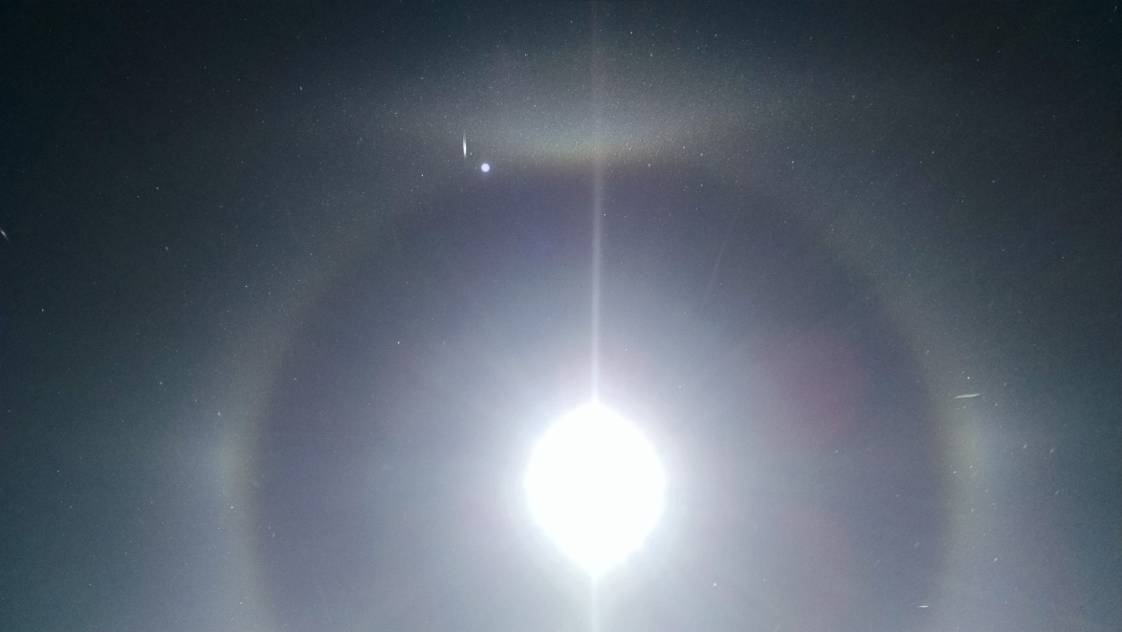

Saw a 22˚ halo, parhelia, and upper and lower tangent arcs throughout the day on Friday, accompanied briefly by a 46˚ halo and parhelic circle from about 13-14z. –Elissa, 9/02

**General:**

* Nothing to report.

**Significant Weather Observations:**

* 8/29: Sct Stratus, Bkn Cumulostratus, BLSN. -11C, 26kts, Visibility 800m.
* 8/30: Sct Stratus, Sct Altocumulous. -14C, 5kts, Visibility 800m.
* 8/31: Few Stratus, Sct Cirrus and Contrails. -18C, 11kts, Visibility 1600m. Parhelia 1201z.
* 9/01: Few Cumulostratus, Bkn Altocumulous. -16C, 11kts, Visibility 1000m.
* 9/02: Few Freezing Fog. -26C, 18kts, Visibility 800m with BLSN. Double halo (22 and 46 degree) and upper and lower tangent arcs 1145 to ~1700z.
* 9/03: Few Stratus, Freezing Fog on horizon. -29C, 8kts, Visibility 4800m.
* 9/04: Few Freezing Fog on horizon. Sct Stratocumulus, -24C, 10kts, Visibility unlimited. Parhelia 1015z

**Dataman Account:**

* 8/29: Data transfer complete at 0612z. File smtmwrl0_143704.MET.NC did not transfer (47 bytes link broken).
* 8/30: Data transfer complete at 0619z.
* 8/31: Data transfer complete at 0633z.
* 9/01: Data transfer complete at 0631z.
* 9/02: Data transfer complete at 0633z.
* 9/03: Data transfer complete at 0625z.
* 9/04: Data transfer complete at 0632z

**MWR:**

* Operating normally.

**SODAR:**

* Operating normally.
* Heavy equipment operating daily for berm construction.

**POSS:**

* Operating normally.

**MMCR:**

* Operating normally.

**CAPABL:**

* Operating normally.

**MPL:**

* Operating normally. VantageVue communication error (17:27) remained present throughout the week
* 8/29: The 17:36 VantageVUE communication error is still present in the Hardware Status box.
* 8/30: Restarted Sigma-MPL and computer at 1720z. Cleared old error message, but new one appeared when data collection was resumed at 1727z.

**VCEIL:**

* Operating normally.

**Hotplate:**

* Off site for repairs since 6/9/2016.

**IceCAM:**

* Operating normally.

**PAERI:**

* Operating normally.
* 8/29: LW Responsivity and SW Responsivity errors (red). As of 1404z, they were not in error, but had been in error around 1200z. Contacted Von.

**TSI:**

* Operating normally.
* Due to decreasing angle of the sun, false low cloud coverage is reported during the early morning and late evening hours, and there are no raw or processed photos from ~0702z-2201z as of 9/04 (time increasing each day).

**IcePIC:**

* 8/XX Slides placed for collection XXXXXz. Images photographed include XXXXXXXX.

**Radiosonde:**

* Twice daily soundings.

**MASC:**

* Offsite for repairs since 5/3/2016.