# ICECAPS Weekly Report

August 8, 2016 – August 14, 2016

Hannah James, Travis Guy, Elissa Barris

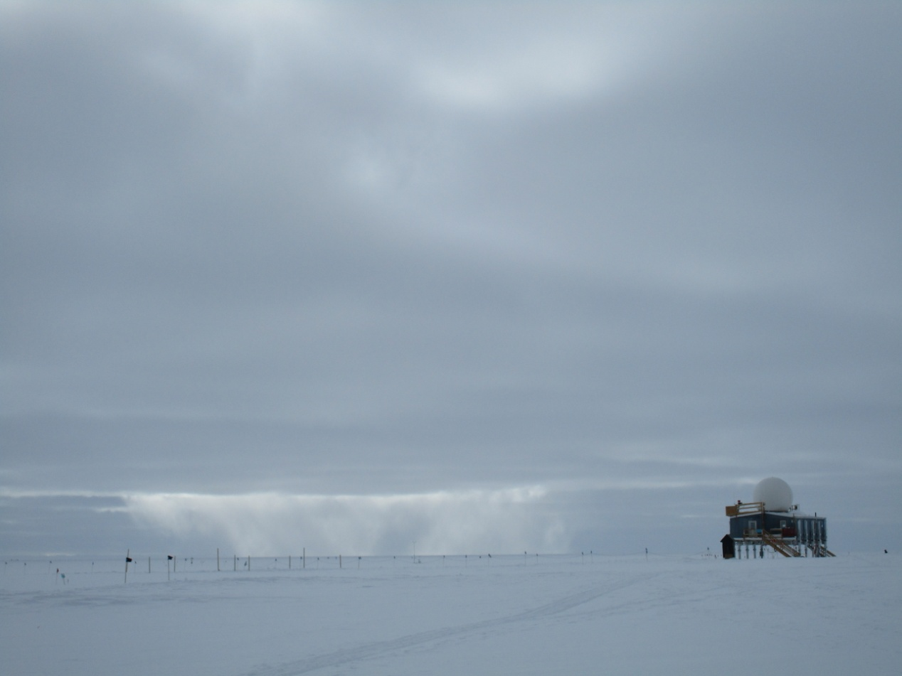

A snowstorm in the distance of the Big House -HJ

**General:**

* Due to server work, the internet was down on 8/9/2016 from 1450-1519z. A planned power outage occurred on 8/12/2016 for generator training. Outage times were 1607-1610z and 1625-1628z. Turnover with Travis and Elissa continued, all daily and weekly tasking has been covered.

**Significant Weather Observations:**

* 8/8: Bkn nimbostratus, ovc stratus. -15C, 12 kts. Visibility 3200m. –Sn in morning.
* 8/9: Few altocumulus, becoming ovc stratocumulus in the afternoon. -12C, 15 kts. Visibility 3200m. IC in the morning. 1115-1300z: 22 degree halo, parhelia, circumzenithal arc, parhelic circle. –Sn in evening (2000z).
* 8/10: Ovc stratus. -10C, 3 kts. Visibility unlimited. 1000z: –Sn.
* 8/11: Few stratus in evening, clear all day. -18C, 10kts. Visibility unlimited. Br in the morning, fogbow. 1200-1500z: IC
* 8/12: Sct altostratus,-20C, 0kts. Afternoon: Ovc stratus, -14C, 0 kts. Visibility unlimited. 1100-1500z: IC.
* 8/13: Bkn altocumulus and stratocumulus. -17C, 5 kts. Visibility unlimited
* 8/14: Bkn altocumulus. -14C, 5 kts. Visibility unlimited. –Sg in the morning. 1700z: verga. 1930z: corona. 2315z: fogbow, corona, and glory.

**Dataman Account:**

* 8/8: Data transfer complete 1719z.
* 8/9: Data transfer complete 1307z.
* 8/10: Data transfer complete 0634z. (I don’t know how or why it was so fast, but everything transferred. Jaime is looking into this.)
* 8/11: Data transfer complete 0632z.
* 8/12: Data transfer complete 1346z.
* 8/13: Data transfer complete 1051z.
* 8/14: Data transfer complete 1127z.

**MWR:**

* Operating normally.
* 8/8: Absolute calibrations preformed on HATPRO and 150-90. 1910z: Terminated running batch. 1912-1914z: 150-90 calibrated. 1923-1927z: HATPRO calibrated. 1927-1957z: internal_external flop measurement run. 1957: Returned to normal v_11scan.mdf collection.
* 8/9: Absolute calibration preformed on HATPRO. 1821z: Terminated running batch. 1834-1836z: HATPRO calibration. 1836-1856z: internal_external flop measurement run. 1901z: Returned to normal v_11scan.mdf collection.
* 8/10: Absolute calibration preformed on HATPRO. 1815z: Terminated running batch. 1833-1835z: HATPRO calibration. 1836-1855z: internal_external flop measurement run. 1905z: Returned to normal v_11scan.mdf collection.

**SODAR:**

* Operating normally.
* 8/12: 1314-1340z- powered down for turnover training.

**POSS:**

* Operating normally.
* 8/12: 1314-13:40z- powered down for turnover training

**MMCR:**

* Operating normally.
* Roll bouncing between 0.32 and 0.43 degrees, pitch bouncing between 0.00 and -0.10.

**CAPABL:**

* Operating normally.
* 8/11: Aligned laser.
* 8/12: Shut down for turnover training. Realigned afterwards.

**MPL:**

* Operating normally.

**VCEIL:**

* Operating normally.

**Hotplate:**

* Off site for repairs since 6/9/2016.

**IceCAM:**

* Operating normally.
* 8/11: Heavy frost covering camera 0245-1030z

**PAERI:**

* Operating normally.

**TSI:**

* Operating normally.
* Due to decreasing angle of the sun, false low cloud coverage is reported during the early morning and late evening hours, and there are no raw or processed photos from ~0000z-0600z (time increasing each day).

**IcePIC:**

* 8/10: Slides placed for collection 1211z. Images photographed include broken stellar plates, rimed hexagonal plates, and radiating irregulars.
* 8/14: Slides placed for collection 1152z. Images photographed include rimed dendrites, rimed irregulars, bullet rosettes, hollow columns, and ice crystals formed on slides that were left out the previous night.

**Radiosonde:**

* Twice daily soundings.
* 8/13: Successful RS41 test launch
* 8/13: No morning balloon due to early ANG arrival.

**MASC:**

* Offsite for repairs since 5/3/2016.