# ICECAPS Weekly Report

December 12 – December 18, 2016

Sam Dorsi

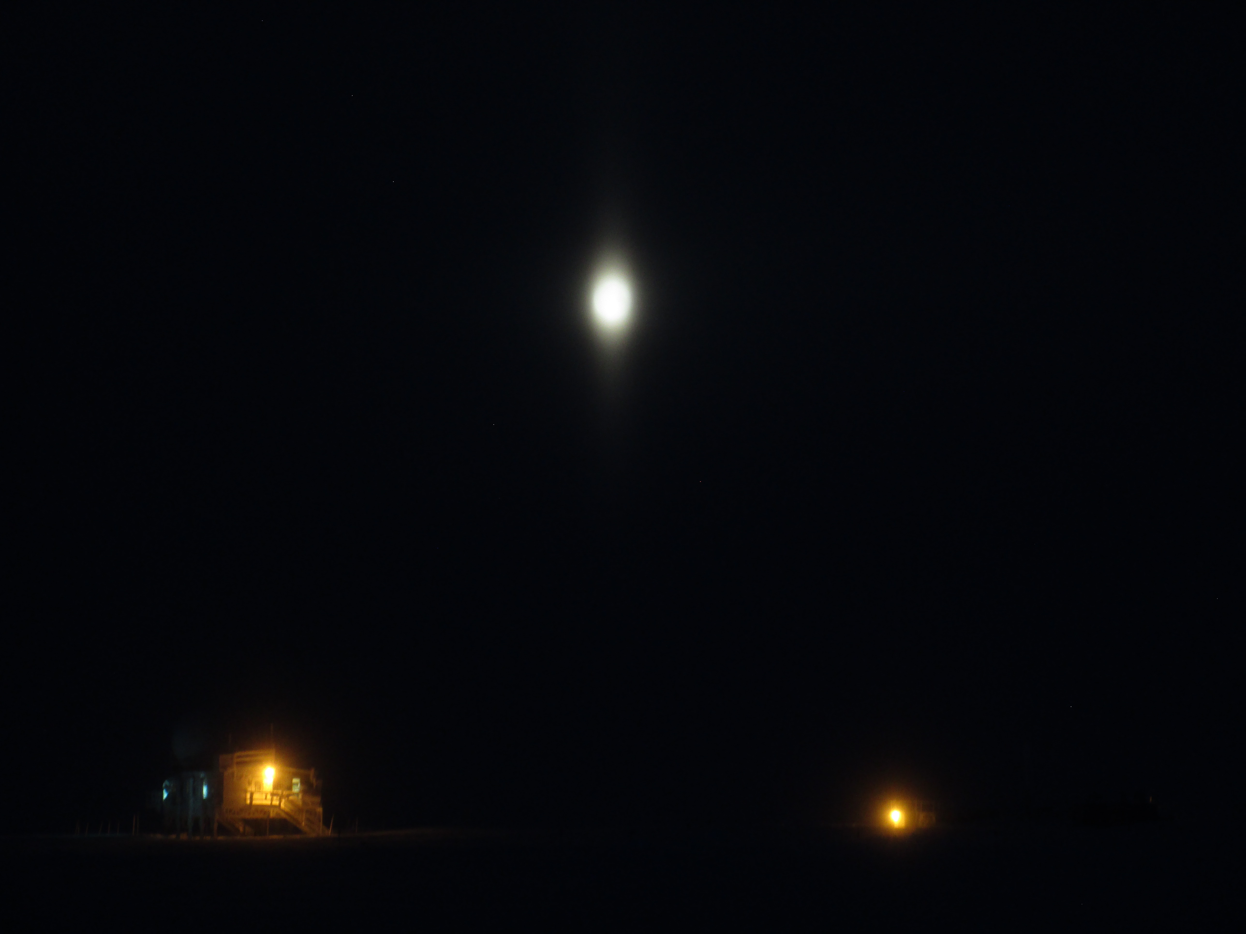

A pillar-elongated moon appears over the Big House and Green House on 12/15. SWD.

General:

* None.

**Significant Weather Observations:**

* 12/12: Freezing fog, -22C, 17 kts.
* 12/13: Broken stratus, -33C, 8 kts.
* 12/14: Broken altostratus, -30C, 16 kts.
* 12/15: Overcast stratus, -28C, 11 kts. Although only weakly visible, the moon showed a ‘solar’ pillar and possible upper tangent arc at 12:20z.
* 12/16: Broken stratus, -28C, 10 kts.
* 12/17: Clear, -47C, 9 kts.
* 12/18: Overcast stratus, freezing fog, blowing snow, -27C, 14 kts.

**ICECAPS Data Management:**

* 12/12: Data transfer complete at 13:00z.
* 12/13: Data transfer complete at 15:06z.
* 12/14: Data transfer complete at 14:32z.
* 12/15: Data transfer complete at 14:04z.
* 12/16: Data transfer complete at 19:10z.
* 12/17: Data transfer complete at 21:37z.
* 12/18: Data transfer complete at 12:52z.

**MWR:**

* Operating normally.

**SODAR:**

* Operating normally.
* 12/12: Cleaned SODAR dishes 14:26 – 14:38z. Adjusted CH1 gain for maximum power without clipping.

**POSS:**

* Operating normally.

**MMCR:**

* Operating normally.
* Pitch 0.22, roll -0.22 as of 12/18.

**CAPABL:**

* Operating normally.
* 12/15: CAPABL found at 12:46z to be displaying a boot screen error message: ‘disk boot failure, insert system disk and press enter.’ System was rebooted, but exhibited unusual symptoms, including no light being produced from Laser 1, no incrementing of the step count, and blotchy displays on the motor controllers. Extensive diagnostics were performed with Robert, which led to suspicions of a damaged Laser 1 Q-switch board or flash lamp. The first laser mirror was manually realigned. CAPABL resumed operation on Laser 2 at ~16:45z.

**MPL:**

* Operating normally.

**VCEIL:**

* Operating normally.

**Hotplate:**

* Offsite for repairs since 6/9/2016.

**IceCAM:**

* Operating normally.

**PAERI:**

* Operating normally.

**TSI:**

* Stored in MSF for winter.

**IcePIC:**

* 12/13: Slides placed for collection 13:15 to 13:50z. Particles photographed include isolated bullets, bullet rosettes, twin columns, hollow columns, and irregulars.

**Radiosonde:**

* Twice daily soundings.
* 12/12: Sounding failed at 12z, due to humidity sensor issues on two consecutive radiosonde units with very different serial numbers. As an identical issue occurred with two consecutive sondes on 11/14, it seems likely that the issue relates to the base station, to the software, or possibly to the (unremarkable) weather on these dates, and not to the radiosonde units themselves. Were this issue to be caused by radiosonde irregularities, one would expect the distribution of failed sondes to be random over time, and not clustered at these failure events (11/14 and 12/12).

**MASC:**

* Offsite for repairs since 5/3/2016.