# ICECAPS Weekly Report

December 19 – December 25, 2016

Sam Dorsi

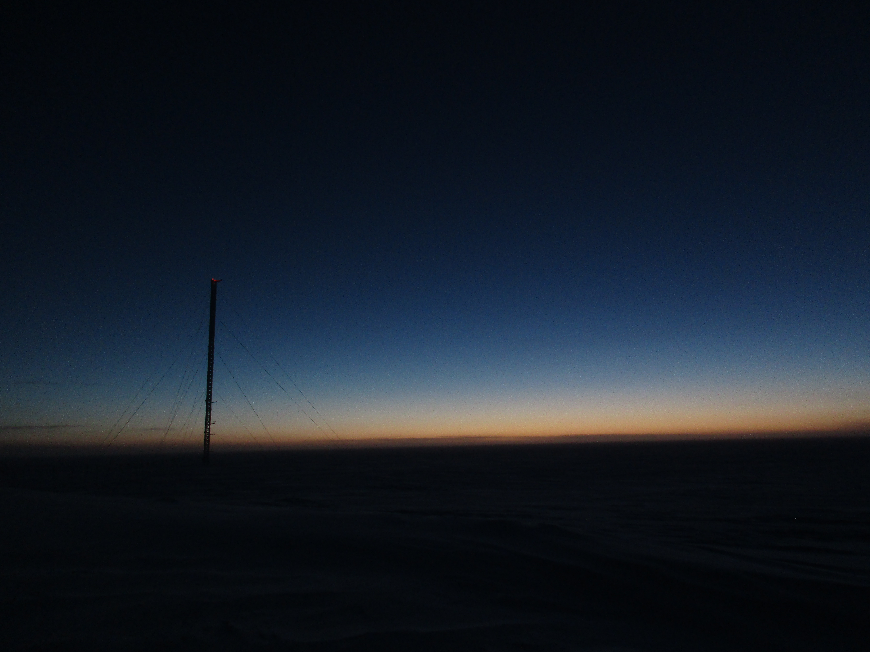

From the MSF at high noon, solstice twilight illuminates the view south. SWD.

General:

* None.

**Significant Weather Observations:**

* 12/19: Overcast stratus, freezing fog, blowing snow, -37C, 15 kts.
* 12/20: Few stratus, -51C, 13 kts.
* 12/21: Broken stratocumulus, -47C, 10 kts.
* 12/22: Scattered stratocumulus, -51C, 14 kts.
* 12/23: Few stratus, -45C, 14 kts.
* 12/24: Broken stratus, drifting snow, -42C, 14 kts.
* 12/25: Broken stratus, drifting snow, -40C, 15 kts.

**ICECAPS Data Management:**

* 12/19: Data transfer complete at 11:54z.
* 12/20: Data transfer complete at 13:52z.
* 12/21: Data transfer complete at 18:09z.
* 12/22: Data transfer complete at 14:18z.
* 12/23: Data transfer complete at 15:14z.
* 12/24: Data transfer complete at 13:55z.
* 12/25: Data transfer complete at 11:40z.

**MWR:**

* Operating normally.

**SODAR:**

* Operating normally.

**POSS:**

* Operating normally.
* 12/21: Several errors of ‘01__: DC offset’ and ’010_: +12V’ appear in main log. Of possible significance, these error codes, and other malformed error codes ‘_100’, ‘_000’, ‘000_’, ‘00_0’, ‘0__0’, can be produced by eliminating a single character from no error ‘0000’ or the very common ‘0100: air temp’ code.
* 12/22: POSS messages appear truncated, and apparently malformed error codes continue.
* 12/23: POSS was operating normally at the time of daily checks (14:10z). POSS acquisition was stopped 14:20 - 14:28z while and the power was briefly cycled, and the outdoor instrument case was opened to check the status of heating element.

**MMCR:**

* Operating normally.
* Pitch 0.30, roll -0.22 as of 12/26.

**CAPABL:**

* Operating normally.

**MPL:**

* Operating normally.

**VCEIL:**

* Operating normally.

**Hotplate:**

* Offsite for repairs since 6/9/2016.

**IceCAM:**

* Operating normally.

**PAERI:**

* Operating normally.

**TSI:**

* Stored in MSF for winter.

**IcePIC:**

* 12/22: Slides placed for collection 12:42 – 13:30z. Particles photographed include isolated bullets, bullet rosettes, hexagonal plates, solid columns, and needles. Images are unusually dark, despite the exposure settings remaining unchanged. This may be related to the gradual failure of the IcePIC LED flashlight that illuminates the stage. I will adjust exposure in next round, but a replacement light may be worthwhile.

**Radiosonde:**

* Twice daily soundings.
* 12/19: Sounding was unable to be performed at 12z, as the system was hung during a Windows update. System was hard reset at 17:07z, and Windows started up after installing updates. Radiosonde system was tested up to the point of sonde release, and worked normally. Subsequent soundings were successful. Updates were installed by a fellow tech who noticed that updates were several years out of date, and felt this was a security risk for the Summit network. We discussed that performing updates on these systems can have unknown impacts, and potentially destabilize associated instruments. Updates should be performed only after PI consultation. The science computers should not be used for web browsing, which reduces risk.

**MASC:**

* Offsite for repairs since 5/3/2016.