# ICECAPS Weekly Report

December 5 – December 11, 2016

Sam Dorsi

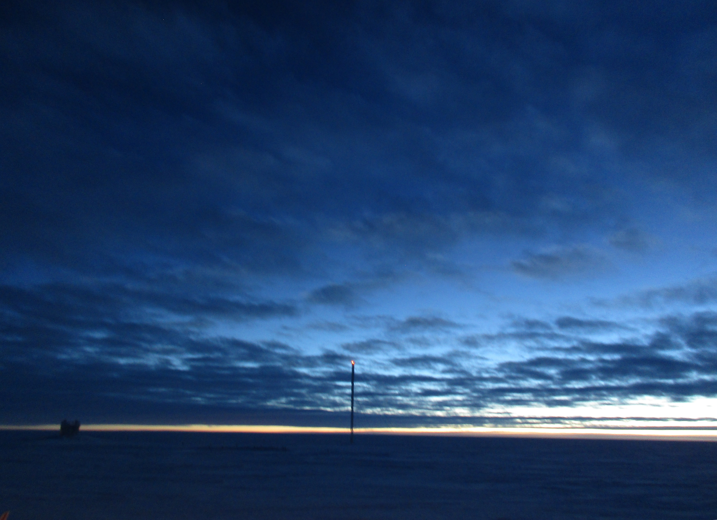

The MSF appears under a great display of twilight stratocumulus on 12/11. SWD.

General:

* 12/6: Strong CAPABL scattering phenomenon, with many diffraction patterns projected onto snow surface, was present from at least 19:25 to 20:50z and likely beyond. A solar pillar effect was visible from artificial lights on Big House and Green House.

**Significant Weather Observations:**

* 12/5: Overcast stratus, freezing fog, ice particles, -22C, 17 kts.
* 12/6: Broken stratus, freezing fog, ice particles, -19C, 12 kts.
* 12/7: Broken stratocumulus, blowing snow, -23C, 20 kts.
* 12/8: Overcast stratocumulus, blowing snow, -22C, 18 kts. Lunar halo observed at 22:35z.
* 12/9: Few stratus, -31C, 12 kts.
* 12/10: Overcast stratus, -22C, 14 kts.
* 12/11: Broken altostratus, -21C, 11 kts.

**ICECAPS Data Management:**

* 12/5: Data transfer complete at 19:04z.
* 12/6: Data transfer complete at 22:21z.
* 12/7: Data transfer complete at 22:23z.
* 12/8: Data transfer complete at 20:44z.
* 12/9: Data transfer complete at 19:26z.
* 12/10: Data transfer complete at 15:23z.
* 12/11: Data transfer complete at 18:53z.

**MWR:**

* Operating normally.

**SODAR:**

* Operating normally.
* 12/6: Cleaned snow out of SODAR dishes 14:49 – 14:59z.

**POSS:**

* Operating normally.
* 12/5: POSS was shut down from 14:21 to 14:52z while the Telebyte data cable-to-terminal-block connection was rebuilt for improved stability.

**MMCR:**

* Operating normally.
* Pitch 0.29, roll -0.22 as of 12/5.
* 12/5: Reported at 18:23z, MMCR observations of a clear sky do not match current conditions, which include perceptible falling ice crystals, and MPL observations of a liquid layer producing ice fall streaks.
* 12/6: At 01:36z, powered down MMCR. Waited several minutes, and then restored power. When MMCR resumed operation at 01:50z, signals from two distinct cloud layers were displayed. These matched MPL observations and visible conditions.

**CAPABL:**

* Operating normally.

**MPL:**

* Operating normally.
* 12/9: The MPL mount has reached 95 % capacity: this is the requested notification threshold.

**VCEIL:**

* Operating normally.

**Hotplate:**

* Offsite for repairs since 6/9/2016.

**IceCAM:**

* Operating normally.

**PAERI:**

* Operating normally.
* 12/9: Memory address error appeared (12:58z) when closing Open Office spreadsheet for daily checks.

**TSI:**

* Stored in MSF for winter.

**IcePIC:**

* 12/6: Slides placed for collection 19:55-20:02. Particles photographed include bullet rosettes, isolated bullets, hexagonal plates, capped columns, and possible triangular ice. A solar pillar effect was dimly visible from artificial lights on Big House and Green House. Fellow tech Marissa was trained in this session and captured these photos.

**Radiosonde:**

* Twice daily soundings.

**MASC:**

* Offsite for repairs since 5/3/2016.