# ICECAPS Weekly Report

February 15, 2016 – February 21, 2016

Sam Dorsi

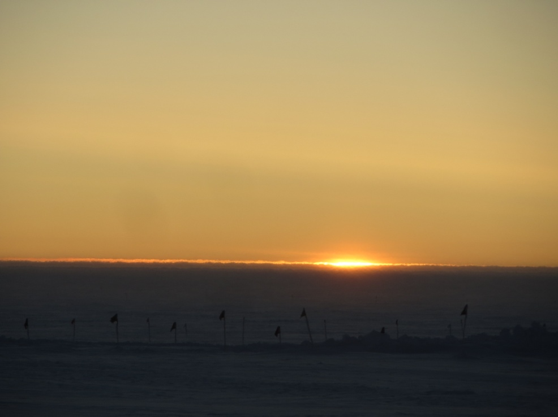

Dawn sunlight spreads along the horizon, above the MSF-to-50-meter-tower flagline. SWD.

**General:**

* 2/20: Drift mitigation on west side of MSF to improve access to main doorway.

**Significant Weather Observations:**

* 2/15: Scattered stratus, 10 kts, -36C
* 2/16: Blowing snow, 15 kts, -31C
* 2/17: Broken stratus, 10 kts, -36C
* 2/18: Blowing snow, 20 kts, -30C
* 2/19: Few stratus, 10 kts, -41C
* 2/20: Overcast stratus, 5 kts, -41C
* 2/21: Few stratus, 7 kts, -47C

**Dataman Account:**

* Operating normally.
* 2/16: Data backlog cleared at 23:47z.
* 2/17: Small backlog occurs as SODAR and IceCam data not transferred (~250MB at 13:00UTC).
* 2/18: ArchiveBoulder process start time shifted to 02:05 UTC.
* 2/18: Backlog increases as SODAR and IceCam data not transferred (~450MB at 12:30z).
* 2/19: Backlog increases as SODAR and IceCam data not transferred (~584MB at 12:30z).
* 2/20: Backlog increases as SODAR and IceCam data not transferred (~705MB at 12:00z).
* 2/21: Backlog decreases slightly (~433 MB at 12:30z).

**MWR:**

* HATPRO removed for repairs.

**SODAR:**

* Operating normally.

**POSS:**

* Operating normally.

**MMCR:**

* Operating normally.
* Roll continues to be off by 5 degrees.
* 2/18: A single incidence of TWTA heater voltage out-of-spec was reported in the 1300UTC health file.
* 2/20: At 12:29z, the MMCR pitch value was observed to have increased to 10.9 degrees. It had previously been within the nominal -0.2 to 0.2 degree range. No physical change in building or dish tilt was apparent.

**CAPABL:**

* Operating normally.

**MPL:**

* Operating normally.
* 2/17: The MPL beam was identified as tangent to the edge of the observation window frame, and a PI request was made to relocate the MPL to ensure an unobstructed field of view. The MPL was shifted towards the western wall of MSF (main door side) by 2 cm and re-bolted in place. The MPL base destination was laid out in advance, and the shift was realized in 20 sec at 17:20:00 (GPS time; MPL clock time was 8 seconds fast). No change was made in the horizontal rotation or north-south position. Although difficult to perceive, the translation may have caused a minor reduction in backscatter signal at all heights.

**VCEIL:**

* Operating normally.

**Hotplate:**

* Operating normally.

**IceCAM:**

* Operating normally.

**PAERI:**

* Operating normally.

**TSI:**

* Stored in MSF and awaiting warmer temperatures for redeployment.

**IcePIC:**

* 2/19: Placed slides on collection bench on N side of MSF at 14:04z. No accumulation on slide had occurred by 15:29z, so fresh slides were placed at 15:34z, and bench was moved to W side of MSF, 2 meters from building for an overnight collection.
* 2/20: Photographed slides at 12:55z. Particles included simple prisms, hollow columns, plates, bullet rosettes.

**Radiosonde:**

* Twice daily sondes.

**MASC:**

* Operating normally.