# ICECAPS Weekly Report

February 22, 2016 – February 28, 2016

Sam Dorsi

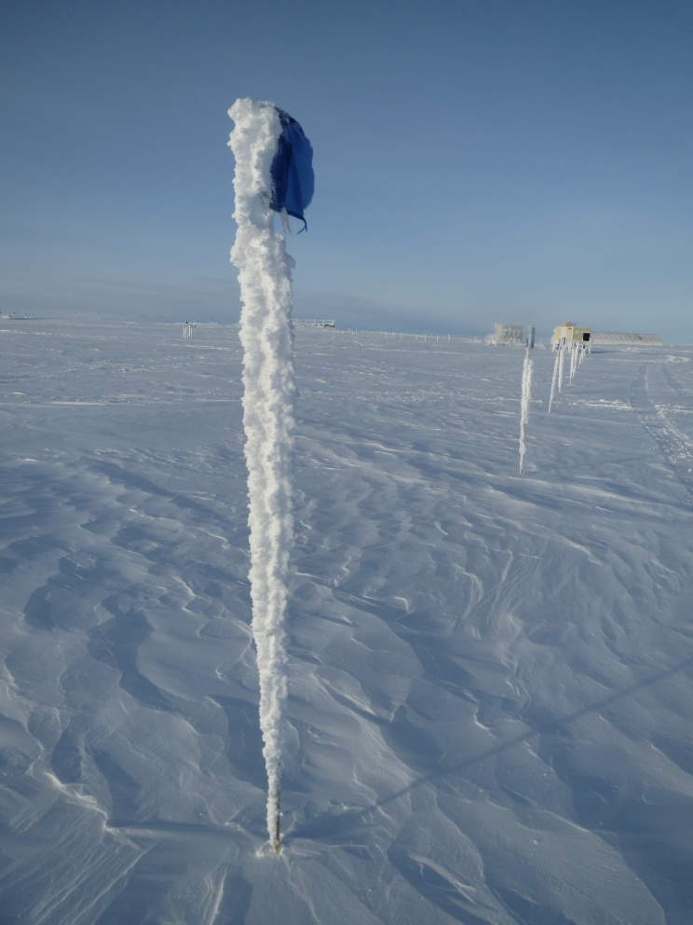

Bamboo poles are heavy with frost along the MSF-Green House flagline. SWD.

**General:**

* 2/24: With favorable winds away from PAERI and CAPABL, and MPL in afterpulse calibration mode, tech was able to remove thick rime accumulations from south railings and deck edges between 13:16 and 13:33z.

**Significant Weather Observations:**

* 2/22: Overcast stratus and drifting snow, 11 kts, -31C
* 2/23: Overcast stratus and freezing fog, 11 kts, -26C
* 2/24: Few stratus and broken altostratus, 8 kts, -32C
* 2/25: Few altostratus, 20 kts, -30C
* 2/26: Few altostratus, 20 kts, -33C
* 2/27: Overcast and freezing fog, 8 kts, -33C
* 2/28: Broken stratus and freezing fog, 12 kts, -33C

**Dataman Account:**

* Operating normally.
* 2/21: Larger quantity of data transferred: backlog reduced to 260 MB at 14:00z.
* 2/23: Backlog 250 MB at 13:00z.
* 2/24: Backlog 240 MB at 13:00z.
* 2/25: Backlog 140 MB at 13:30z.
* 2/26: Backlog 160 MB at 12:30z.
* 2/26: The ArchiveBoulder log file shows ‘lost connection’ errors, possibly due to seasonal solar interference.
* 2/27: Backlog 1.0 GB at 13:15z.
* 2/28: Backlog 1.0 GB at 13:15z.

**MWR:**

* HATPRO removed for repairs.

**SODAR:**

* Operating normally.

**POSS:**

* Operating normally.

**MMCR:**

* Operating normally.
* Measurements of roll, pitch and outdoor temperature appear erroneous.

**CAPABL:**

* Operating normally.

**MPL:**

* Operating normally.
* 2/24: Afterpulse calibration performed from 13:03z to 13:36z.

**VCEIL:**

* Operating normally.

**Hotplate:**

* Operating normally.

**IceCAM:**

* Operating normally.

**PAERI:**

* Operating normally.

**TSI:**

* Stored in MSF and awaiting warmer temperatures for redeployment.

**IcePIC:**

* 2/25: Slides were placed at 13:35z on wooden bench 6 m NW of MSF, during strong drifting snow conditions (20 kts, but level of wind-carried snow low). Removed 14:22z. No accumulation occurred on slide at upwind side of T-barrier; on downwind side of T-barrier, several metamorphosed ice pellets were collected and photographed.

**Radiosonde:**

* Twice daily sondes.
* 2/14 – 2/28: Due to the failure of the NOAA air temperature sensor (TAWO tower, 2 m) normally used for sonde surface conditions, the air temperature from the Green House tower was recorded instead. The NOAA temperature sensor was restored to service on 2/28.

**MASC:**

* Operating normally.