# ICECAPS Weekly Report

February 29, 2016 – March 6, 2016

Sam Dorsi

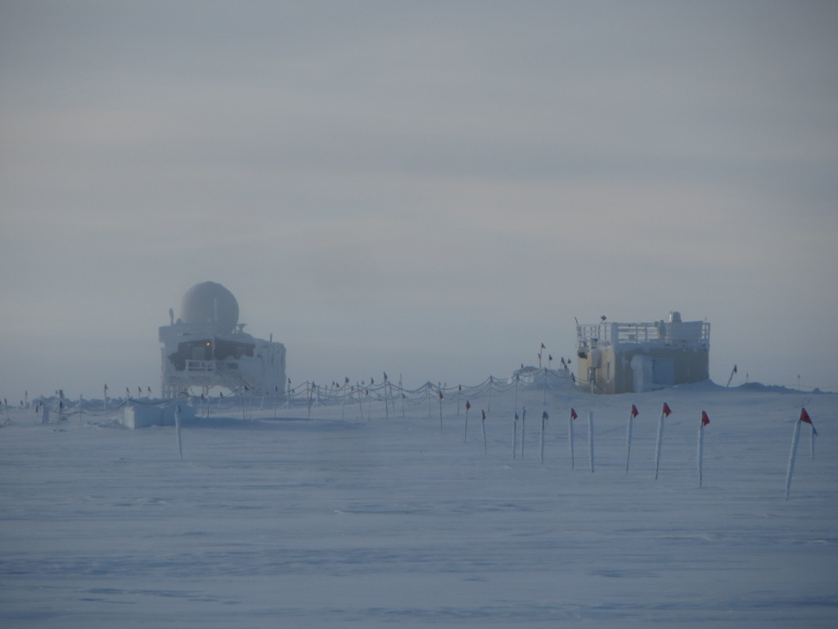

The MSF and Big House appear at the end of the bamboo forest flagline. SWD.

**General:**

* Season inventory performed of ICECAPS radiosonde He cylinders.

**Significant Weather Observations:**

* 2/29: Overcast stratus, 7 kts, -28C
* 3/1: Few stratus and scattered altostratus, 9 kts, -33C
* 3/2: Freezing fog, 9 kts, -33C
* 3/3: Broken stratus and freezing fog, 14 kts, -33C
* 3/4: Freezing fog, 8 kts, -34C
* 3/5: Overcast stratus and freezing fog, 12 kts, -22C
* 3/6: Overcast stratus and freezing fog, 10 kts, -26C

**Dataman Account:**

* Operating normally.
* 2/29: Backlog 850 MB at 12:30z.
* 3/1: Backlog 825 MB at 12:45z.
* 3/2: Backlog 790 MB at 13:00z.
* 3/3: Backlog 560 MB at 12:30z.
* 3/4: Backlog 560 MB at 13:00z.
* 3/5: Backlog 415 MB at 12:30z. A total of 2.32 GB was transferred in the previous two days, but the backlog was only reduced by 145 MB (i.e., one sodar file).
* 3/6: Backlog 411 MB at 12:15z.

**MWR:**

* HATPRO removed for repairs.

**SODAR:**

* Operating normally.

**POSS:**

* Operating normally.

**MMCR:**

* Operating normally.
* Measurements of roll, pitch and outdoor temperature appear erroneous.

**CAPABL:**

* Operating normally.

**MPL:**

* Operating normally.

**VCEIL:**

* Operating normally.

**Hotplate:**

* Operating normally.

**IceCAM:**

* Operating normally.

**PAERI:**

* Operating normally.

**TSI:**

* Stored in MSF and awaiting warmer temperatures for redeployment.

**IcePIC:**

* 2/29: Particles collected from 12:46z to 13:45z. Collection was 6 m west of MSF in very low winds. Photographs show bullet rosettes and aggregates.

**Radiosonde:**

* Twice daily sondes.

**MASC:**

* Operating normally.
* 3/6: Found 20 ‘camera bus reset’ errors to have appeared by 12:15z.