# ICECAPS Weekly Report

February 8, 2016 – February 14, 2016

Mike Finnegan and Sam Dorsi

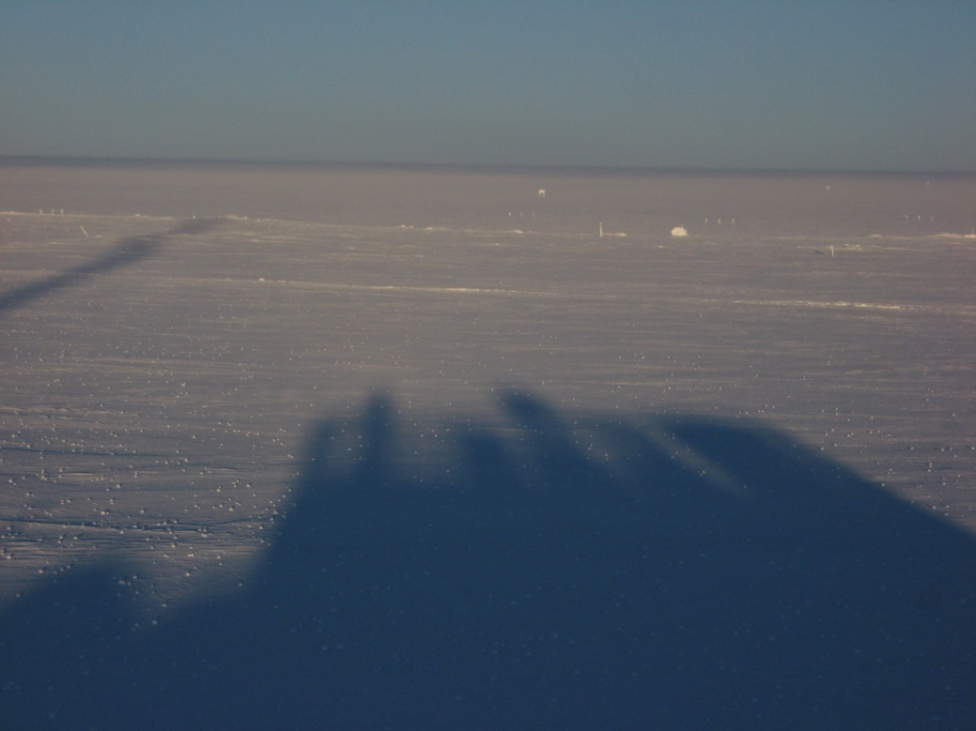

The shadow of the MSF falls on a field of yukimarimo. SWD.

**General:**

* 2/10: Yukimarimo appeared during the night.
* 2/13: The outgoing crew departs for warmer shores.

**Significant Weather Observations:**

* 2/08: Few altocumulus, broken cirrostratus, 12 kts, -46C
* 2/09: Overcast stratus, 13 kts, -40C
* 2/10: Few stratus, 9 kts, -51C
* 2/11: Few stratus, 8 kts, -58C
* 2/12: Few stratus, 7 kts, -55C
* 2/13: Broken stratus, 6 kts, -42C
* 2/14: Few altostratus, 12 kts estimated (anemometer, -46C

**Dataman Account:**

* Operating normally.
* 2/11: USB drive swap performed at 14:19z. USB drive #4 was removed and USB drive #3 was installed. The disk search file path was updated on Dataman. Drive #4 will be hand-carried to Boulder by Matt Okraszewski, along with the previous USB drive (swapped 6 Dec 2015).
* 2/11: At the time of the swap, 870 MB of data were queued in the ‘ToBoulder’ folder. Four SODAR ‘.nc.gz’ data files, for Julian dates 038-041, were moved to a temporary folder ‘sodar untransferred backup’ on the Dataman desktop. Remaining in the ‘ToBoulder’ folder were 287 MB of data.
* 2/12: SODAR backups deleted from Dataman by PI request.

**MWR:**

* HATPRO removed for repairs.
* 2/9-2/12: Occasional brief low temperature readings appear in the 150/90 housekeeping data. These spikes are very brief and simultaneous across all temperature channels, which suggests that they may be spurious.

**SODAR:**

* Operating normally.

**POSS:**

* Operating normally.

**MMCR:**

* Operating normally.
* Roll continues to be off by 5 degrees.
* 2/9: The MMCR desiccant swap was performed at 13:50z.

**CAPABL:**

* Operating normally.
* 2/10: Successfully performed CAPABL laser realignment at 14:15z.

**MPL:**

* Operating normally.

**VCEIL:**

* Operating normally.

**Hotplate:**

* Operating normally.
* 2/11: LED Red on instrument, but no errors reported in software. Temperature was -57.8C.

**IceCAM:**

* Operating normally.

**PAERI:**

* Operating normally.
* 2/9: The PAERI fan shelter was removed at approximately 13:45z. A new spare PAERI fan was fitted with an outlet plug and used to replace the existing fan. The fan shelter was returned to operation at 14:15z.
* 2/12: PAERI rebooted at 12:57z in order to resolve to scene mirror errors. The mirror did resume its normal measurement cycle movements, but the alignment was slightly off (~15 deg).
* 2/12: PAERI was again rebooted at 19:06z, due to the ongoing scene mirror encoder discrepancy. This reboot restored PAERI to normal operation. Von suggests that the scene mirror encoder may struggle to identify its proper orientation during very cold periods, and that periodic reboots may be necessary if this issue reoccurs.

**TSI:**

* Stored in MSF and awaiting warmer temperatures for redeployment.

**IcePIC:**

* No photos taken.

**Radiosonde:**

* Twice daily sondes.

**MASC:**

* Operating normally.
* 2/8-2/14: On a daily basis, the MASC PC reports an error with the Windows registration.