# ICECAPS Weekly Report

February 01, 2016 – February 07, 2016

Mike Finnegan and Sam Dorsi

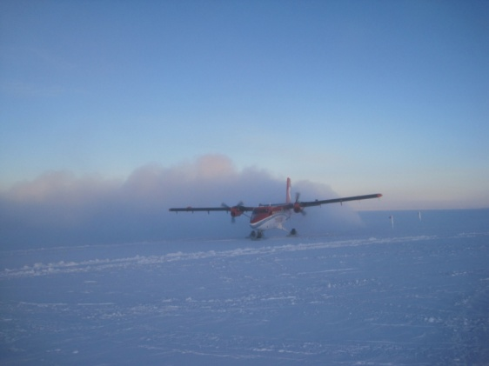

Flying Machine with Friends! - MOF, 2/4

**General:**

**Significant Weather Observations:**

* 2/01: drsn, few150, 17.0kts, -43.6C
* 2/02: bkn altostratus, 9.0kts, -49.0C
* 2/03: br, bkn altostratus, ovc cirrostratus, 11.6kts, -43.1C
* 2/04: few altocumulus, few cirrus, 10.2kts, -48.2C
* 2/05: few cirrocumulus, 7.4kts, -49.9C
* 2/06: few cumulus, bkn altostratus, 4.0kts, -42.9C
* 2/07: Broken stratus, 7.0 kts, -37.2C

**Dataman Account:**

* Operating normally.

**MWR:**

* HATPRO: Removed for repairs.
* 150-90: operating normally.

**SODAR:**

* Operating normally.
* Cleared receiver and transceiver of snow, 1418-1436Z, 2/7.

**POSS:**

* Operating normally.

**MMCR:**

* Operating normally.
* Roll continues to be off by 5 degrees. May be a wiring issue since last time it was off this much, I check connectivity of the wires, found them all good, and the roll suddenly corrected itself. As it is off by the same amount this time suddenly, I don’t think the building shifted 5 degrees.
* Found error “Could not read calibration table Net CDF File” on 2/1 daily checks. Rebooting the MMCR fixed this error.

**CAPABL:**

* Operating normally.

**MPL:**

* Operating normally.

**VCEIL:**

* Operating normally.

**Hotplate:**

* Operating normally.

**IceCAM:**

* Operating normally.

**PAERI:**

* Operating normally.

**TSI:**

* Shutdown and removed from the roof for the winter.

**IcePIC:**

* No photos taken.

**Radiosonde:**

* Twice daily sondes.
* Replaced regulator on 2/6.
* 2/7 12z: Error “cannot communicate with data server” reported on starting sounding in DigiCora. Rebooted SPS and sounding laptop, and found that issue was resolved.

**MASC:**

* Operating normally.
* Cleared light rime from flashes. (2/5, 2/6, 2/7)