# ICECAPS Weekly Report

January 04, 2016 – January 10, 2016

Mike Finnegan

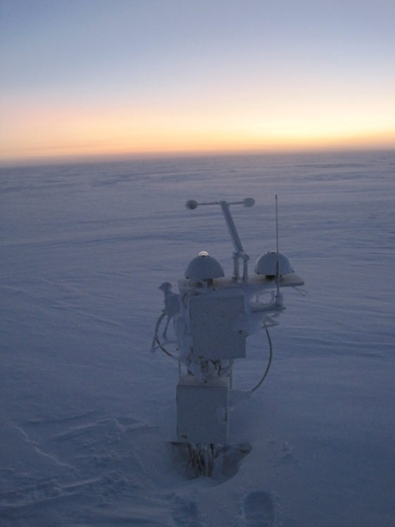

Proof that Light is Returning. - MOF

**General:**

* Re-aimed MSF WiFi antenna on 1/5. Improved RSSI from -84dB to -64dB.

**Significant Weather Observations:**

* 1/4: few altocumulus, bkn cirrostratus, 7.6kts, -38.1C
* 1/5: ovc stratus, blsn,13.0kts, -24.4C
* 1/6: ovc stratus, drsn, 19.8kts, -23.6C
* 1/7: bkn stratus, ovc altostratus, blsn, 18.0kts, -28.8C
* 1/8: sct stratocumulus, bkn altostratus, ic, drsn, 13.0kts, -25.5C
* 1/9: br, 3.8kts, -43.3C
* 1/10: sct stratocumulus, 0.0kts, -43.4C

**Dataman Account:**

* Operating normally.
* Archive to Boulder reported:  
  *smtwrL0_160104_201729.MET.NC*  
  *Read from remote host 140.172.38.113: Connection timed out  
  lost connection*  
  And reported lost connection for all subsequent log messages on 1/5  
  File count dropped from 1600 to 300, but size is still 1.9 GB  
  This may be related to a server problem we are having as of this morning.

**MWR:**

* HATPRO: operating normally besides Noise Diode Rec.1 Red flag.
* 150-90: operating normally.
* Removed MWR box from berm for HATPRO retro – 1/8

**SODAR:**

* Operating normally.
* Removed snow from receiver dish on 1/9 from 1434-1439z.

**POSS:**

* Operating normally.

**MMCR:**

* Operating normally – Roll value still approx. 5 degrees.

**CAPABL:**

* Operating normally.

**MPL:**

* Operating normally.

**VCEIL:**

* Operating normally.

**Hotplate:**

* Operating normally.

**IceCAM:**

* Operating normally.

**PAERI:**

* Operating normally.

**TSI:**

* Shutdown and removed from the roof for the winter.

**IcePIC:**

* No Photos Taken

**Radiosonde:**

* Twice daily sondes.

**MASC:**

* Operating normally.